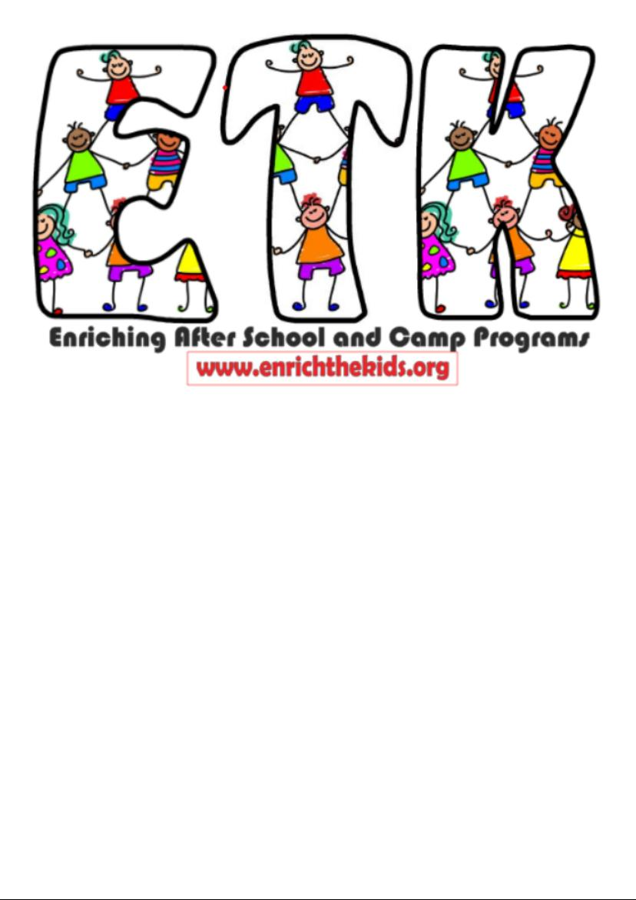

FAMILY HANDBOOK

Site Co-Directors: Alexis Reyes
575-270-8740

Tracey Gantzler - Program Director
575-805-4618

Introduction

Welcome to EnrichTheKids, Inc. Our program provides enrichment, childcare, and activities for the children in our program. It is fee-based and self-supporting. EnrichTheKids, Inc. is a non-profit organization, so we can offer services at a lower rate because we are not subject to gross receipts tax. This allows us the privilege of operating in the schools. Please read and become familiar with the policies and procedures. Keep this handbook for your reference and call your site director if you have questions.

To enroll your child, please provide a filled-out medical card and a signed parent consent form and agree to follow all Las Cruces Public Schools immunization regulations. Per our insurance, we need copies of shot records and insurance cards.

General Information

Philosophy
We understand that children have unique gifts and abilities and need positive guidance and support to learn and grow. With input from the students, parents, staff, and stakeholders, we plan many activities to assist with the child's overall growth. As part of their community and support group, we are responsible for creating as many opportunities as possible to promote positive interactions and relationships with peers and adults. We embrace that all families are different and unique and support everyone having equal access to appropriate services that all families deserve to reach their full potential.
We are committed to building trust through developing inclusive practices and overcoming biases, so we may establish creative partnerships to help our families, children, and employees grow. We are accountable to every child and family to uphold these ideals.

Mission
Enriching the lives of youth and their families by supporting systems that promote holistic growth, resilience, and a brighter future for all.

Curriculum
The curriculum is created by staff intending to prepare and teach age/developmentally appropriate lessons within their expertise. Site directors prescreen all lesson plans. Teachers/caregivers must go through 12 hours of college, community, and online training in early childhood development annually. Relationships and play are instrumental in the child's learning, so our daily routines allot time for space and spending time on building relationships that develop and foster self-reflection. We provide a diverse variety of services and experiences to meet the needs of our students. We are sensitive to their family experiences, culture, beliefs, abilities, and circumstances based on information shared by the family. We provide flexibility and choice for the best outcomes for all. We continuously use dialogue, surveys, and research to improve our methods to effectively meet the needs of the children and families in our programs.

Values
At EnrichTheKids, Inc., we are committed to fostering an environment that nurtures growth for the children in our care, their families, and our dedicated team. We believe that every child deserves the opportunity to develop their potential in a safe, supportive, and stimulating environment. We value teamwork as the foundation of our success. By collaborating with families, educators, and the community, we create a strong network of support that empowers children to thrive. Together, we work to create an inclusive environment where ideas, strengths, and contributions are respected and celebrated. Care is at the heart of everything we do. We are dedicated to providing compassionate, individualized attention to each child, ensuring their emotional, social, and physical well-being. Through our sincere commitment to care, we help children build confidence, empathy, and a love for learning.

Program Location
The Explore Academy Program is at 850 N Telshor Blvd.

License number:
25920550

Days and hours of operation: This program provides childcare during the school year from 2:40 PM until 6:00 PM. The program does not offer childcare on National holidays when the school is closed. Enrichthekids, Inc. is open to school-age children from kindergarten through 6th grade. We will also accept home-schooled students or students from other schools, but EnrichTheKids, Inc does not provide transportation.

Site Co-Directors: Please call or text for immediate assistance during our operating hours of 2 PM-6 PM.

Program Director: Tracey Gantzler: 575-571-7734. Call or text Tracey for general information.

Snacks and Meals
We provide one healthy snack daily. We request that you check with the directors before sending peanut products, as we may have participants with peanut allergies. If your child has a food allergy, please let us know so we can make appropriate substitutions.

Daily Schedule: The schedule is subject to change to take advantage of good weather or impromptu learning opportunities!

Daily Schedule during non-enrichment times;
2:40-3:00 - Sign in & bathroom break/wash hands, snack & wash hands again
3:00-4:00 - Recess
4:00-4:30 – Homework, reading
4:30-6:00 - Free time/organized craft or game time

Enrichment Time Schedule:
2:40-3:00 - Sign in & bathroom break/wash hands, snack & wash hands again
3:00-4:00 – Enrichment classes
4:00-4:30 – Homework or reading
4:30-5:15 - Recess
5:15-6:00 - Free Play

Open Door Policy: Custodial parents/guardians or grandparents are always welcome at the program! We are supportive of and encourage family involvement. Visitors must check in with the Program Director before visiting. The director reserves the right to deny a requested visit based on the circumstances. We will not allow non-family members or non-custodial parents to observe the children or the program. We have cooperative agreements with NMSU's College of Education to enable students to do community service as part of their Multicultural Education Class and Service Learning. They are already cleared through the district to come into the schools to observe and volunteer.

Clothing and Personal Possessions
Students should always wear washable, practical clothing, including appropriate footwear and outerwear. We follow the school district's policy for dress code. Please ensure children bring jackets, hats, and gloves during cold weather months that are clearly labeled. EnrichTheKids, Inc. is not responsible for lost or stolen property. Even though children are accountable for their personal belongings, the staff will do everything possible to ensure that items will not be lost or stolen. Enrichthekids, Inc. highly suggests not sending cash with your children, as we are not responsible if it does get lost. Please send a change of clothes with your child that can stay at camp for impromptu wet play or messes.

Holidays:
We celebrate and learn about all holidays as part of our enriching after-school program. If you object to anything we have planned, please send an alternate activity for your child that day. For example, you may send in a healthy snack or an activity for your child's birthday.

Liability Insurance: We carry independent insurance, independent of Las Cruces Public Schools. Contact the director to see a copy of this policy.

Policies and Procedures
Enrollment /Disenrollment Procedures/Payment Procedures

Enrollment is managed with Procare. You can find the QR code for registration at your school after school program, by texting your director, or visiting our website. Https//www.enrichthekids.org/explore-academy
Every family must apply for childcare assistance through ECECD to help cover the program's cost. https://www.nmececd.org/apply-for-services/

If you want to disenroll your child, please let the program director know at least a week before doing so. Written notice is preferred.

EnrichTheKids, Inc will give your spot to another child if your child stops coming to the program.

EnrichTheKids, Inc. Expulsion Policy
Unfortunately, there are sometimes reasons we must expel a child from our program, either on a short-term or permanent basis. We want you to know that we will do everything possible to work with the family of the child(ren) to prevent this policy from being enforced. The following are reasons we may have to expel or suspend a child from this center:
IMMEDIATE CAUSES FOR EXPULSION
- -The child is at risk of causing severe injury to other children or themselves.
- -The parent threatens physical or intimidating actions toward staff members.
- -The parent exhibits verbal abuse to staff in front of enrolled children.
PARENTAL ACTIONS FOR CHILD’S EXPULSION
- -Failure to pay/habitual lateness in payments.
- -Failure to complete required forms, including the child's immunization records.
- -Habitual tardiness when picking up your child.
- -Verbal abuse to staff.
- -Harassment or intimidation to staff, either on or off campus.
CHILD’S ACTIONS FOR EXPULSION
- -Bullying other children.
- -Uncontrollable tantrums/angry outbursts.
- -Ongoing physical or verbal abuse to staff or other children.
- -Bringing a gun or weapon on campus.
- -Continually intentionally damaging property
SCHEDULE OF EXPULSION
An expulsion action is to be a period so that the parent/ guardian may work on the child's behavior or come to an agreement with the center. EnrichTheKids, Inc will inform the parent/guardian of the expulsion period's length and the expected behavioral changes required for the child or parent to return to the center. The expulsion date will allow sufficient time to seek alternate child care (approximately one to two weeks' notice depending on the risk to other children's welfare or safety). Failure of the child/parent to satisfy the plan's terms may result in permanent expulsion from the center.
EnrichTheKids, Inc will not expel a child for the following reasons;
If a parent
- or guardian has complained to the Office of Licensing regarding a center's alleged violations of the licensing requirements.
- Reported abuse or neglect occurring at the center
- or questioned the center regarding policies and procedures.
To avoid expulsion, our staff will be proactive in mitigating unwanted behaviors.
- Staff will try to redirect the child from negative behavior.
- Staff will reassess the classroom environment, appropriate activities, and supervision.
- Staff will always use positive methods and language while disciplining children.
- Staff will praise appropriate behaviors.
- Staff will consistently apply consequences for rules.
- EnrichTheKids Staff will give the child will verbal warnings
- and time to regain control of their behavior.
- The child's disruptive behavior will be documented and maintained in confidentiality.
- EnrichTheKids Staff will notify the parent/guardian verbally.
- EnrichTheKids Staff will give the parent/guardian written copies of the disruptive behaviors that might lead to expulsion.
- The director, staff, and parent/guardian will have a conference(s) to discuss how to promote positive behaviors.
- The parent will be given literature or other resources regarding helping their child improve their behavior.

Late Arrivals
The after-school program begins when the child arrives. We appreciate your prompt arrival. If parents know in advance that a child will arrive late, please call and let us know. There is no discount/refund for late arrival.

Late Pick Up Fees
We strongly recommend that parents have a backup plan if they cannot pick up their child on time and make considerations for bad weather and accidents. Please have the site director's phone number to inform us of your situation. We will assess late pick-up fees five minutes after the end of the program or session. The cost is $5.00 per minute. Late pick-up fees in the form of a check or money order are due a
to pick-up.

EnrichTheKids Staff will call if a parent or an authorized person does not arrive to pick up a child within five minutes after the program closing time. If the parent/guardian is unavailable, EnrichTheKids staff will contact the authorized person listed on the enrollment form. If an authorized person is unavailable to pick up the child, EnrichTheKids staff will contact the police and Child Protective Services. Children will never be left unattended or taken home with a staff member after hours.

Absences
If you know your child will not be attending the after-school program session, please call the after-school program site director to inform the program of your child's absence.

Field Trip Policy: We will give parents/guardians permission slips at least seven days before a field trip. We are not liable or responsible for any accidents or injuries during "family field trips," where we meet as a group, and parents supervise and transport their children.

Health Policy
All Enrichthekids, Inc. staff are certified in CPR and first aid. Suppose a child experiences a minor or non-emergency injury. In that case, a staff member will tend to the wound, fill out an incident report and inform parents at pick-up time. EnrichTheKids staff will contact a parent or authorized guardian in case of severe injury or illness. Suppose the team determines a child is contagious, feverish, or incapacitated. In that case, the staff will isolate the child, and a staff member will call a parent/guardian to pick up the child as soon as possible. EnrichTheKids staff will notify the designated emergency person if a parent is unavailable. Our staff will consult the child's physician if all designated emergency persons on the emergency form are unavailable. EnrichTheKids staff will follow the same procedures for field trips. Suppose your child is ill with any infectious diseases listed by the NM Dept of Epidemiology. In that case, a physician must clear the patient before returning to the program. Please do not send a child to the program who has had a fever or diarrhea within 24 hours of the incident to keep from infecting other children and staff members.

Emergency Procedures/Safety Policy
EnrichTheKids, Inc. follows school procedures in case of an emergency. Students will never be automatically dismissed during emergencies but will remain in the building. In an extreme situation where the building is determined unsafe, staff will remove the children to safety and immediately contact parents or emergency contact people. In case of fire, students will evacuate the building through designated doors to assigned holding areas until EnrichTheKids staff receives the signal that the practice drill or emergency is over. In case of a tornado, students will move to a designated safe place inside the school building and wait with the staff until the danger has passed. We have practice drills regularly. Suppose your child has an accident resulting in loss of consciousness or excessive blood loss. In that case, our procedure is to call 911 and the parents. We follow all the safety rules and regulations the school has for playground use.

Hospital Contacts:

Mountain View Regional Medical Center - (575) 556 - 7600
Three Crosses Regional Hospital - (800) 421 - 8274
Memorial Medical Center - (575) 522 - 8641

Hot Weather
We will conduct all activities in the air-conditioned building in extremely hot or windy weather. Otherwise, we will use the playground to enjoy outdoor activities. We will go inside every 15 minutes for water and offer the children who would rather play inside the option to do so after a 30-minute recess. Please provide sunscreen for your child.

Confidentiality Policy
We only share information with people outside the program regarding your child or family if solicited by the Early Childhood, Education and Care Department (ECECD) or another State entity that requires it. We may request information regarding your child's schoolwork or performance to serve your child better.

Reporting Child Abuse
We are mandated reporters. EnrichTheKids staff members must report any form of child abuse, apparent or suspected. The EnrichTheKids, Inc. Staff Handbook outlines the specific procedure to follow. Parents/guardians may, upon request, view this policy. Contact the Child Care Services Bureau at 575-524-6044 or report neglect at 1-800-832-1321 to report suspected child abuse.

Guidance Policy
The Enrichthekids, Inc. after-school staff aims to provide all participants with a safe, fun, and educational environment. We expect all children to show respect for one another and adults. Students and staff must use appropriate language always. School and district policies regarding alcohol, tobacco, and any weapons or drugs will be adhered to completely. Conduct that disrupts the operation of our programs, interferes with the rights of others, endangers the safety of any person, or damages property is not tolerated.

When EnrichTheKids staff observe unacceptable behavior, they ask the student to discontinue it and offer suggestions for alternative activities. Staff members will not engage in any form of physical or humiliating punishment. Following these initial steps, EnrichTheKids staff will call parents/guardians to help redirect the behavior.

Emergency Evacuation Plan:

In an emergency that requires evacuation, East Picacho students will seek shelter at RTD, 4501 N. Valley Dr. Parents will find their children and staff there. (Please sign up for emergency text messaging with the site director to help keep you informed). We will make every effort to contact all parents, and the director will remain with the students until they are all picked up.

Sign Out
Parents must sign children out of each session with the time picked up and their initials. Children will only sign themselves out if requested by the parent/guardian.
This program is not responsible for the children before they are signed in or after they are signed out of the program.

Children may leave the program only with those specified in the enrollment form. Suppose a parent desires the child to go with someone not specified on the enrollment form. In that case, the parent must supply written permission, with signature, in advance. Suppose an unknown person arrives to pick up a child. In that case, the staff will contact the parent and receive verbal permission to authorize the child's departure. The unknown person will then show their identification to ensure their identity. Please update emergency information regularly so the program staff can contact the appropriate persons immediately.

If you come to pick up your child during enrichment classes or scheduled activities, please be prepared to wait a few minutes for us to retrieve your child from their class. Please turn off or silence cell phones during an after-school pick-up, as it interferes with reuniting with your child and any messages or information our staff may have for you to hear.

Medications
Medication should be given to children at home whenever possible. We will work with the school nurse to have emergency/rescue medications available if circumstances demand it. Program Director or Site Director will administer all medications. If your child has asthma or extreme food allergies, you must cite it on your child’s registration form so we can adequately care for your child.

Closing Procedures
When the last child is gone, the EnrichTheKids, Inc. staff will check the sign-out sheet to ensure all children are picked up and signed out. We will also check the building to ensure all children are gone.

Location of Children
To locate a child in the after-school program, please go to the school cafeteria and consult a staff member. EnrichTheKids, Inc will take periodic roll calls during the day to ensure the whereabouts of all children. Please call the site director, the phone number listed on the front page of the parent handbook, if no staff are in the cafeteria at that time.

Lost Children
A child is lost when staff cannot determine their whereabouts and cannot guarantee the child's safety. Staff members will make every reasonable effort to search the immediate building and grounds. If, after a search, the child's whereabouts are still undetermined, a staff member will call the child's home, the parent's place of work, and the emergency contact person. If the child is still not located, EnrichTheKids staff will contact the police to assist in the search for the missing child. EnrichTheKids staff will follow the same procedure for lost or missing children on all field trips.

Cell Phone/Toys/Video Games Policy
We strive to keep the children positively engaged in activities. The children will not need toys or video games; we will confiscate them if we see them. We request that if your child has a cell phone and brings it to school, they keep it off and store it in their backpack. We will confiscate any cell phones used without permission during after-school hours. Seized items are given to the parents/guardians at the end of the day.

Television and Video Policy
The EnrichTheKids programs will occasionally show videos the site director previews and deemed age-appropriate. The program will only show G and PG movies to the children whose parents have signed the movie release on the application.

Release of Children
EnrichTheKids staff will release children to a parent or an authorized pick-up person. For safety, children must be signed out according to the procedure described above in the section titled "Sign Out." Follow this procedure to avoid dismissal from the program. There is no discount for early pick-ups.

Special Needs Children
Enrichthekids, Inc.'s programs provide care for children with special needs if EnrichTheKids can reasonably accommodate the requirements. Parents of special needs children must meet and teach us the best ways to interact with their child/children. Discussion at this meeting will center on specifics about the child's needs and any additional information that parents consider essential. Failure to fully disclose information that can help us work with your child will result in dismissal from the program.

After the child attends the program, a second meeting may occur if staff have difficulty meeting the child's needs due to behavioral or physical limitations. EnrichTheKids staff will then use agreed-upon alternative strategies for a specified trial period. In extreme cases, parents will have two weeks to make other arrangements for care if we cannot successfully accommodate the child's needs.

Due to laws about daycare and facilities and for your child's protection, we cannot assist a child with more than offering a change of clothing if there is a toilet accident. If a child needs more assistance than our staff can offer, we will call the parents to handle the situation.

Complaints
If you have a complaint regarding the program or services your child is receiving, please talk to your Site Director. If the Site Director is unable to resolve the issue to your satisfaction, don't hesitate to get in touch with Tracey Gantzler, Program Director, at 575-805-4618

Revised July 2025-EnrichTheKids, Inc.

