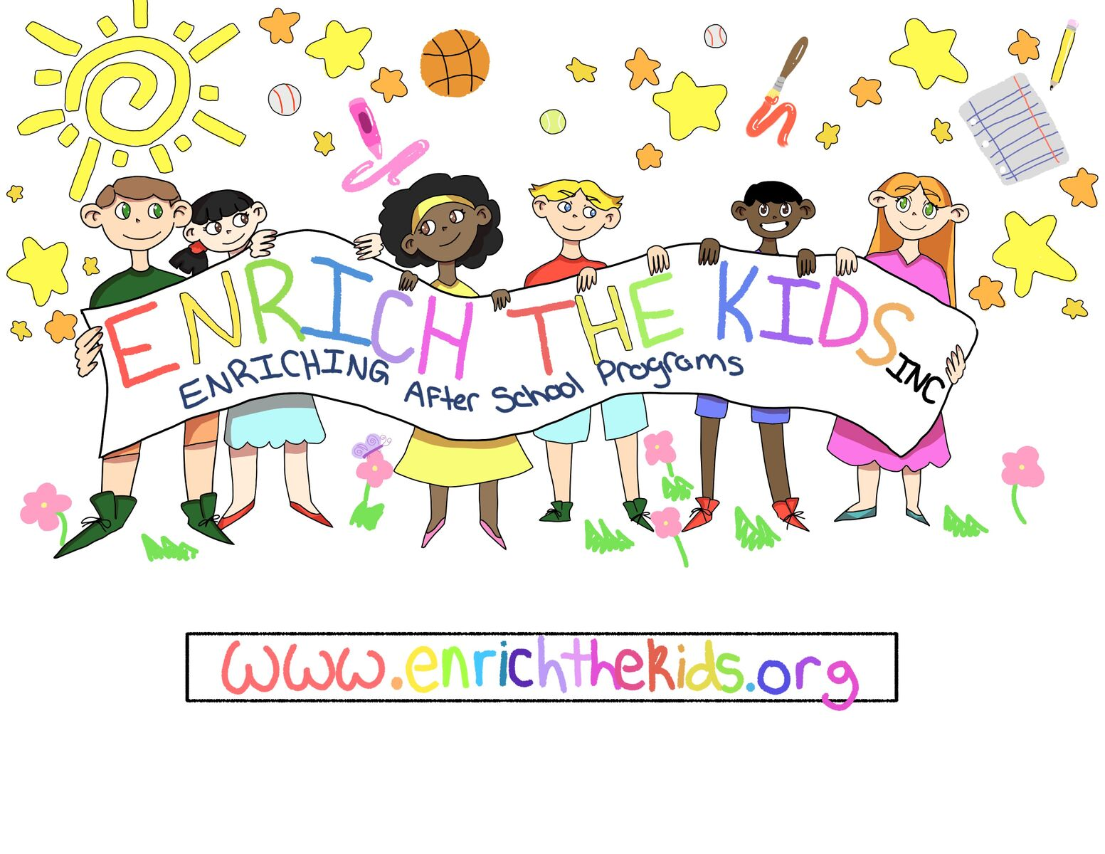

PARENT HANDBOOK

Lori Phelps – Hillrise Site Director;
575-650-6448

Angie Montes - Program Director;
575- 571-7734

Introduction

Welcome to Enrichthekids, Inc. Our program provides enrichment, child care and activities for the children that are enrolled in our program. The program is fee based and self-supporting. EnrichTheKids, Inc is a non-profit organization, which means that we can offer services at a lower rate because we are not subject to gross receipts tax and it allows us the privilege of operating in the schools. Please read and become familiar with the policies and procedures. Keep this handbook for your reference and call your site director if you have questions.

To enroll your child, we need the following: A filled out medical card, a signed parent consent form and to follow all Las Cruces Public Schools regulations regarding immunizations. We do not need copies of shot records unless your child is not enrolled in LCPS.

General Information

Philosophy
We understand that children have unique gifts and abilities and need positive guidance and support to learn and grow. With input from the students, parents, staff and stakeholders, we plan many activities to assist with the child’s over-all growth. As part of their community and support group it is our responsibility to create as many opportunities as possible to promote positive interactions and relationships with peers and adults. We embrace that all families are different and special and support everyone having the equal access to appropriate services that all families deserve to reach their full potential.
We are committed to building trust through developing inclusive practices and overcoming biases, so we may establish creative partnerships to help our families, children and employees grow. We are accountable to every child and family to uphold these ideals.

Mission
Helping school aged children grow in body, mind and spirit during their out of school time by providing enriching activities in a safe, familiar and non-evaluative environment.

Curriculum
Curriculum is made up by individuals who were hired to prepare and teach age/developmentally appropriate lessons within their field of expertise and are compensated commensurately. All lesson plans are prescreened by site directors. Teacher/caregivers must go through 12 hours of college, community and/or online training in early childhood development annually. Relationships and play are instrumental in the child’s learning, so our daily routines allot time for play and spending time on building relationships that develop and foster self-reflection. We provide a diverse variety of services and experiences to meet the needs of our students and are sensitive to their family experiences, culture, beliefs, abilities and circumstances based on information shared by the family. We provide flexibility and choice for the best outcomes for all. We continuously use dialogue, surveys and research to improve our methods to effectively meet the needs of the children and families in our programs.

Program Location
We are located at East Picacho and Hillrise Elementary Schools. The after-school program is based in the cafeteria but also uses the library, classrooms (for enrichment classes only), courtyard and playground.

License number:
Hillrise: 156049

Days and hours of operation: This program provides child-care during the school year from 2:30 PM until 6:00 PM. The after-school program may provide childcare on Parent-Teacher Conference Days depending on school availability. The program does not provide childcare on National holidays when the school is closed. We also offer a summer camp program, but it may not occur at the school your child attends during the school year. Enrichthekids, Inc. is open to school age children from Kindergarten through 6th grade. We will also accept home schooled students or students from other schools, but transportation will not be provided.

Services offered: We offer after school care, homework help, social skills development and enrichment classes.

Site Director: Lori Phelps: 575-650-6448

Program Director: Angie Montes: 575- 571-7734

Snacks and Meals
Healthy snacks will be provided for all sessions. During "no school" full days or the summer camp program, the children need to bring a sack lunch. Monthly menus will be posted so that you can see what your child will snack on each day. If your child has a food allergy, please let us know so that we can make appropriate substitutions.

Daily Schedule during non-enrichment times;
2:25-2:35 - Sign in & bathroom break/wash hands
2:35-2:50 - Have snack & wash hands
2:50-4:00 - Recess
4:00-4:30 - Homework & silent reading time
4:30-6:00 - Free time/organized craft or game time

Enrichment Time Schedule:
2:25-2:35 - Sign in & wash hands
2:35-2:50 - Have snack & wash hands
2:50-3:05 - Outside physical activity
3:05-4:00 - Enrichment time
4:00-4:30 - Homework or silent reading
4:30-5:15 - Recess
5:15-6:00 - Free Play

Open Door Policy: Custodial parents/guardians or grandparents are always welcome at the program! We are supportive of, and encourage, family involvement. Visitors must check in with the Program Director before visiting. The director reserves the right to deny a requested visit based on the circumstances surrounding the visit. We will not allow non-family members or non-custodial parents to observe the children or the program. We do have cooperative agreements with NMSU’s College of Education to allow students to do community service as part of their Multicultural Education Class and Service Learning. They are already cleared through the district to come into the schools to observe and volunteer.

Clothing and Personal Possessions
Students should always wear washable, practical clothing, including appropriate footwear and outerwear. We follow the school district’s policy for dress code. When it is cold please make sure children bring jackets, hats and gloves. All items must be clearly labeled with the child's name. Enrichthekids, Inc. is not responsible for lost or stolen property. Even though children are responsible for their own personal belongings, the staff will do everything possible to ensure that items will not be lost or stolen. Enrichthekids, Inc. highly suggests not sending cash with your children, as we are not responsible if it does get lost. Please send a change of clothes with your child (usually Kindergarten and 1st graders) who still has accidents occasionally. We will discreetly allow them to change and get on with their day.

Holidays:
We celebrate and learn about all holidays as part of our Enriching after school program. If you object to anything we have planned, please send an alternate activity for your child for that day. You may send in a healthy snack or an activity for your child’s birthday.

Liability Insurance: We do carry liability insurance that is independent of Las Cruces Public Schools. Please contact the director to see a copy of this policy.

Policies and Procedures

Enrollment /Disenrollment Procedures/Payment Procedures
Registration takes place in the cafeteria anytime from 2:30-6 PM daily. Full payment for the after-school program is expected the by 1st of the month. Please make checks payable to Enrichthekids, Inc. A registration fee of $50.00 is charged to each family annually. Parents paying for the full semester in one payment at the beginning of the semester will receive one week free.

Costs: The cost of the after-school program is $12.00/day from 2:30PM - 6:00PM or $8/day if attending from 2:30PM - 4:15PM. Drop in care is $18 a day and must be paid in advance along with the annual registration fee for unregistered students. If your child is registered with EnrichTheKids and he or she shows up without prier payment or notification, you will be charged $18. You must commit to the times and days your child will attend our program and pay at the beginning of each month. If payment is not received by the 3rd day of the month you will be charged a late fee of $5.00 a day. There are no credits or make up days.

There is no additional charge for enrichment classes for students enrolled in the afterschool program. Please come in to register your child for enrichment classes. They must be registered for a class for each day they are present. If you do not register your child for enrichment, we will help your child choose classes.

Payment must be made by check or money order or cash. No credits are given under any circumstances.

Unpaid fees will result in dismissal from the program after 1 week of nonpayment, with legal action taken after 30 days of non-payment. Court costs and legal expenses will be billed back to the overdue account.

All returned checks are subject to a $30 fee that is due with the payment as soon as we are aware of the problem.

To dis-enroll, please let the program director know at least a week before dis-enrolling your child. Written notice is preferred. If you stop coming to the program your spot will be given away to another child.

ENRICHTHEKIDS, Inc Expulsion Policy
Unfortunately, there are sometimes reasons we must expel a child from our program either on a short term or permanent basis. We want you to know we will do everything possible to work with the family of the child(ren) to prevent this policy from being enforced. The following are reasons we may have to expel or suspend a child from this center:
IMMEDIATE CAUSES FOR EXPULSION
- The child is at risk of causing serious injury to other children or himself/herself.
- Parent threatens physical or intimidating actions toward staff members.
- Parent exhibits verbal abuse to staff in front of enrolled children.
PARENTAL ACTIONS FOR CHILD’S EXPULSION
- Failure to pay/habitual lateness in payments.
- Failure to complete required forms including the child’s immunization records.
- Habitual tardiness when picking up your child.
- Verbal abuse to staff.
- Harassment or intimidation to staff, either on or off campus.
CHILD’S ACTIONS FOR EXPULSION
- Bullying other children.
- Uncontrollable tantrums/angry outbursts.
- Ongoing physical or verbal abuse to staff or other children.
- Bringing a gun or weapon on campus.
- Continually intentionally damaging property
SCHEDULE OF EXPULSION
If after the remedial actions above have not worked, the child’s parent/guardian will be advised verbally and in writing about the child’s or parent’s behavior warranting an expulsion. An expulsion action is meant to be a period so that the parent/ guardian may work on the child’s behavior or to come to an agreement with the center. The parent/guardian will be informed regarding the length of the expulsion period. The parent/guardian will be informed about the expected behavioral changes required for the child or parent to return to the center. The parent/guardian will be given a specific expulsion date that allows the parent sufficient time to seek alternate child care (approximately one to two weeks' notice depending on risk to other children’s welfare or safety). Failure of the child/parent to satisfy the terms of the plan may result in permanent expulsion from the center.
A CHILD WILL NOT BE EXPELLED If a child’s parent(s):
- Made a complaint to the Office of Licensing regarding a center’s alleged violations of the licensing requirements.
- Reported abuse or neglect occurring at the center.
- Questioned the center regarding policies and procedures.
PROACTIVE ACTIONS THAT CAN BE TAKEN IN ORDER TO PREVENT EXPULSION
- Staff will try to redirect child from negative behavior.
- Staff will reassess classroom environment, appropriate of activities, supervision.
- Staff will always use positive methods and language while disciplining children.
- Staff will praise appropriate behaviors.
- Staff will consistently apply consequences for rules.
- Child will be given verbal warnings.
- Child will be given time to regain control.
- Child’s disruptive behavior will be documented and maintained in confidentiality.
- Parent/guardian will be notified verbally.
- Parent/guardian will be given written copies of the disruptive behaviors that might lead to expulsion.
- The director, staff, and parent/guardian will have a conference(s) to discuss how to promote positive behaviors.
- The parent will be given literature or other resources regarding methods of improving behavior.

Late Arrivals
The afterschool program begins when the child arrives. We appreciate prompt arrival. If parents know in advance that a child will arrive late, please call and let us know. There is no discount/refund for late arrival.

Late Pick Up Fees
We strongly recommend that parents have a backup plan in case they are unable to pick up their child on time. Consideration will be made for bad weather and accidents. Please be sure to have the site directors’ phone number to inform us of your situation. If you child is a 4:15 pick up, you will have until 4:20 after that you will be charged the full day rate. We will begin to assess late pick up fees at five minutes after the end of the program or session. The fee is $5.00 per minute. Late pick up fees in the form of a check or money order are due and will be collected at the time the child is picked up.

If a parent or an authorized person does not arrive to pick up a child within five minutes after the program closing time, the staff will attempt to contact the parent at home, or at work. If the staff is unable to speak with the parent by phone, they will contact the authorized person listed on the enrollment form. If the authorized person cannot be contacted by phone, the police will be notified. CYFD will also be notified at that time. Children will never be left unattended at the program or taken home with a staff member.

Absences
If you know your child will not be attending the after-school program session, please call the after-school program site director to inform the program of your child's absence. We will call to verify that your child is with you if we don’t find out from the school office that your child was absent from school.

Field Trip Policy: If a field trip is planned, parents will be given permission slips at least 7 days in advance. We are not liable or responsible for any accidents or injuries that may occur during “family field trips”, where we meet as a group and parents are providing supervision and transportation of their own children.

Health Policy
All Enrichthekids, Inc. staff are certified in CPR and first aid. If a child experiences a minor or non-emergency injury, a staff member will tend to the injury, fill out an incident report and inform parents at pick up time. In case of serious injury or illness, a parent or an authorized person will be contacted immediately. If the staff determines that a child is contagious, feverish, or seriously incapacitated, the child will be isolated, and a parent will be called to pick up the child as soon as possible. If a parent is unavailable, the designated emergency person will be notified. If all designated emergency persons on the emergency form are unavailable, the child's physician will be consulted. These procedures will also be followed on field trips. If your child is ill with any of the infectious diseases listed by the NM Dept of Epidemiology, they must be cleared by a doctor before returning to the program. Please do not send a child to the program who has had fever or diarrhea within 24 hours of the incident to keep from infecting other children and staff members.

Emergency Procedures/Safety Policy
In case of emergency, school procedures will be followed. Students will never be automatically dismissed during emergency conditions but will remain in the building. In an extreme situation where the building is determined unsafe, staff will remove children to safety and immediately contact parents or emergency contact people. In case of fire, students will evacuate the building through designated doors to assigned holding areas until the signal is given that the practice drill or emergency is over. In case of a tornado, students will move to a designated safe area inside the school building and wait with the staff until the danger has passed. Practice drills are held and recorded on a regular basis. If your child has an accident resulting in loss of consciousness or excessive blood loss, our procedure is to call 911 and then call the parents. We follow all safety rules and regulations that the school has in place for playground use.

Snow/School Closure

On days that the school is closed or ends up closing due to weather, we will also be closed. Please use this website www.lcps.k12.nm.us as a valuable resource on most things that pertain to the Las Cruces Public School District, including school closures. We will still play outside on cold weather days so be sure to send a jacket when the temperature starts to drop.

Hot Weather
In extremely hot or windy weather we will conduct all activities in the building where air conditioning and shelter is provided; otherwise, we will use the playground to enjoy outdoor activities. We will go inside every 15 minutes for water and offer the children who would rather play inside the option to do so after a 30-minute recess. Please provide sunscreen for your child.

Confidentiality Policy
We do not share information with people outside the program regarding your child or family unless it is solicited by Children, Youth and Families Department, or other State entity that requires it. We may request information regarding your child’s schoolwork or performance to better serve your child.

Reporting Child Abuse
Staff members are required by law to report any form of child abuse, obvious or suspected. The Enrichthekids, Inc. staff handbook outlines the specific procedure that is to be followed and may be reviewed by parents upon request. If a parent suspects child abuse, you need to contact the Child Care Services Bureau at 575-524-6044 or to report neglect, 1-800-832-1321.

Guidance Policy
The goal of the Enrichthekids, Inc. after school staff is to provide a safe, fun, and educational environment for all participants. We expect all children to show respect for one another, and the adults. Students are expected to use appropriate language always. School and district policies regarding alcohol, tobacco and any form of weapons or drugs will be adhered to completely. Conduct which disrupts the operation of our programs, interferes with the rights of others, endangers the safety of any person or damages property will not be tolerated.

When unacceptable behavior is observed, a staff member will give the student a verbal warning, followed by a time-out if necessary. Staff members will not engage in any form of physical or humiliating punishment. Following these initial steps, a conduct report and/or a phone call to the parent may be made. We reserve the right to suspend or dismiss any child immediately who a threat to him or herself is, or others in the program. The parent or guardian will be given one week to find alternative care. Leaving school property without permission and hurting others is grounds for automatic dismissal. These disciplinary measures have been established to ensure each child's right to a safe, fun and educational environment.

Emergency Evacuation Plan:
In the event of an emergency that requires evacuation, Hillrise students will seek shelter at Good Samaritan, 3025 Terrace Dr. Parents will find their children and staff there. (Please be sure to sign up for emergency text messaging with the site director, to help keep you informed)

In the event of an emergency that requires evacuation, Hillrise will relocate to the Meca Therapies Center at 1350 Hillrise Circle. We will make every effort to contact all parents and the director will remain with the students until they are all picked up.

Sign Out
Parents must sign children out of each session with the time picked up and their initials. Children will not sign themselves out unless requested by the parent/guardian.
This program is not responsible for the children before they are signed in, or after they are signed out of the program. Children are responsible for reporting directly to the program, located in the school cafeteria, right after school. Attendance for the after-school program will be taken within five minutes after the school dismissal bell rings.

Children may leave the program only with the persons specified on the enrollment form. If a parent desires the child to leave with someone who is not specified on the enrollment form, the parent must supply written permission, with signature, in advance. If an unknown person arrives to pick up a child, the staff will contact the parent and receive verbal permission to authorize the child's departure. The unknown person will then be asked for a form of identification to assure his/her identity. Please update emergency information regularly so that the program staff can always contact the appropriate persons immediately in case of an emergency.

If you come to pick up your child during enrichment classes or scheduled activities, please be prepared to wait a few minutes for us to retrieve your child from his or her class. Please turn off or silence cell phones during after school pick up, as it interferes with reuniting with your child and any messages or information that our staff may have for you to hear.

Medications
Medication should be given to children at home whenever possible. We will work with the school nurse to have emergency/rescue medications available if circumstances demand it. Such medication will only be administered by the Program Director or Site Director. If your child has asthma or extreme food allergies you must cite it on your child’s registration form, so we are able to properly care for your child.

Closing Procedures
When the last child is picked up, the Enrichthekids, Inc. staff will check the sign out sheet to be sure that all children were picked up and signed out. We will also check the building to make sure that all children are gone.

Location of Children
To locate a child in the after-school program between the hours of 2:30PM to 6:00PM, please go to the school cafeteria and consult a staff member. Enrichthekids, Inc will take periodic roll calls during the day to ensure the whereabouts of all children. Please call site director, phone number listed on front page of parent handbook, if no staff are in cafeteria at that time.

Lost Children
A child is lost when staff is not able to determine his/her whereabouts and cannot guarantee the child's safety. Every reasonable effort will be made by staff members to search the immediate building and grounds. If, after a search, the child's whereabouts are still undetermined, a staff member will call the child's home, the parent's place of work, and the emergency contact person. If the child is still not located, the police will be contacted. This procedure will be followed in as brief a time as possible. This procedure will also be followed on all field-trips.

Cell Phone/Toys/Video Games Policy
We strive to keep the children positively engaged in activities always. The children will have no need for toys or video games, and we will confiscate them if we see them. We request that if your child has a cell phone and brings it to school, they keep it off and stored in their backpack. We will confiscate any cell phones that are used without permission during after school hours. Confiscated items will be returned to the parents at the end of the day

Television and Video Policy
On occasion, the Enrichthekids programs will show videos. These videos will have been previewed by the site director and be completely age appropriate. The program will only show G and PG movies to the children whose parents have signed the movie release on the application.

Release of Children
Children will only be released to a parent or an authorized pick-up person. For safety, children must be signed out according to the procedure described above in section titled, "Sign Out". Failure to follow this procedure will result in dismissal from the program. There is no discount for early pick-ups.

Special Needs Children
Enrichthekids, Inc.'s programs provide care for children with special needs as long as their needs can be reasonably accommodated. Parents of special needs children must meet and teach us the best ways to interact with their child/children. Discussion at this meeting will center on specifics about the child's needs, and any additional information that parents consider important. Failure to fully disclose information that can help us work with your child will result in dismissal from the program.

After the child attends the program, if staff have difficulty meeting the needs of the child due to behavioral or physical limitations, a second meeting may occur. Staff will then use agreed upon alternative strategies for a specified trial period. If problems persist throughout the trial period, in all but the most extreme cases, parents will be given two weeks to make other arrangements.

Due to laws pertaining to day care and facilities and for your child’s protection, we are unable to assist a child with more than offering a change of clothing if there is a toilet accident. If a child needs more assistance, we will call the parents to come take care of the situation.

Complaints
If you have a complaint regarding the program or services, your child is receiving please talk to your Site Director. If the Site Director is unable to resolve the issue to your satisfaction, please contact Angie Montes, Program Director at 571-7734

Revised May 15, 2018- EnrichTheKids, Inc.

