LOUISIANA SOUTHERN BALL & HAYRIDE COMPETITION 2026--MASTER COUNTRY FORM
APRIL 30 – May 3 (Final Registration Date MONDAY, April 20th, 2026)
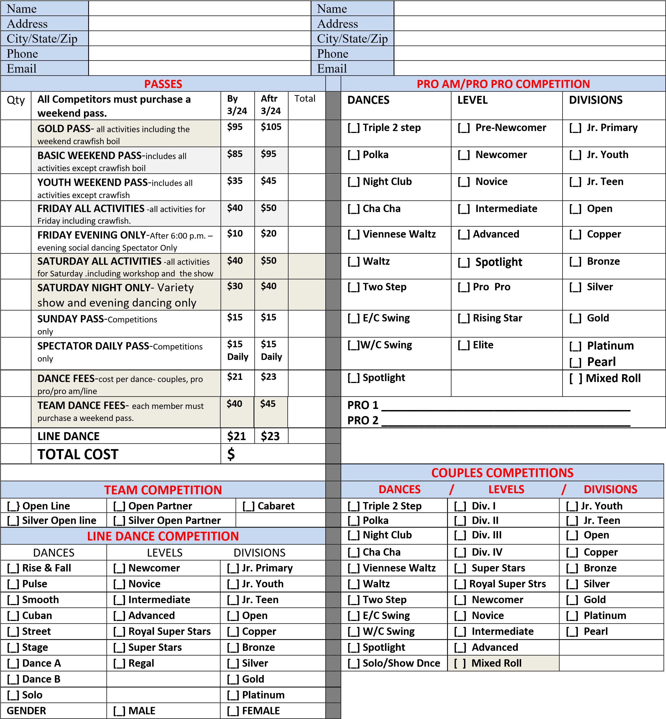
We agree to hold the organizers of this event and their agents harmless from all suits, claims, or demands of every kind and character arising out of and in conjunction with this event. We, hereby, authorize the reproduction, sale, copyright, exhibition, broadcast, and/or distribution of any event videotape without limitations. We understand the physical risks of entering dance competitions and social dancing and assume full responsibility for any injury of person or of personal damages resulting from the event named above. We certify that we are 18 years of age or older (applicable to legal guardian if under 18 years of age. The decision of the judges is final and binding.
Male Signature  (or parental guardian if under 18 yrs. of age) | Date | Female Signature  (or parental guardian if under 18 yrs. of age) | Date

