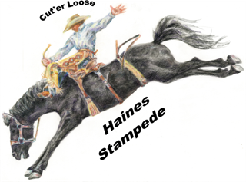 Haines Stampede Demolition Derby Advertising Packages

$1000 Includes-10 Covered Seats/10 drink tokens/Arena banner
5 VIP parking passes

$750 Includes – 8 covered Seats/8 drink tokens/Fence Sign
4 VIP parking passes

$550 Includes 6 covered Seats/6 drink Tokens/ Fence Sign
3 VIP parking passes

$350 Includes – 4 covered Seats/4 drink Tokens/ Fence Sign
2 VIP parking passes

$200 Includes – 2 covered Seats/2 drink Tokens
I VIP parking pass

All sponsors will be announced the entire evening of the derby, put on our Facebook page, Flyers as well as the local newspaper!

All sponsors are responsible for their banner being made if you want one displayed. We will collect the banners the week prior to the derby and return them the week after the derby. This is to insure your banner is takin care of and not damaged or lost in our hands. Recommended banner size is 3’ by 5’. If you already have a banner, please let us know! We greatly appreciate your support f the Haines Stampede Demolition Derby!!

Questions-Please call Aimee McKibbin at 1-541-239-5474
To mail your payment please send to:

Haines Stampede P O Box 202 Haines, OR 97833

