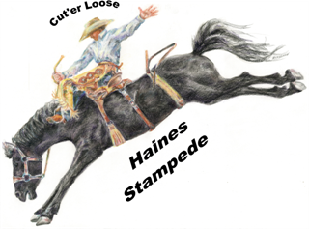HAINES STAMPEDE RODEO ADVERTISING PACKAGES

Arena Gate Sponsors- $500, plus 4 tickets to rodeo (tickets can be used on Third or Fourth of July) banner on gates in area during the Haines Stampede, in program, and webpage. Also Appears on the Court horse trailer under Arena/Tower Sponsors. Court horse trailer travels to Eastern Oregon
Rodeos. Sponsor to provide banner.

Rodeo Bucking Chute Gates - $500, with three year commitment. receive 4
tickets to use on the third or Fourth of July. Wooden signage on gate remains up during all Events at the Haines Stampede arena, in program, and webpage . Also appears on the Court horse Trailer when renewed. Court horse Trailer travels to Eastern Oregon Rodeos And parades.

Bleacher signs facing Hwy 30 - $100.00 annually. Displayed year round Advertiser Responsible
for cost of building the sign and replacing do to wear or logo change.

Award Rodeo Buckles - $175 annually, name in program & announced during Buckle event. Webpage as a buckle sponsor and on winners page of webpage. 2 tickets to rodeo

Horse Trailer Advertisement – This depends on the placement and size of name/advertisement. -name also appears in Program and on webpage as court trailer sponsor. Horse Trailer travels to all the rodeos/ parades in Eastern Oregon. Prices range from $100 to $350 annually.

Court Crown or Buckle Sponsor - $175 – listed as court sponsor in program and on court
Webpage

The Haines Stampede is a two day rodeo event, July 3rd and 4th in the City of Haines. The attendance for the two days averages 6000. We also have a Big Loop roping on July 2nd that Has an attendance of an additional 1000.

Contact information: Colleen Taylor
Rodeo@hainesstampede.com or
Bctaylor01@msn.com
541-403-0800

