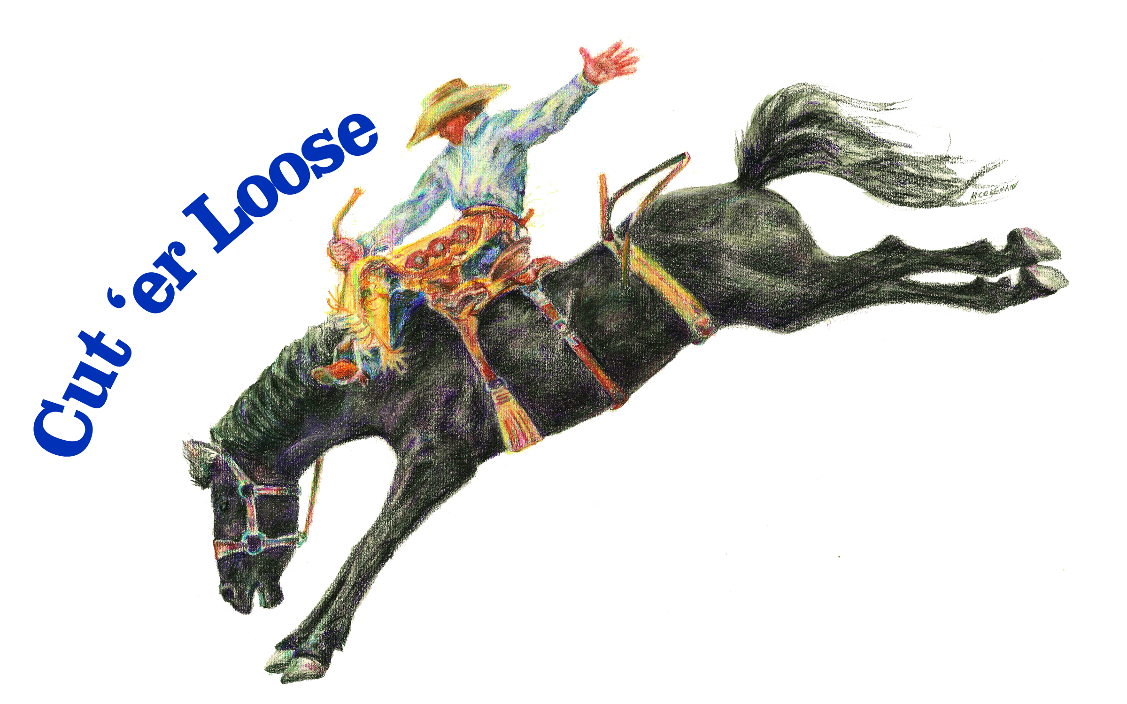**Haines Jr Stampede**

Haines, OR

July 9th & 10th, 2022

Saturday Rodeo at 1pm, Sunday Rodeo at 10am.

**Entries must be post marked by July 1st, 2022 or handed in at Haines Rodeo by July 4th.**

**NO LATE ENTRIES ACCEPTED!**

Contestant Name:____________________________________________________DOB:_________________________

Address:____________________________________________________________Age as of Jan 1, 2022:_________

City:_______________________________________State:_____________________ Zip:___________________________

Phone #:__________________________________Parent/Guardian Name:________________________________

PLEASE CHECK EVENTS YOU WISH TO ENTER BELOW **Contestants can enter up an age group, but points only count towards current age group.**

**SENIORS…Ages 14-18**

**GIRLS EVENTS** **BOYS EVENTS**

Breakaway ($25)__________ Calf Roping ($25)_________

Goat Tying ($25)__________ Chute Dogging ($25)__________

Barrel Racing ($25)__________ Bareback, Saddle Bronc, Stock Saddle($50)(Circle One)

Pole Bending ($25)__________ Bull Riding ($50)__________

(GIRLS & BOYS) Team Roping($25) I am a Header or Heeler (circle one) & my Partner is__________________________________________________.

_______Check if you would like to draw a partner. ______Check if you would like to be a partner for the draw.

*JR & SR’s can rope together, but points only count for their current age division.

(JR & SR GIRLS & JR & SR BOYS)Wild Pony Race($20/contestant) 3 kid team. Contestant Weight:____________________________

Team Members: _____________________________________________________________________________________________________________________

**JUNIORS…Ages 10-13**

**GIRLS EVENTS** **BOYS EVENTS**

Breakaway ($25)_________ Breakaway ($25)__________

Goat Tying ($25)_________ Calf Tying ($25)__________

Barrel Racing ($25)__________ Pony Broncs ($40)__________Weight:________

Pole Bending ($25)__________ Steer Riding ($40)__________

(GIRLS & BOYS) Team Roping($25) I am a Header or Heeler (circle one) & my Partner is___________________________________________________.

_______Check if you would like to draw a partner. ______Check if you would like to be a partner for the draw.

*JR & SR’s can rope together, but points only count for their current age division.

**PEEWEE…Ages 6-9**

**GIRLS EVENTS** **BOYS EVENTS**

Breakaway ($15)________ Breakaway ($15)_________

Barrel Racing ($15)__________ Barrel Racing ($15)__________

Goat Tail Tying* ($15)__________ Goat Tail Tying*($15)__________

Figure 8 Race ($15)__________ Figure 8 Race ($15)__________

Steer Riding ($15)__________ Steer Riding ($15)__________

Dummy Roping ($15)__________ Dummy Roping ($15)__________

Make checks payable to:

**Haines Stampede**

C/O Haines Jr Stampede

PO Box 202

Haines, OR 97833

Office Fee (per child) $5.00

Saturday Entry Fees $____________

Sunday Entry Fees $____________

-------------------------------------------

Total $_____________________________

Paid: Cash Check#___________

**MINI-MITES…Ages 5 & under NO LEAD LINE!**

**BOYS & GIRLS EVENTS**

Barrel Racing ($10)__________

Stake Race ($10)__________

Goat Tail Untying* ($10)_________

Wooly Bucker ($10)__________

Dummy Roping* ($10)__________

*Events will be without a horse near the rodeo office.

**We are doing our best in these odd times to get as many prizes and sponsors that we can. Lineup of prizes may vary.

**Must compete both days to be eligible for prizes. Day money will be paid each day.

**Questions? Please call Lexi Shaw (541)571-7653.