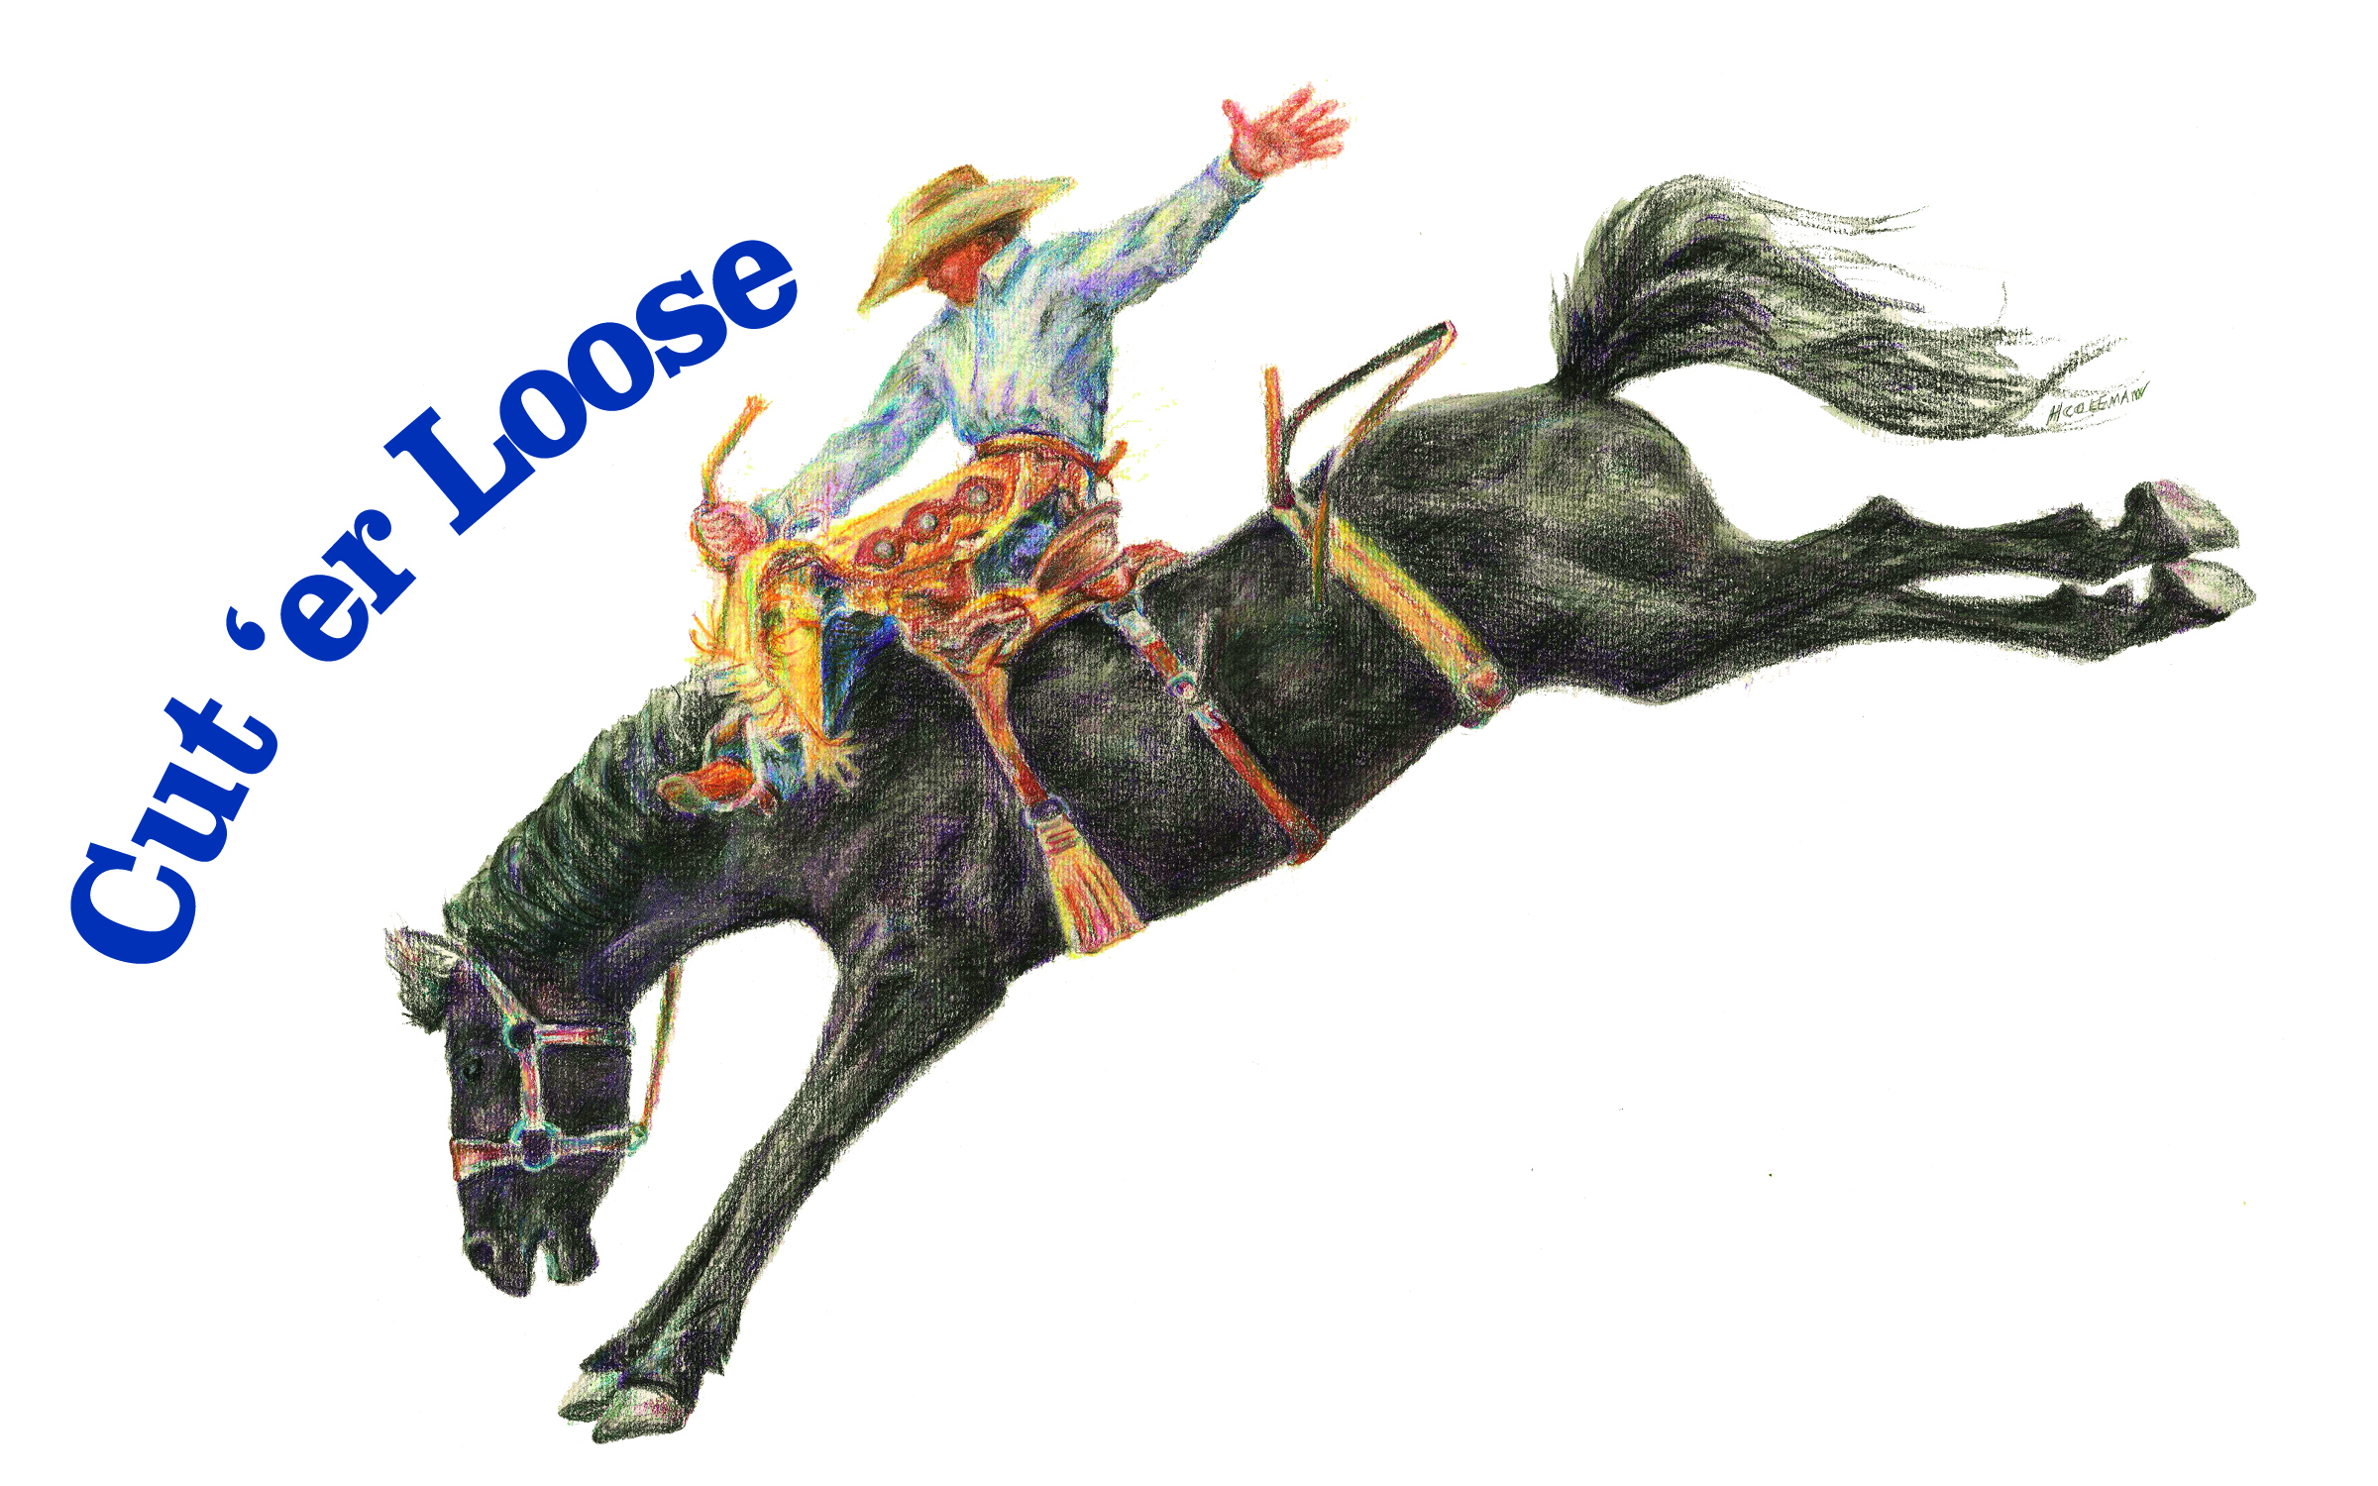
Haines Jr Stampede
Haines, OR
July 9th & 10th, 2022
Saturday Rodeo at 1pm, Sunday Rodeo at 10am.
Entries must be post marked by July 1st, 2022 or handed in at Haines Rodeo by July 4th.
NO LATE ENTRIES ACCEPTED!

We, the undersigned parents/guardians of _________________________________, a minor, give the ambulance, hospital, and the physicians or medical staff permission to administer necessary treatment of injuries incurred while participating in the Haines Jr Stampede. We do hereby release and discharge the stock contractor, Haines Stampede, Haines Jr Stampede, and its officers or representatives from any and all claims, demands, damages, suits, actions, or cause which may, can and shall have by reason of illness, injury or accident incurred or suffered by said son or daughter while participating in the Haines Jr Stampede being held at the Haines Stampede Rodeo Grounds on July 9th^{th} & 10th, 2022. I also assume and accept full responsibility for any damages done by my child, myself, or their horse at this rodeo. The Contestant and or parent/guardian agree to this waiver clause.
Printed name of Parent/Guardian_____________________________________________
Signature of Parent/Guardian________________________________________________

State of _____________________ County of ______________________
Personally appeared the above-named__________________________________ acknowledged the foregoing instrument to be ______ voluntary act and deed.
BEFORE ME this _____________ day of __________________, 2022.
Notary Public for_________________________________________
My commission expires____________________________________
Notary Signature__________________________________________

