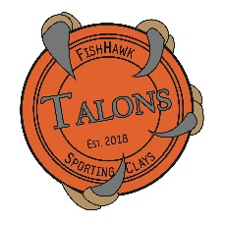

2024-2025 Photo Consent to Release Form

I hereby grant permission to The Fishhawk Talons, FishHawk Youth Actions Sports, and Fishhawk Sporting Clays, to take and use photographs, video, and/or digital images of my child for the purposes of publicity and promotion and may be used in print publications, online publications, presentations, news media, websites, and social media.

I agree that my child’s name and identity may be revealed in descriptive text, and/or commentary in connection with the image(s). I authorize the use of these images without compensation to me or my child.

Parent Printed Name________________________________________

Parent Signature ______________________________Date:________

