Butte County Search and Rescue Building

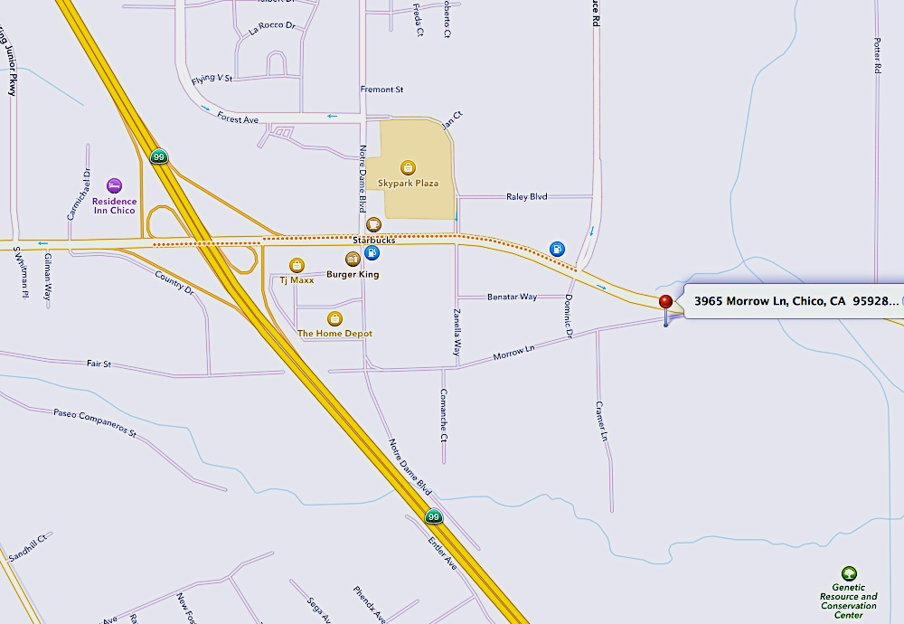

Classroom Location: 3965 Morrow Lane, Chico CA
From Highway 99 take the Skyway exit, Head east on Skyway, Right turn onto Dominic Dr, Left onto Morrow Lane. The building is at the end of morrow lane on the right. If you need further assistance please call Jason at 530-520-6813.

