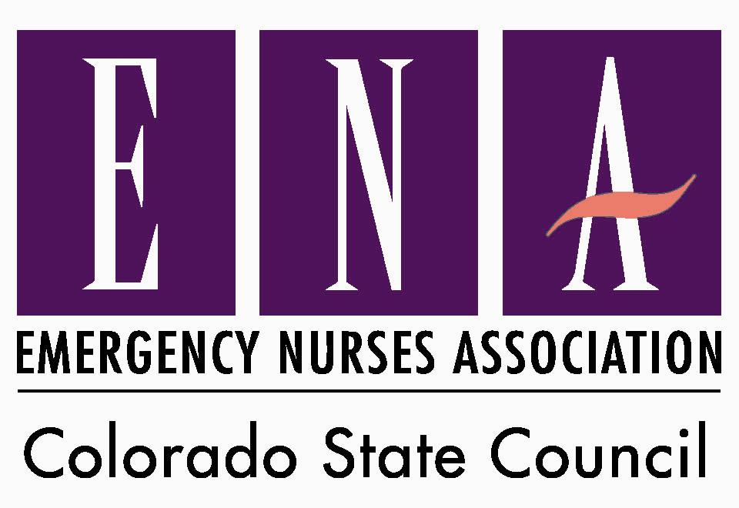
Conflict of Interest
All policies and procedures of Colorado ENA will be reviewed, updated, and ratified annually by the
Colorado ENA Board of Directors. This Policy may be amended or any exceptions to it may be authorized by resolution of the Board of Directors at any time.

THIS POLICY HAS BEEN REVIEWED AND RATIFIED FOR YEAR 2016 2/1/2016

CONFLICT OF INTEREST POLICY STATEMENT

1. The Colorado Emergency Nurses Association ("Association") will not permit and has never permitted conflicts of interest on the part of its directors. Accordingly, no individual holding any of the above-mentioned positions shall knowingly allow himself/herself to become involved in a conflict of interest, either directly or through a member of his/her immediate family, or upon the discover thereof, allow such a conflict to continue.
2. In general, any outside activity or direct or indirect financial interest which might, in any way, adversely influence or appear to influence an individual's judgment in the performance of his/her duties to the Association, involves a possible conflict of interest.
3. The Association recognizes that there are many situations which give rise to a conflict of interest. It intends to approach each case objectively, giving full recognition to all attendant circumstances.
4. Situations in which a conflict of interest would or might arise (and should be reported immediately to the Association) include, but are not limited to, the following:

A. Involvement with the Association's clients, providers, vendors or insurers.
1) Ownership of a material interest in any client, provider, vendor, insurer or other entity with which the Association, or one of its affiliates or subsidiaries, does business.
2) Acting in any capacity, including as a director, officer, partner, consultant, employee, distributor, agent or the like, for any entity which does business with the Association, its affiliates or subsidiaries.
3) The acceptance, directly or indirectly, of payments, services or loans from an entity with which the Association or one of its affiliates or subsidiaries does business. This includes gifts, trips, entertainment or other favors, of more than nominal value.

B. Misuse of information to which an officer or director has access by reason of his position.
1) Use of such information in a manner, which is or can be detrimental to the Association's interest.
2) The disclosure of or other misuse of confidential information of any kind obtained through the individual's connection with the Association.

C. Interest in or position with a competitor or potential competitor.
1) The ownership, directly or indirectly, by an officer or director of a material interest in any entity which competes or might compete with the Association.
2) Acting as a director, officer, partner, consultant, employee or agent of any enterprise which is actual or potential competition with the Association.

5. After reading this Policy Statement, a Conflict of Interest Disclosure Statement will be completed by the above-mentioned on an annual basis prior to his/her name being entered onto the ballot for election.

6. The Immediate Past President will review each completed Conflict of Interest Disclosure Statement. If a clear, potential or questionable conflict of interest involving a director is identified, this issue will become a matter for board consideration. In the event that the Colorado ENA Board of Directors cannot resolve the issue, the national ENA board of directors liaison will be contacted for further direction.

7. The Board of Directors, exclusive of interested members, shall review and resolve each issue in order to prevent conflict(s) that might be to the detriment of the Association. The discussion and resolution of each actual or potential conflict will be recorded in accord with standard procedures for board meeting minutes.

8. In some circumstances, full disclosure of the facts by the board member, is all that is necessary to enable the Association to protect its interests, and those of its members. If no improper motivation appears to exist and the Association's interests have not suffered, prompt elimination of the outside interest may be necessary. Should the board find, however, that an inexcusable violation of Association's policy is involved, more drastic action will be taken, including, when appropriate, the termination of board membership and reimbursement to the Association for any financial detriment it may have suffered as a result of the conflict.

9. In all instances in which a director has reported that a potential conflict of interest exists with respect to a proposed transaction under board consideration, that director will not be entitled to participate in discussions regarding the transaction or to vote. Furthermore, such transaction shall not be approved unless and until (1) the material facts of the transaction and director’s interest or relationship are disclosed or known to the Board of Directors (2) the board approves or ratifies the transaction by the affirmative vote of a majority of disinterested directors, even though the disinterested directors be less than a quorum.

10. The presence of the director, who is directly or indirectly a party to the transaction being considered by the board, or a director who is otherwise not disinterested, may be counted in determining whether a quorum is present but may not be counted when the Board of Directors takes actions on the transaction.

11. Use of Organizational Titles. In 1999, the National ENA Board of Directors adopted the philosophy that ENA, as an organization, will not endorse, sponsor, or support any for-profit venture, program, or function, unless specifically authorized by the Board of Directors.

On occasion, members of the Colorado Emergency Nurses Association (CENA) Board of Directors, are asked to represent CENA or attend certain non-profit types of ventures or functions. These events will often publicize the member’s CENA title to promote the event. In such cases, where an individual has been asked to represent CENA or attend an event which produces no conflict with CENA’s philosophy on endorsement and sponsorship, the CENA Board of Directors approves individuals to have their organizational title used in publicizing the event. The Board strongly suggests that any member who has been approached to participate in a media event, venture, program, or function as a CENA representative, contact the CENA President to determine if any conflicts are imminent and seek advisement for participation.

CENA does not support or condone individuals knowingly associating their CENA title to a for-profit venture or function. CENA’s Board of Directors discourages any individual knowingly utilizing their association title in a for-profit venture or solicitation unless prior approval is received from the CENA Board of Directors. This policy recognizes that a member may not have prior knowledge of their name and title being utilized. However, it is the responsibility of the member to take all reasonable efforts to ensure they are not being misrepresented.

12. Conflict of Interest Disclosure Statements are confidential and will not be used by the Association for its benefit, nor any reviewing Association member for his benefit.

CONFLICT OF INTEREST DISCLOSURE STATEMENT

Instructions for completing questionnaire:

1. Please read the Colorado Emergency Nurses Association Conflict of Interest Policy Statement before completing this questionnaire.

2. If additional space is needed for answering a question, please attach an additional sheet and indicate the number of the question which is being answered.

3. The terms "family relationship" and "immediate family" as used herein, refer to any relationship by blood, marriage or adoption not more remote than first cousin.

4. The term "affiliate" means any organization that directly or indirectly through one or more intermediaries, controls or is controlled by, or is under common control with the Association.

5. If any item is inapplicable, answer "none" or "n/a" as appropriate.

6. After completing the questionnaire, please sign and date it and return it to the Association.

CONFLICT OF INTEREST DISCLOSURE STATEMENT

I. NAME AND BACKGROUND INFORMATION

A. Name:

Address:

Position / nomination with Association:

B. I hereby state that I or members of my immediate family have the following affiliations or interests and have taken part in the following transactions that, when considered in conjunction with my position with or relation to the Colorado Emergency Nurses Association ("Association") or any of its affiliates or subsidiaries, might possibly constitute a conflict of interest. (Check "none" where applicable.)

II. OUTSIDE INTERESTS ( ______ ) None

Identify any position held by yourself or a member of your immediate family in any outside concern from which the Association or any of its subsidiaries or affiliates secures goods or services or that provides services competitive with the Association or any of its subsidiaries or affiliates.

III. OUTSIDE ACTIVITIES ( ______ ) None

List any other activities in which you or your immediate family are engaged that might be regarded as constituting a conflict of interest, giving particular attention to activities rendered as a director, manager, consultant or employee of any outside concern that does business with or competes with the Association or any of its subsidiaries or affiliates, and to activities in which it would be possible to disclose or use information relating to the Association or any of its subsidiaries or affiliates for your advantage or of that of a member of your immediate family.

IV. GIFTS, GRATUITIES AND ENTERTAINMENT ( ______ ) None

List and describe any gifts, gratuities or entertainment that you or members of your immediate family have received from any person or outside concern that does business, hopes to do business, or competes with the Association or any of its subsidiaries or affiliates. (If you have received such benefits, please approximate their value. Do not list gifts or entertainment of nominal value.)

ACKNOWLEDGEMENT AND SIGNATURE

I hereby agree to report to the President any changes in the response to each of the foregoing questions which may result from changes in circumstances before completion of my next Conflict of Interest Disclosure Statement.

The information I have given in this Statement is complete and accurate to the best of my knowledge.

I have read and understand the CENA Board of Directors Belief Statement regarding the Use of Organizational Titles ( #11) and I will abide to the sentiment expressed in the statement.

Signature

Position / Nomination

Date

