Slide 1 | 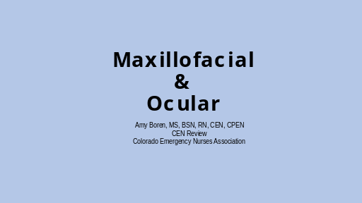
Slide 2 | 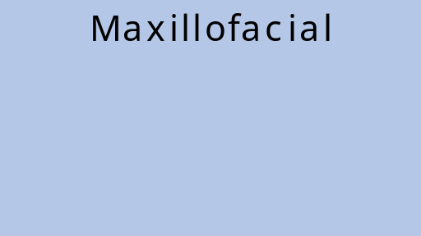
Slide 3 | 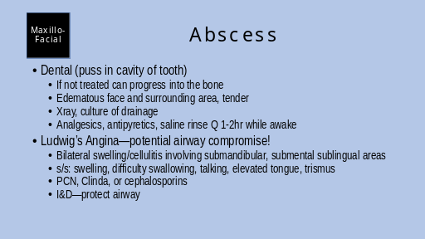 | Ludwig’s: secondary infection involving 2nd and 3rd molars  s/s severe pain, swelling, fever, malaise, dysphagia, dysphasia
Slide 4 | 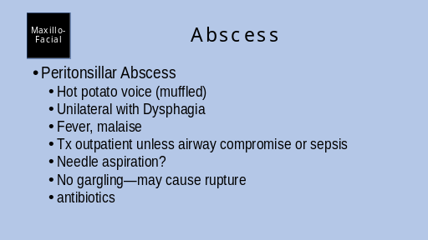 | Common organisms: streptococcus (aerobic), prevotella, Peptostreptococcus (anaerobic)
Slide 5 | 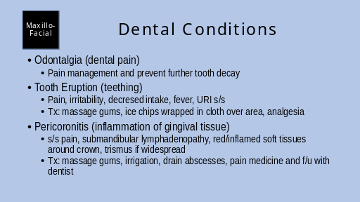 | Odontalgia: pain medicine, dental nerve block, abx, stress f/u care
Slide 6 | 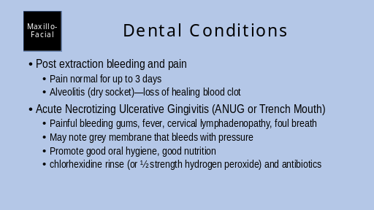 | Alveolitis: irrigate socket, topical analgesia (gauze moistened with clove oil), change daily  Post extraction bleeding: small vessels continue to bleed. Apply pressure—bite gauze roll, may need lidocaine with epi or suture. Avoid hot or hard foods  ANUG—non-contagious infection  Risk factors: immunosuppressed, nutritional deficit, smoking. Common after URI. Most often adolescents and young adults
Slide 7 | 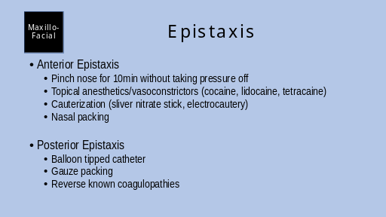
Slide 8 | 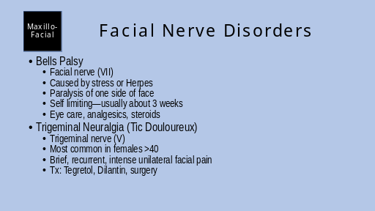 | Bells palsy—no CT needed, differentiate from stroke because BP can’t raise eyebrows/wrinkle forehead (stroke can). Because facial never affected expect incomplete eye closure—tape eye shut, eye drops. Moist heat and facial massage  May r/u Lyme disease, but Lyme disease usually has bilateral facial paralysis  Trigeminal Neuralgia  Might be caused by structural lesion on nerve causing rapid refiring in nerve  Precipitated by exposure to cold, facial stimulation (washing, make up application, eating)  Occurs more on R side than L  Narcotics, minimally helpful  Regional nerve block
Slide 9 | 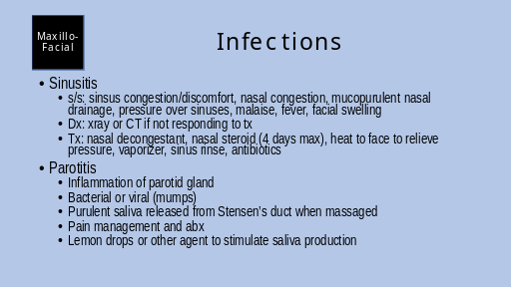 | Sinusitis  Inflammation of mucous membranes that line paranasal sinuses  Maxillary sinus most affected  Progresses over 5-7 days  Most common cause: haemaophilis influenzae, Streptococcus pneumoniae  Suspect bacterial if worsening after 5 days
Slide 10 | 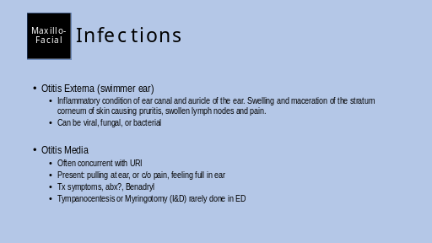 | Otitis externa  Green exudate: gram-neg bacteria (pseudomonas)  Yellow exudate or crusting: staphylococcus aureus  Fluffy white to black materal: Aspirgillus or candida  Clean ear, ear drops for 1 week (fungal or abx)  Ear wick (otowick) saturated with abx may be placed if swelling to great for drops (falls out 2-3 days)  If no improvement in 7 days, get cultures and follow up with ENT  Otitis media  s/s: decreased hearing, irritability, fever, N/V/D, vertigo  Assessment: nasal drainage, erythema of pharynx, erythema of TM, retracted or bulging of TM, yellow/white discoloration of TM, drainage  Tx: pain, abx?, bendadryl
Slide 11 | 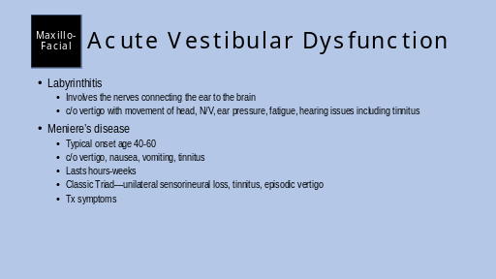 | Meniere’s disease: Etiology unknown, theory destruction of vestibular and cochlear apparatus from increased fluid/pressure in endolymphatic system. maybe r/t head injury, infection, allergies, or inner ear deterioration.  Assess: spontaneous nystagmus regardless of position change, fall risk b/c of vertigo. Maybe abdominal pain, diaphoresis, bradycardia b/c of vagal nerve stimulation
Slide 12 | 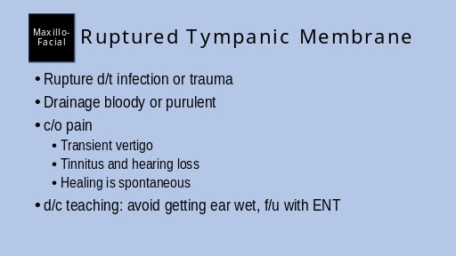
Slide 13 | 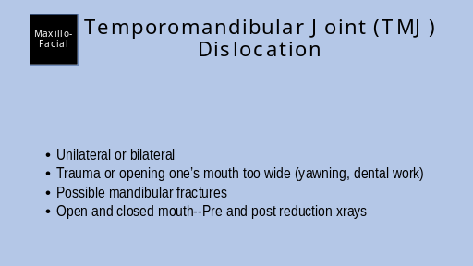 | Anterior and superior displacement of the jaw—spasms and muscle contractions of the jaw prevent condyles from returning to normal position  Risk factors: malocclusion, poorly fitting dentures, bruxism (grinding/clenching), emotional stress—alters muscular balance  D/C teaching: soft diet for 3-4 days, avoid stress on TMJ, awareness of habits that make them at risk for TMJD, avoid opening mouth too wide
Slide 14 | 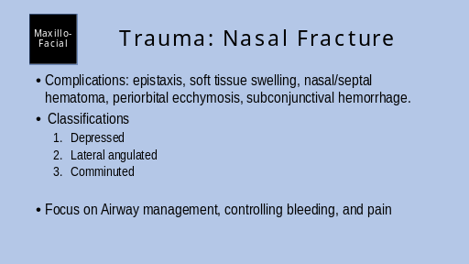
Slide 15 | 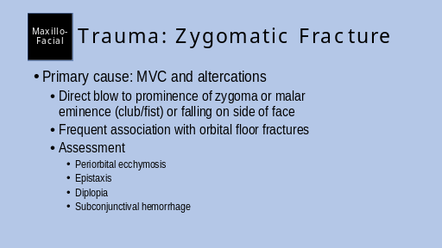 | Facial CT or xray  Treat pain and edema
Slide 16 | 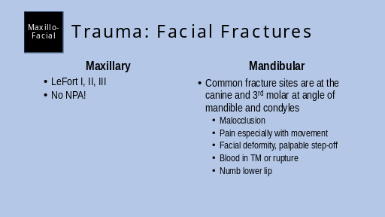 | LeFort I: transverse maxillary bone fx, occurs just above the teeth separating from maxilla, may note lip laceration or fractured teeth  LeFort II: pyramid shape fracture mid face: may not nasal and face swelling, malocclusion, CSF rhinorrhea  LeFort III: complete cranial facial separation involving maxilla, zygoma, orbits, and bones at cranial base. May note: massive facial edema, able to lift zygomatic bones, eccymosis, diplopia d/t nerve entrapment, or open bite/malocclusion.
Slide 17 | 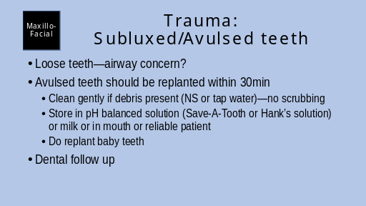
Slide 18 | 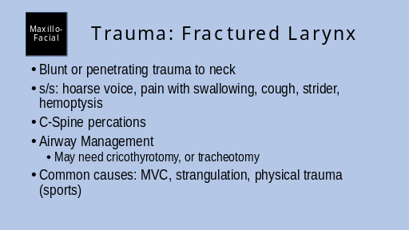
Slide 19 | 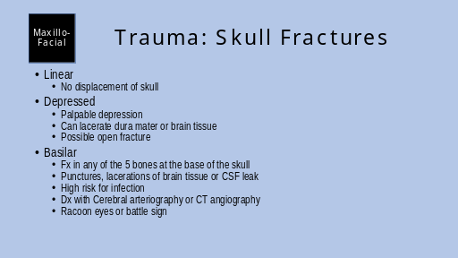
Slide 20 | 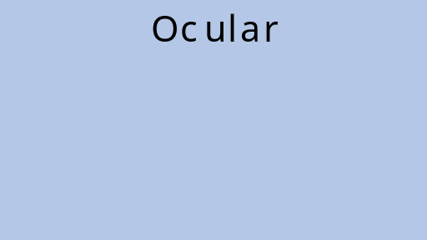
Slide 21 | 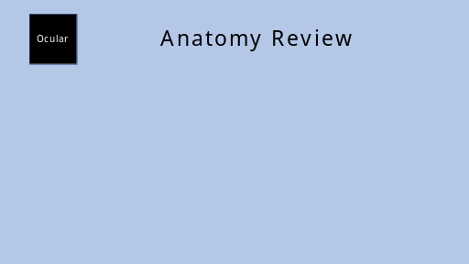
Slide 22 | 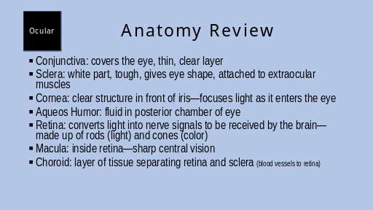
Slide 23 | 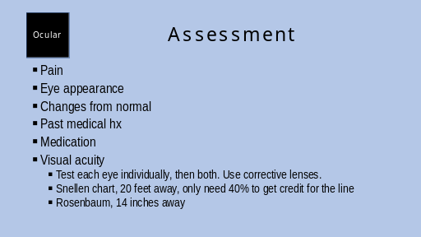
Slide 24 | 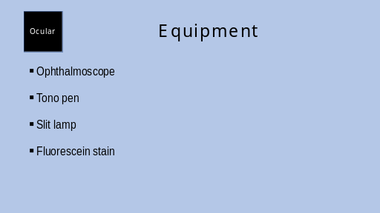
Slide 25 | 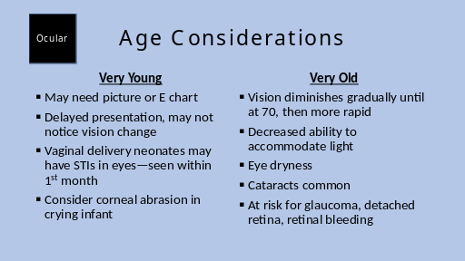 | Neonate STI eye infections: gonorrhea, chlamydia, herpes
Slide 26 | 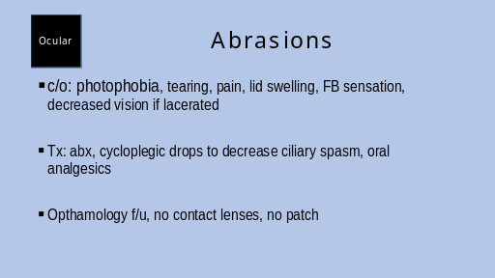
Slide 27 | 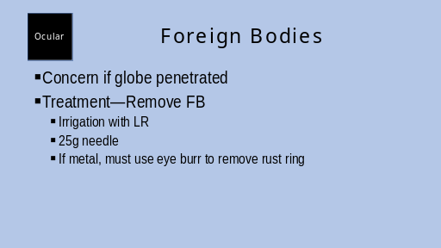
Slide 28 | 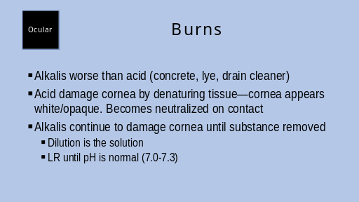
Slide 29 | 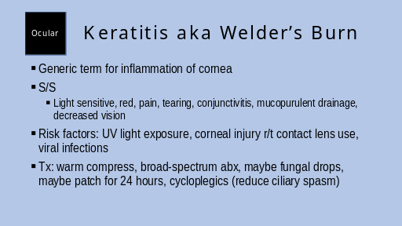
Slide 30 | 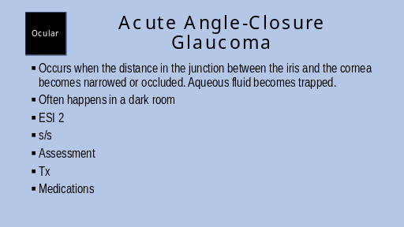 | Emergent tx or blindness can occur (pressure damages optic nerve, retina not perfused)  s/s: severe sudden onset unilateral pain, HA, blurred vision, halos around lights  Assessment: hazy cornea, pupil poorly reactive or fixed, pressure 40-80mmHg, rock-hard if palpated  Tx: Opthamology consult, iridotomy, admit  Medications: analgesics, antiemetics (no extra pressure), diuretic agents, Beta-adrenergic antagonist eye drops (lower IOP), Pilocarpine eye drops (lower IOP)
Slide 31 | 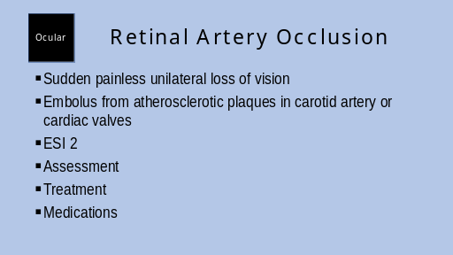 | Blockage must be relieved within 1-2 hours to preserve vision  Assessment: may be able to perceive light or count fingers, afferent pupil defect (pupils don’t restrict the same when light shown into eye), retina pale and edematous  Tx: ophthalmology, digital massage of globe (physician only), maybe surgery  Meds: betablocker drops (decreases IOP), acetazolamide, carbogen gas (95% O2, 5% CO2) if available for vasodilatation, tPA?
Slide 32 | 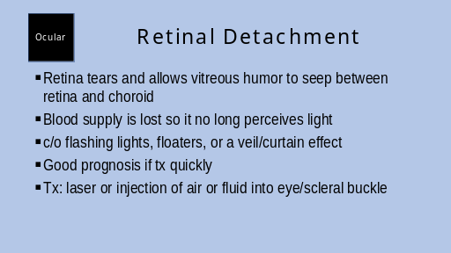
Slide 33 | 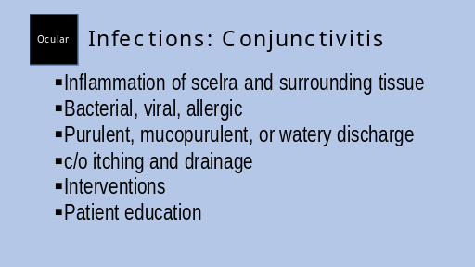 | Interventions: visual acuity, clean eye medial to lateral, warm compress for bacterial, cool for viral, eye drops and pain medication  Patient education: hand washing, medication administration, no contacts, no makeup, throw away eye make up
Slide 34 | 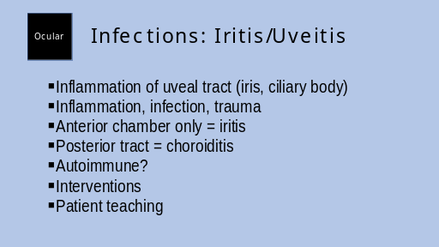 | Interventions: visual acuity, slit lamp, tono pen, steroids, cycloplegics to paralyze ciliary muscle, warm compress  Patient teaching: light sensitivity (protective eyewear)
Slide 35 | 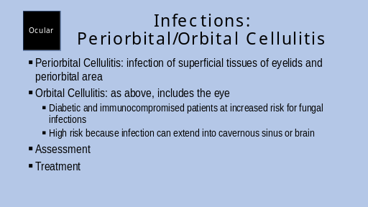 | Periorbital Cellulitis: swollen erythematous eyelid, mild-diffuse conjunctival injection. Causes: laceration, bug bite, sinusitis, common bacteria: pneumococcal, staphylococcal, or streptococcal  Orbital Cellulitis: decreased visual acuity, proptosis (eye displacement), pain with movement  Assessment/diagnostics: fever, edema of structures, discomfort, decreased pupillary reflexes, afferent pupil defect, orbital CT, culture discharge, blood cultures, LP to R/O CNS infection (if pt looks toxic).  Treatment: ophthalmology consult, Warm compress, possible surgery for abscess, IV abx
Slide 36 | 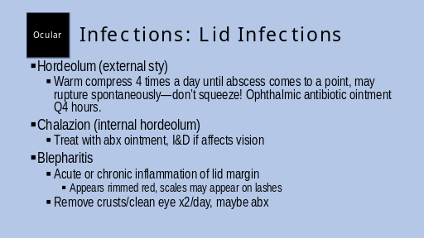
Slide 37 | 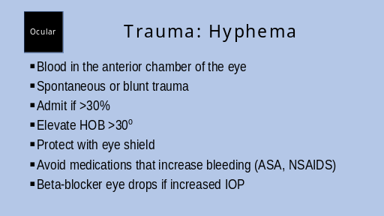
Slide 38 | 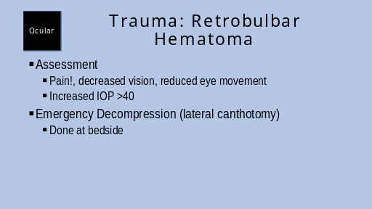 | Video of lateral canthotomy  https://youtu.be/MhGQ1ikN93M
Slide 39 | 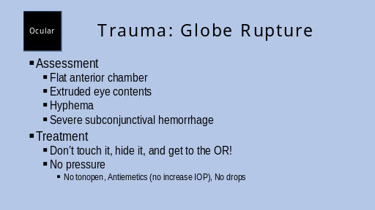
Slide 40 | 