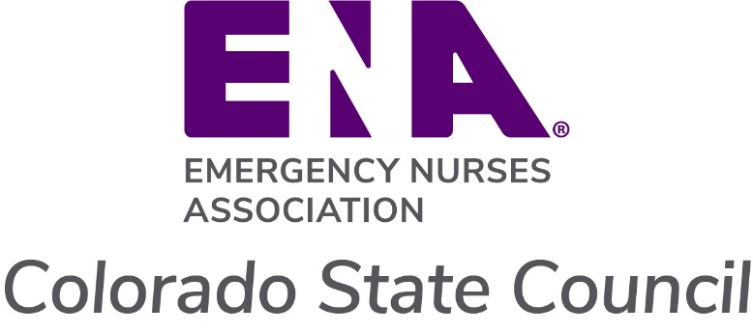

Professional Development Reimbursement Request

**Incomplete forms will not be processed.**

1. This form should be used to request reimbursement from the Colorado ENA State Council for all or part of the registration fee for conferences, review courses, or ENA University programs (up to a maximum of $100).
2. An education brochure or registration form must be attached to the request, along with a receipt of the paid registration fee.
3. Membership in the Colorado ENA State Council must be current through the date of the course.
4. Requests will be reviewed quarterly by the Board of Directors (March, June, September, December):
   1. Up to five (5) recipients will be selected for reimbursement each quarter.
   2. If there are more than five applicants, recipients will be chosen by lottery.

|  |  |
| --- | --- |
| Member name |  |
| Name of course |  |
| Date of course |  |
| ENA # and expiration date |  |
| Full address |  |
| Best contact number |  |
| Email |  |

**Registration form and receipt must be attached**

Return this form and required attachments to: [Treasurer@ColoradoENA.org](mailto:Treasurer@ColoradoENA.org)

For Treasurer use only:

Amount______________ Check #_____________ Date Processed_______________