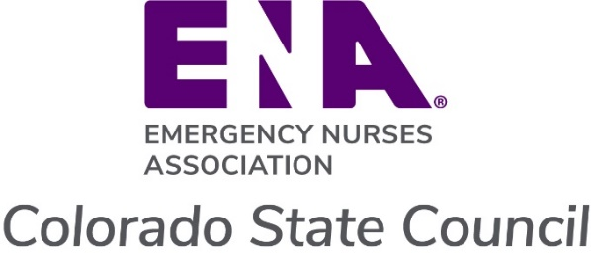
2026 Academic Scholarship Application

Application Process
Complete and submit the following form and supplemental information by June 1, 2026. Incomplete applications will not be considered. To help you here is a checklist of all the required items:
- Application Form and Essay
- Resume
- Photo
- 2 completed references
Requirements:
- Must have an active ENA membership (student memberships included) at the time of application.
- Cannot have received a COENA scholarship in the last three (3) years. National ENA scholarships do not apply to this restriction.

Submit forms and accompanying documents: Awards@ColoradoENA.org
Subject line: 2026 SCHOLARSHIP APPLICATION – LAST NAME, FIRST NAME

Scholarship Selection Process

All completed applications will be reviewed by the ENA Committee and Board members. Scholarships will be made payable to the applicant’s academic institution or lender, not to the individual. Checks are expected to be sent by August 1, 2026. Please work with your institution to ensure credit to your account and that it does not impact other financial/scholarship agreements already in place.

Application Form

Basic Information
Full Legal Name
Address
Phone Number
Email
ENA Number
Expiration Date

Education Information
What degree are you working toward?
When will you graduate?
What school are you attending?
Are you attending full time, part time, or self-directed?

School / Lender Information
Scholarship checks will be sent directly to your school or lender
School / Lender Name
Address
Contact information
Student ID or Account #

ENA Involvement

Describe your involvement with the state and/or national ENA. This may include participation in state or national elections, meetings, committees, conferences, or other activities:

Please list ways you plan on continuing your involvement with the state and/or national ENA. This may include joining a committee, attending a member meeting in-person, applying to be an ED liaison, volunteering to assist at the annual education conference, etc.:

Other Involvement

How else are you involved in your community? This can include at school, work or elsewhere, or involvement in research, EBP, or QI activities, or anything else you would like to share:

Essay

Please submit a 500-750 word essay describing each of the following elements:
- Your commitment to Emergency Nursing
- How this scholarship will benefit you
- How this scholarship will support your future contributions to further the practice of Emergency Nursing

References

Please submit two (2) references by the June 1st deadline for your application to be considered complete.
 | Name | Email address
1
2

Please have your references use the following link or QR code and complete the survey:

2026 CO ENA Scholarship Referral Questionnaire – Fill out form

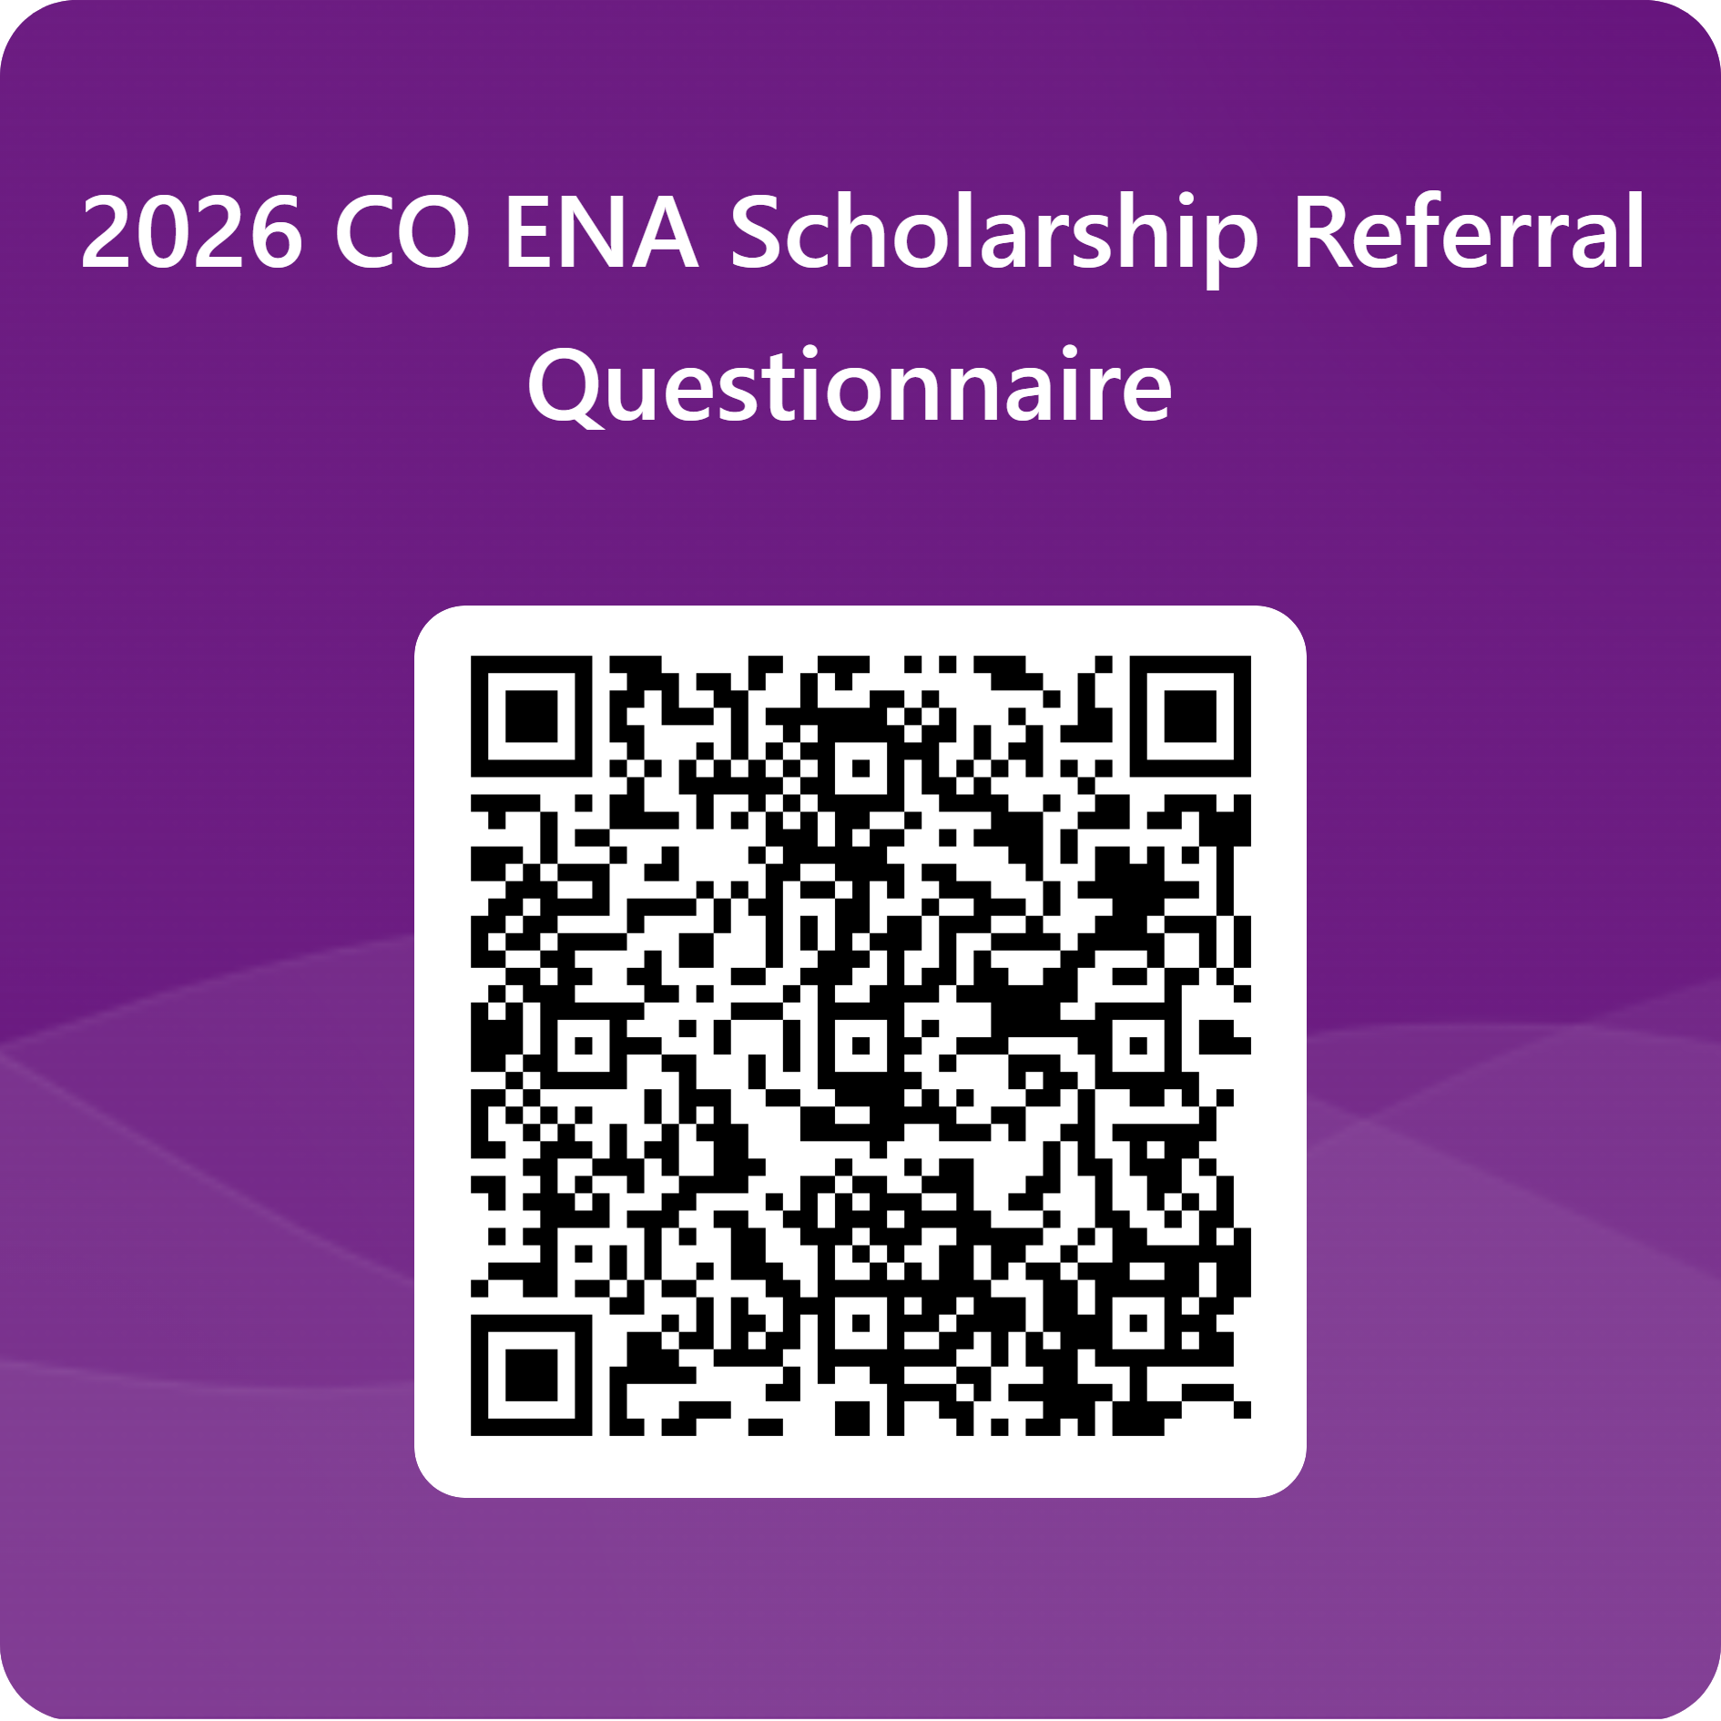

Colorado ENA is committed to promoting the advancement, development, and safe practice in the specialty of Emergency Nursing throughout the state of Colorado. For further information on opportunities for involvement and member benefits, please visit our website at: www.coloradoena.org

