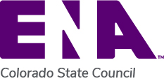
Paid Registration Fee Request
Incomplete forms will not be processed.
- This form is to be used when requesting Colorado State Council ENA to pay all or part of the course registration fee (limit $100).
- Education brochure/registration form MUST be attached. Include receipt if pre-paid.
- Membership in CO ENA must be current through date of course.
- Requests reviewed quarterly by board (March, June, September, December). Limit 5 registrations per quarter, chosen by lottery if greater than 5 applicants.
I am Requesting:
 | Payment (made directly to event) |  | Reimbursement (provide receipt)

Name
Course
Date
ENA # and expiration date
Full address
Best contact number
email

CONFERENCE REGISTRATION AND REGISTRATION FORM MUST BE ATTACHED
Return this form and required attachments to: Treasurer@coloradoena.org

For Treasurer use only:
Amount______________ Check #_____________ Date Processed_______________

