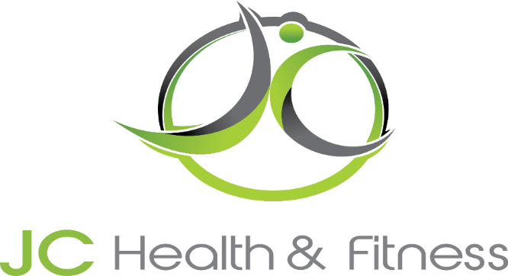
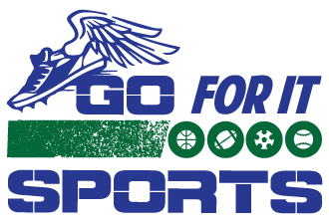

New Membership packages requires a $50 Enrollment Fee
Membership Packages – Yorkville Location
 | Single  Membership | Double  Membership | Family  Membership
Senior (60+)  Student  (22 under) | $65 | $120
Monthly | $85 | $155 | $190
3 Month | 5% Off  $242.25 | 5% Off  $441.75 | 5% Off  $541.50
6 Month | 10% Off  $459.00 | 10% Off  $837.00 | 10% Off  $1026.00
Yearly | 15% Off  $867.00 | 15% Off  $1581.00 | 15% Off  $1938.00
Membership Includes: Unlimited Classes with Monthly Membership Packages,
Open Gym Facility Access – when available,
10% JC Sponsored Camps, Clinics, Specialty Classes
Purchase of Yearly Membership includes 10% discount on all Personal Training Packages

