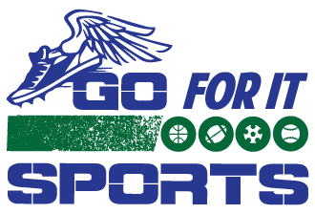
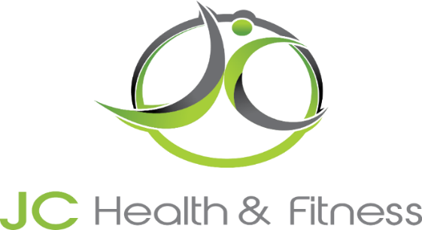

New Membership packages requires a $50 Enrollment Fee
Yorkville Membership Packages
 | Single  Membership | Double  Membership | Family  Membership
Senior (60+)  Student (22 under) | $65 Each | $120
Monthly | $85 | $155 | $190
3 Month | 5% Off  $242.25 | 5% Off  $441.75 | 5% Off  $541.50
6 Month | 10% Off  $459.00 | 10% Off  $837.00 | 10% Off  $1026.00
Yearly | 15% Off  $867.00 | 15% Off  $1581.00 | 15% Off  $1938.00
Track Only | $30 per month
Golf Only | $45 per month

Membership Includes: Unlimited Classes with Monthly Membership Packages, Open Gym
Yearly Membership includes 10% discount on all Personal Training Packages

