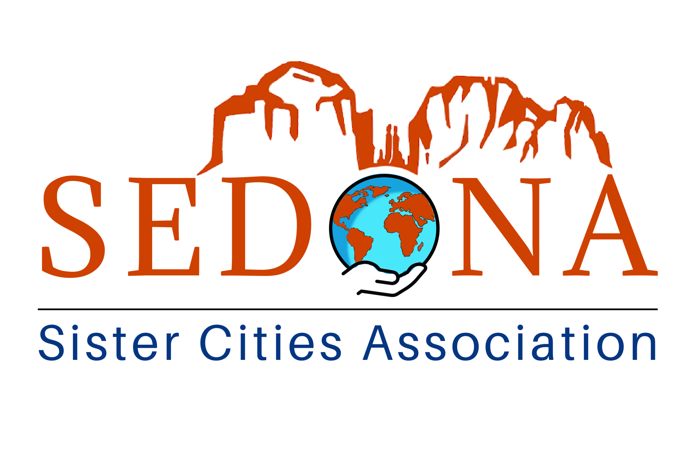
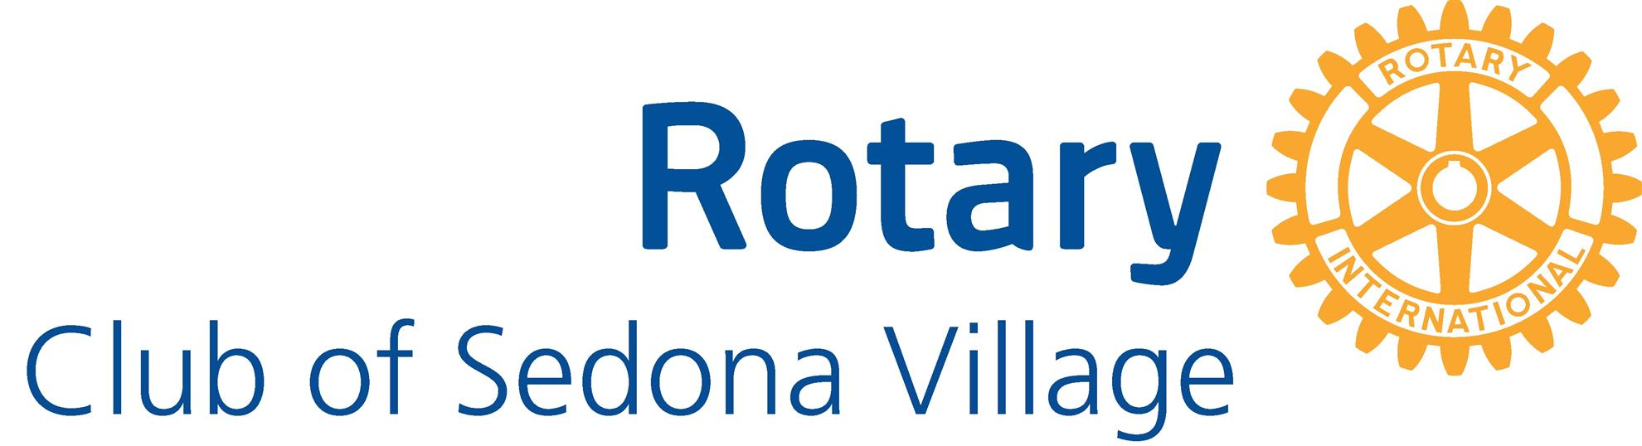

News Release
RedRed Rock High School Student Selected for International Youth Leadership S
Red Rock High School Student Selected for International Youth Leadership Summit

Fernando Quisumbing chosen by Rotary Club of Sedona Village and Sedona Sister Cities to attend Sister Cities International Youth Leadership Summit in Washington, D.C.

The Rotary Club of Sedona Village and the Sedona Sister Cities Association have announced that Red Rock High School student Fernando Quisumbing has been selected to participate in the 2026 Sister Cities International Youth Leadership Summit, to be held June 21–27 in Washington, D.C.
Fernando is the second Red Rock High School student chosen for this prestigious international youth leadership experience. He was recommended by teachers and selected through interviews conducted by representatives from Rotary and Sedona Sister Cities.
During the week-long Summit, youth leaders ages 14–18 from across the United States and around the world will participate in leadership workshops, cultural diplomacy programs, and collaborative sessions addressing global challenges. One highlight of the program is a diplomacy simulation at the U.S. Department of State, facilitated by the National Museum of American Diplomacy.
Fernando has already demonstrated exceptional leadership and service. A 4.0 student who is simultaneously completing an Associate Degree, he volunteers approximately 15 hours per week with the Community Library Sedona and Rotary programs. He has participated in Rotary’s Youth Leadership Awards (RYLA) program and returned as a Junior Counselor helping mentor other students.
Educators and mentors describe Fernando as a thoughtful “servant leader” who seeks to bring people together and help others succeed. In addition to academic excellence, he recently starred as Ebenezer Scrooge in the school musical while also supporting fellow cast members to build teamwork and collaboration. Fernando’s parents are Gioia and Jan Quisumbing .
“Fernando already demonstrates the qualities we hope to inspire through Sister Cities—curiosity about the world, respect for different cultures, and a commitment to bringing people together,” said Carol Myers, Sedona Sister Cities Coordinator. “The Youth Leadership Summit will give him the opportunity to develop those skills even further and return to Sedona as a true citizen diplomat.”
Through the Youth Leadership Summit, Fernando will join young leaders from around the world to explore the principles of citizen diplomacy—the idea that individuals, through dialogue and cultural exchange, can help build international understanding and peace.
The program is sponsored locally by the Rotary Club of Sedona Village and the Sedona Sister Cities Association, organizations committed to developing youth leadership and strengthening global relationships.

*****
media contact: C. Marr, cmarr2@icloud.com

