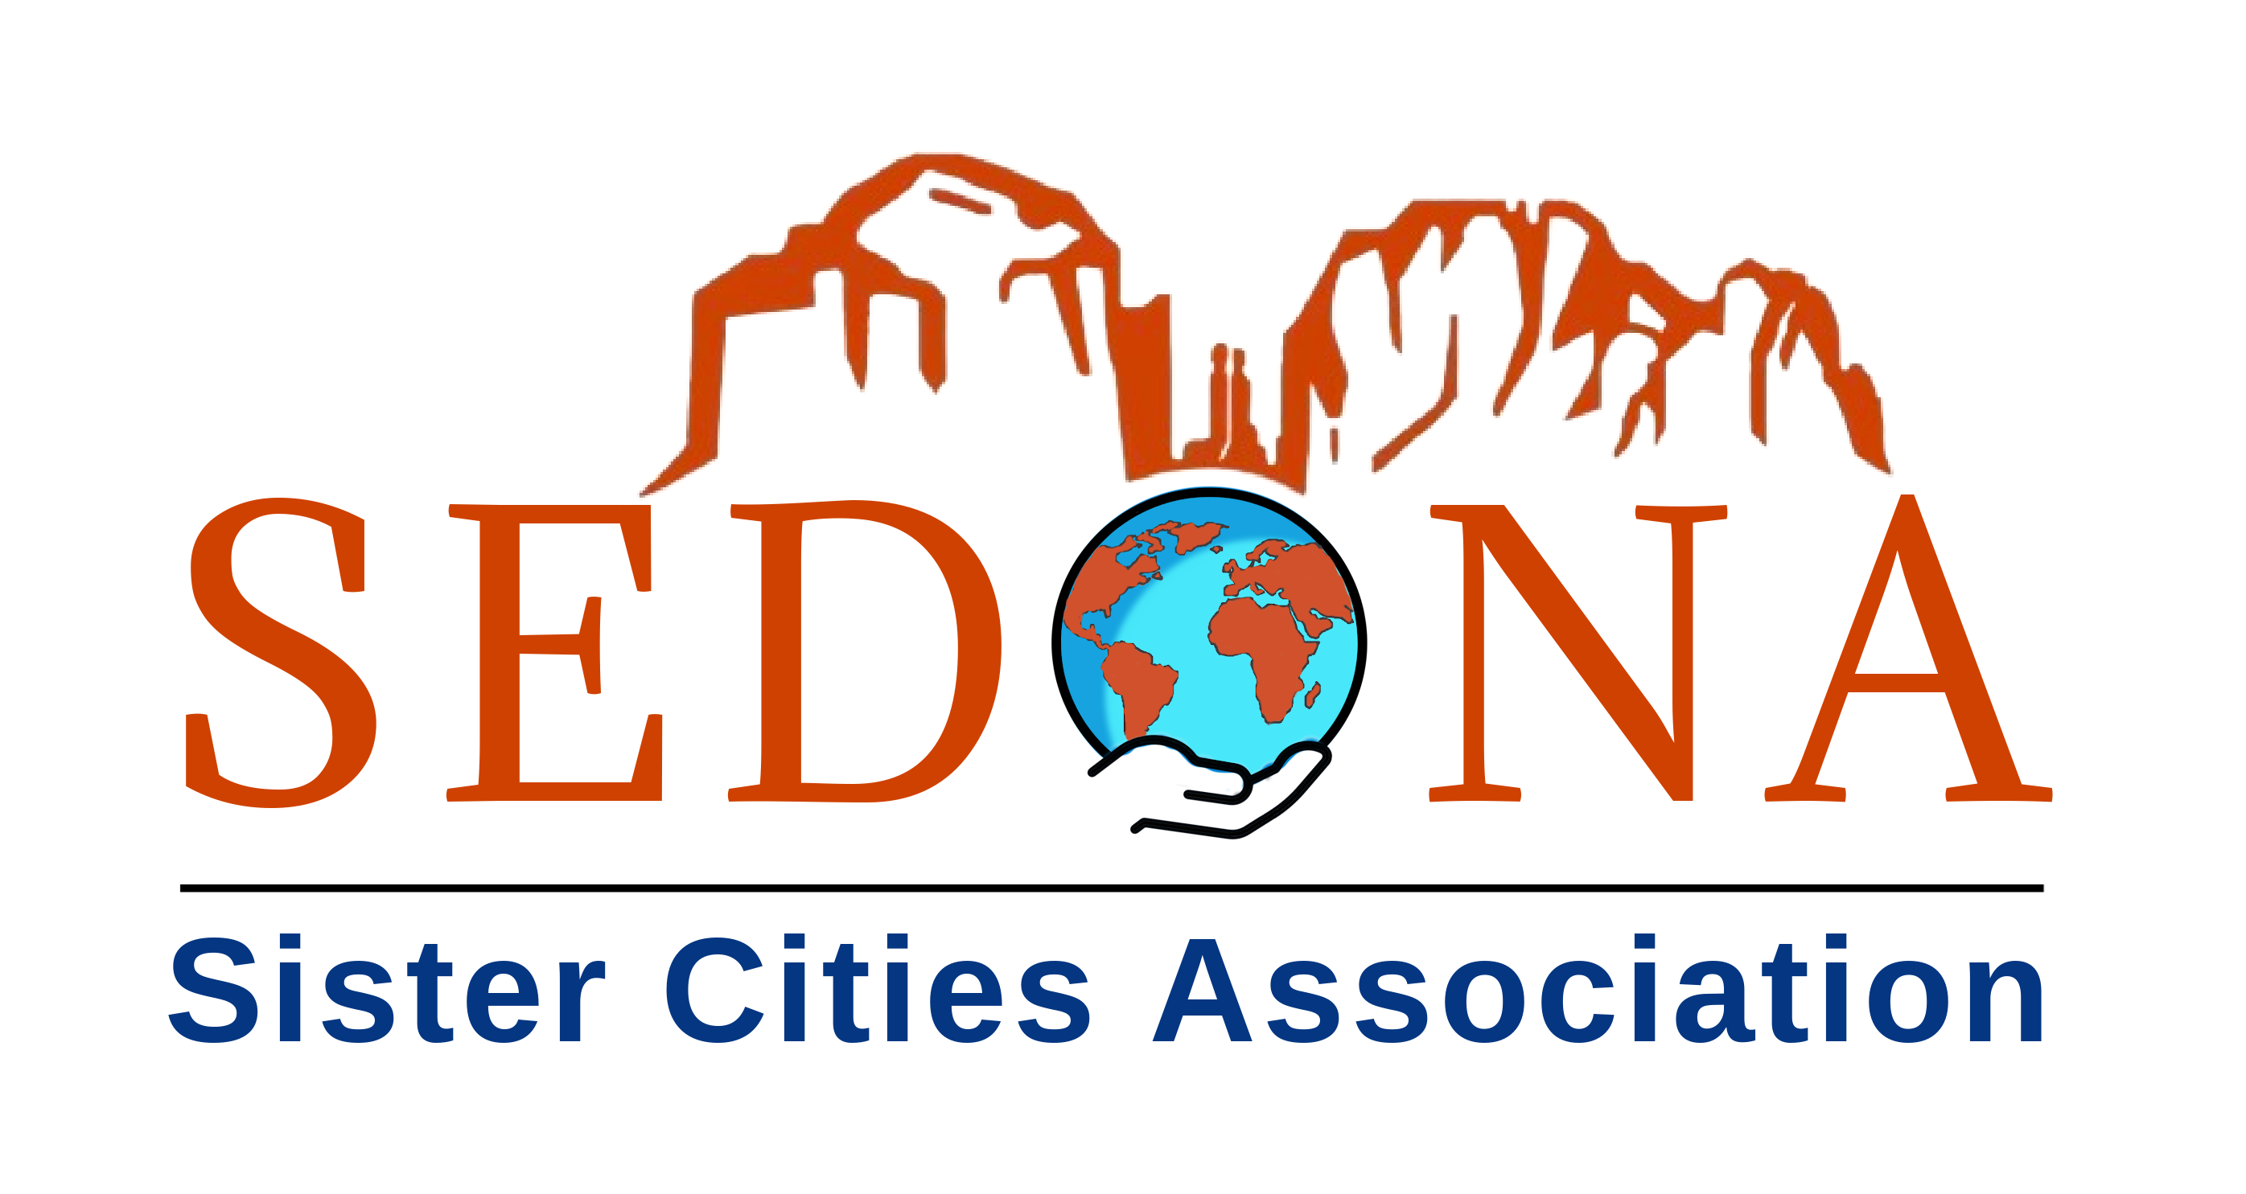

For Immediate Release
Sedona Sister Cities Association Celebrates a Landmark Year of Global Partnerships and Cultural Exchange

Sedona, Arizona — The Sedona Sister Cities Association (SSCA) is celebrating a milestone year marked by new international agreements, expanded cultural programming, and growing community engagement. In 2025, SSCA strengthened Sedona’s global presence through significant partnerships with Canmore, Canada, and Jasło, Poland, while deepening educational and cultural exchanges across both communities.
A major highlight came on June 28, when Sedona formalized its first Sister City agreement with Canmore, Alberta. Canada. A nine-member Sedona delegation traveled to Canmore for the historic signing ceremony, which also included the first Sister Library Agreement between Community Library Sedona and the Canmore Library—cementing a collaborative foundation for future joint programming.
On August 30, Sedona broadened its global reach with a Friendship Cities Agreement with Jasło, Poland. The virtual ceremony featured the participation of U.S. Consul to Poland Colette Clark, underscoring the significance of community-based diplomacy. Sedona’s Through the Lens photographic exhibit was opened during the delegation’s visit, and Jasło welcomed the Verde Valley Wine Consortium to present 18 Verde Valley wines at its Days of Wine Festival.
“Building strong international relationships has never been more important,” said SSCA President Chuck Marr. “Through cultural exchange and personal connection, we strengthen understanding, expand opportunity, and bring the world closer to Sedona. The presence of U.S. Consul Colette Clark at our Friendship Cities signing with Jasło underscored the value of people-to-people diplomacy and the role communities like ours can play in fostering global goodwill.”
Throughout 2025, SSCA advanced cultural and educational programs including the Local Authors Exchange, a Canada Day celebration, an OLLI workshop on Canadian culture, the inaugural Rising Stars Concert with Canmore, and the Sedona–Canmore Photo Contest. Signature events such as the Polish Picnic, which drew more than 700 attendees, and the International Days Dinner further strengthened community involvement.
SSCA also reached 100 active members, expanded volunteer participation, and sponsored two Sedona youth—Khrystian Cordova and Maryam Jaffe—in Sister Cities International programs.
With expanding partnerships and strong community momentum, SSCA enters 2026—its fifth anniversary year—positioned for continued growth and global engagement.

For more information, visit: www.sedonasistercities.org

*****
Media contact: cmarr2@icloud.com

