What keeps you up?
The L&D role in the era of AI: What do you see happening that concerns and/or excites you?

Positioning yourself: How are you meeting the moment of change you anticipate or observe?

This time was worthwhile if _______________________________________________________________________
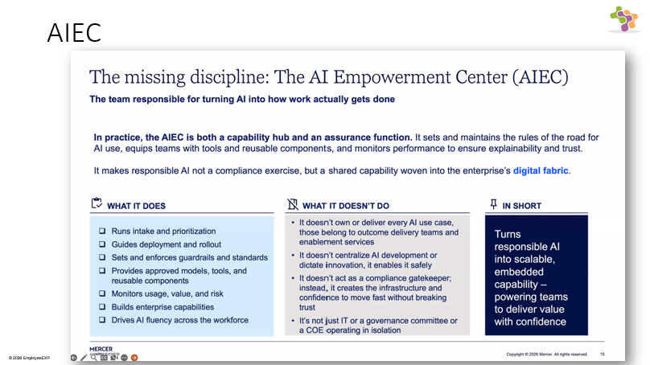

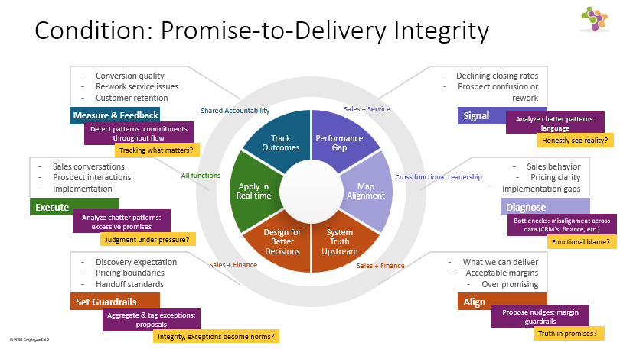

The Cases

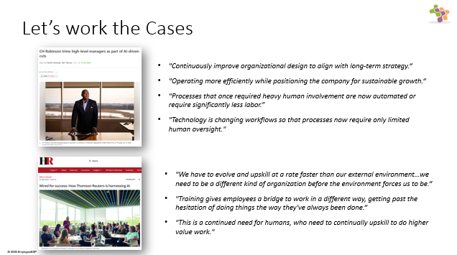
What is L&D’s role when:
- business reduces human work
- business expands human potential

Productivity Pressure
You are in a C.H. Robinson type organization. Headcounts are down 29% in a year. Automation and AI reduce the need for manual work on routine tasks. The company is hiring in customer and carrier facing roles. The public statements are about margin, efficiency, and strategy. Less about the people who remain.
Logistics firms like C.H. Robinson rely heavily on networks of brokers and agents to match freight capacity with shipper demand. Automation tools can streamline pricing, routing, and tracking, potentially reducing headcount needs without sacrificing service quality. Investors note that similar moves by peers have led to margin expansion, though short-term restructuring costs may pressure near-term earnings.
The announcement underscores broader trends in transportation where AI is transforming manual processes. For C.H. Robinson, this could mean faster decision-making in volatile freight markets, where spot rates fluctuate daily based on capacity and demand dynamics.
- Where does decision quality degrade as headcount decreases?
- Where could efficiency gains create hidden risk (e.g., customer trust, unwanted employee turnover)?
- What happens to capability pathways for those who remain?
Discussion Questions
If L&D is accountable for future workforce capability vs. training, what must it own, change, start or stop doing to support this strategy?
- Generate one or two ideas for each level:
- Executive Level (System): What assumptions should change?

- Manager Level (Workflow): Where should capability show up differently in day-to-day work?

- Workforce Level (Behavior): What should people do differently? How will we know?

- Positioning statements:
- System Shift (CEO-level): We need to move from _______________________ to ____________________ in how we manage…

- Capability Shift (Manager-level): Managers must be able to ___________________________, currently missing…

- Behavior Shift (Workforce-level): Employees must demonstrate ____________________________ in _______________________________________ situations, measured by…

- From this conversation, what have you discovered you will:
- Stop or start doing?
- Redefine as L&D’s responsibility?
- Ask the CEO to own?

People Partner
You are in a Thomson Reuters-type organization. The CHRO sat down with the head of technology and the executive team and said: “We need to jointly lead an internal strategy. We must evolve faster than our external environment. The organization builds a bridge for employees and measures learning and community, not just adoption. The biggest gains have been in things nobody predicted. L&D is at the table before the strategy is announced.”
For all employees, Hasker said, Thomson Reuters has added some base-level AI training and know-how.
“There’s no way to fudge that,” Hasker said. “You cannot sort of delegate that to other people and you cannot delegate that to technology. You actually have to personally invest in it and then follow through.”
At Thomson Reuters, we do not just see AI as a tool for efficiency; we see it as a catalyst for unprecedented human creativity and innovation. It is about amplifying our uniquely human capabilities – our imagination and our capacity for complex problem-solving.
What makes our perspective unique is our focus on empowering every colleague to harness AI as their innovation partner. We are using AI to automate routine workflows, but more importantly, we are creating opportunities for our people to experiment, learn, and discover how AI can amplify their individual strengths and capabilities.
- Where could high AI usage create false confidence in capability?
- What does “higher-value work” require people to do differently?
- Where might judgment quietly weaken due to AI reliance?
- Where might there be measurement challenges e.g., usage vs. change in productivity?

Discussion Questions
If L&D is accountable for future workforce capability vs. training, what must it own, change, start or stop doing to support this strategy?
- Generate one or two ideas for each level:
- Executive Level (System) What assumptions should change?

- Manager Level (Workflow) Where should capability show up differently in day-to-day work?

- Workforce Level (Behavior) What should people do differently? How will we know?

- Positioning statements:
- System Shift (CEO-level): We need to move from _________________________ to __________________ in how we manage…

- Capability Shift (Manager-level): Managers must be able to ___________________________, currently missing…

- Behavior Shift (Workforce-level): Employees must demonstrate ____________________________ in _______________________________________ situations, measured by…

- From this conversation, what have you discovered you will:
- Stop or start doing?
- Redefine as L&D’s responsibility?
- Ask the CEO to own?
