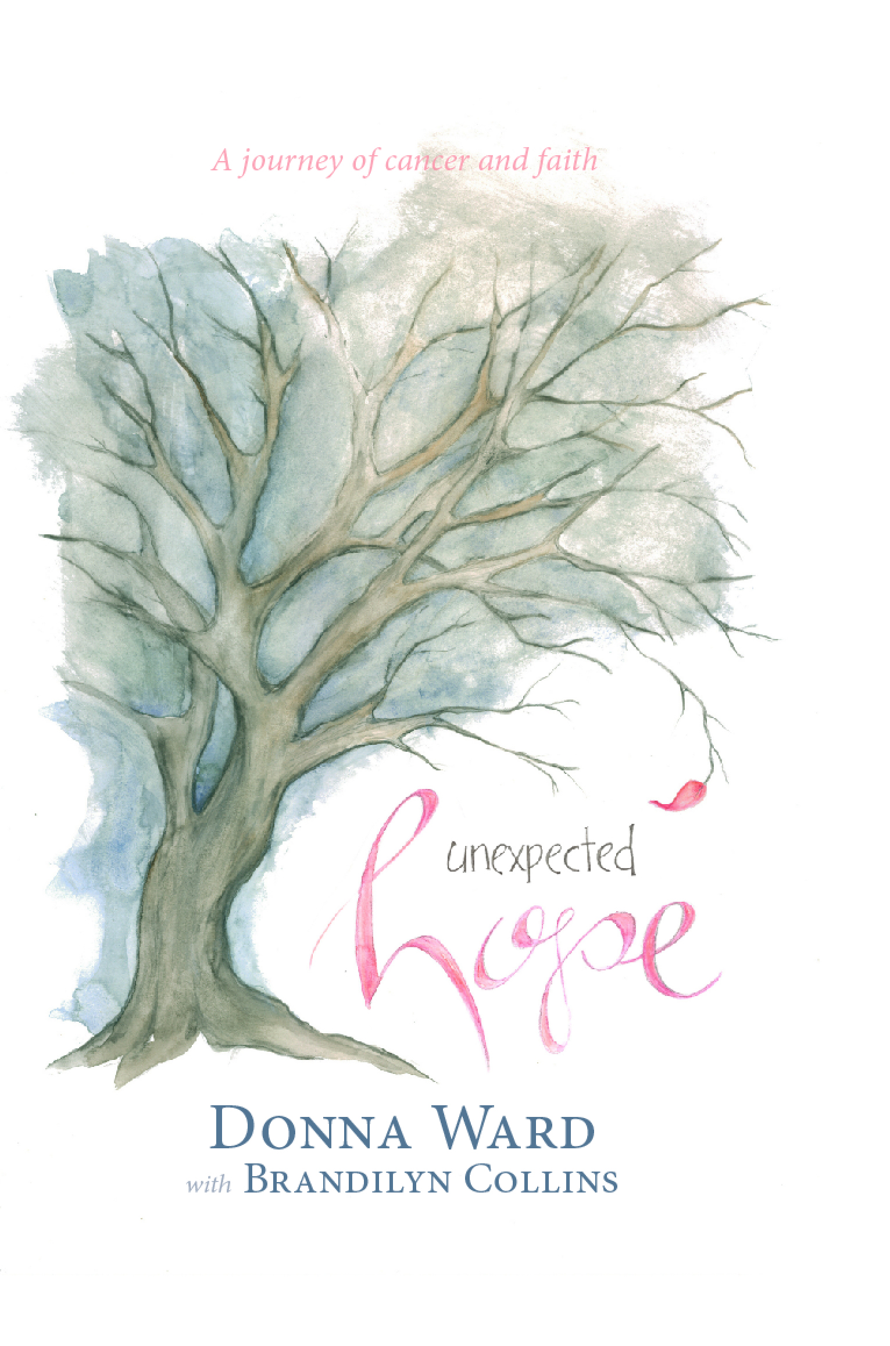

For Immediate Release

MEDIA CONTACT:
Pam Denham
pdenham6400@att.net
C: 251.656.3843

ANNOUNCING NEWLY RELEASED BOOK – “UNEXPECTED HOPE”
Author, Donna Ward & Husband, Turner Ward, Former Major Leaguer/Current MLB Coach on Speaking Tour to Share Their Powerful Message of Hope & Vulnerable Testimony of Donna’s Arduous Battle with Cancer & Multiple Reconstructive Surgeries.

Mobile, AL (August 31, 2020) – “It is Cancer.” Those three words would send Donna Ward, wife of former major leaguer and current MLB coach Turner Ward, on a terrifying journey. First came the double mastectomy, resulting in overwhelming pain and a body that would not heal. Over the next eight years, Donna would face eleven more surgeries to repair the damage. The constant suffering and exhaustion left her questioning God, whom she had trusted since a child. Yet today she is convinced cancer has been one of the greatest gifts of her life.

Through raw and vulnerable journal entries, Ward takes us on her journey. She uses current narrative sections to speak of what she has learned since writing those words. Her deeply moving story is one of faith in God, love between husband and wife, and hope.

WHO WILL BENEFIT FROM READING UNEXPECTED HOPE & ATTENDING A SPEAKING EVENT WITH DONNA/DONNA AND TURNER WARD?
Anyone who has fallen into deep, dark, and desperate place of hopelessness due to unexpected life events.

ABOUT DONNA WARD
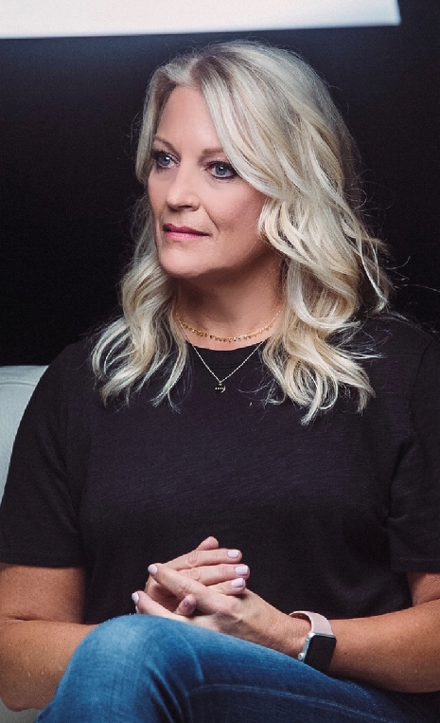
Author and speaker, Donna Ward is the mom to three and wife of her high school sweetheart, Turner Ward. They have been married for 31 years. She is a breast cancer survivor and author of Unexpected Hope - A Journey of Cancer & Faith. She is the founder of hope4110, a non-proﬁt that helps women facing breast cancer and breast reconstruction. Learn more at hope4110.com and donnamarieward.com. (Photo: Donna Ward)

WHY THIS BOOK WAS WRITTEN
“Life was predictable, and then, in a moment, everything changed. My stable world became a world of unknown and fear. I have a story that needs to be told. A story of HOPE. A cancer diagnosis followed by 12 surgeries in 7 years has been a journey of pain, suffering, and questioning in the God that I have trusted in, all my life. The cancer has been probably one of the greatest gifts of my life.”
- Donna Ward, Author & Speaker
BOOK ACCOLADES
“A powerful and vulnerable testimony of an arduous battle with cancer, told with heartrending intimacy through journal entries. Unexpected Hope will encourage others walking through similar circumstances.”
~ Mark Batterson, New York Times bestselling author of The Circle Maker, Lead Pastor
National Community Church
“Donna exempliﬁes what it means to live second—by trusting and serving God ﬁrst in all circumstances. Her real and authentic story of continued faith and growing intimacy with God through her cancer diagnosis and medical trials is a truly inspiring one that points all who encounter it directly to the cross.”
~ I Am Second
“I have known Donna and Turner Ward for years and watched them go through this treacherous journey. This is an inspiring and gripping account of all they faced. Donna’s honesty about her struggles reveals a faith that is fragile at times but never failing.”
~ Orel Hershiser, Broadcaster for the L.A. Dodgers

FEATURED MEDIA ENGAGEMENTS
- Turner and Donna Ward are featured in A White Chair Film with I Am Second (iamsecond.com/thewards).
- Featured in (2) I Am Second blog post(s): iamsecond.com Blog: “5 Surprising Truths from a Cancer Survivor and Husband” (October 25, 2019) - https://blog.iamsecond.com/5-surprisingtruths-from-a-cancer-survivor-and-husband
- Devon Walsh, CBS-Affiliate News Story: https://www.wkrg.com/whats-working/wife-of-local-baseball-star-writes-book-about-private-cancer-battle/
- Blog: “3 Reasons Why a Change of Plan Doesn’t Mean Failure” (January 03, 2020) - https://blog.iamsecond.com/3-reasonswhy-a-change-of-plan-doesnt-mean-failure
- Jason Romano with Sports Spectrum *Sports Spectrum Podcast episode 409 interview with Turner and Donna Ward - Baseball, Faith and Cancer (listen on Spotify)

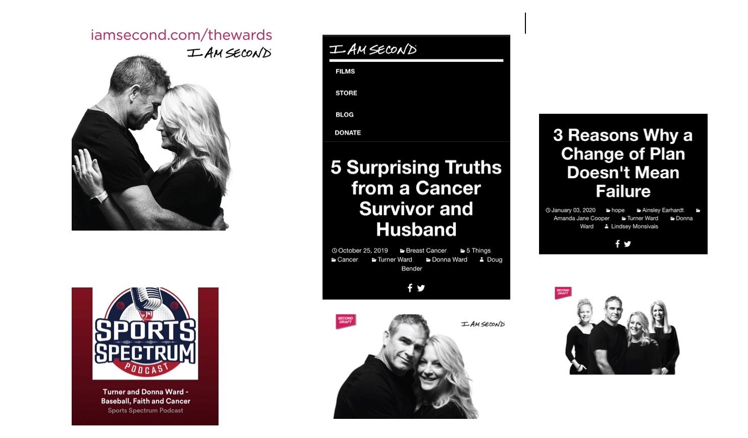

TO SCHEDULE INTERVIEW/SPEAKING/SIGNING EVENT:
For more information and to schedule speaking/signing engagements with Donna and Turner Ward, visit donnamarieward.com.

###



