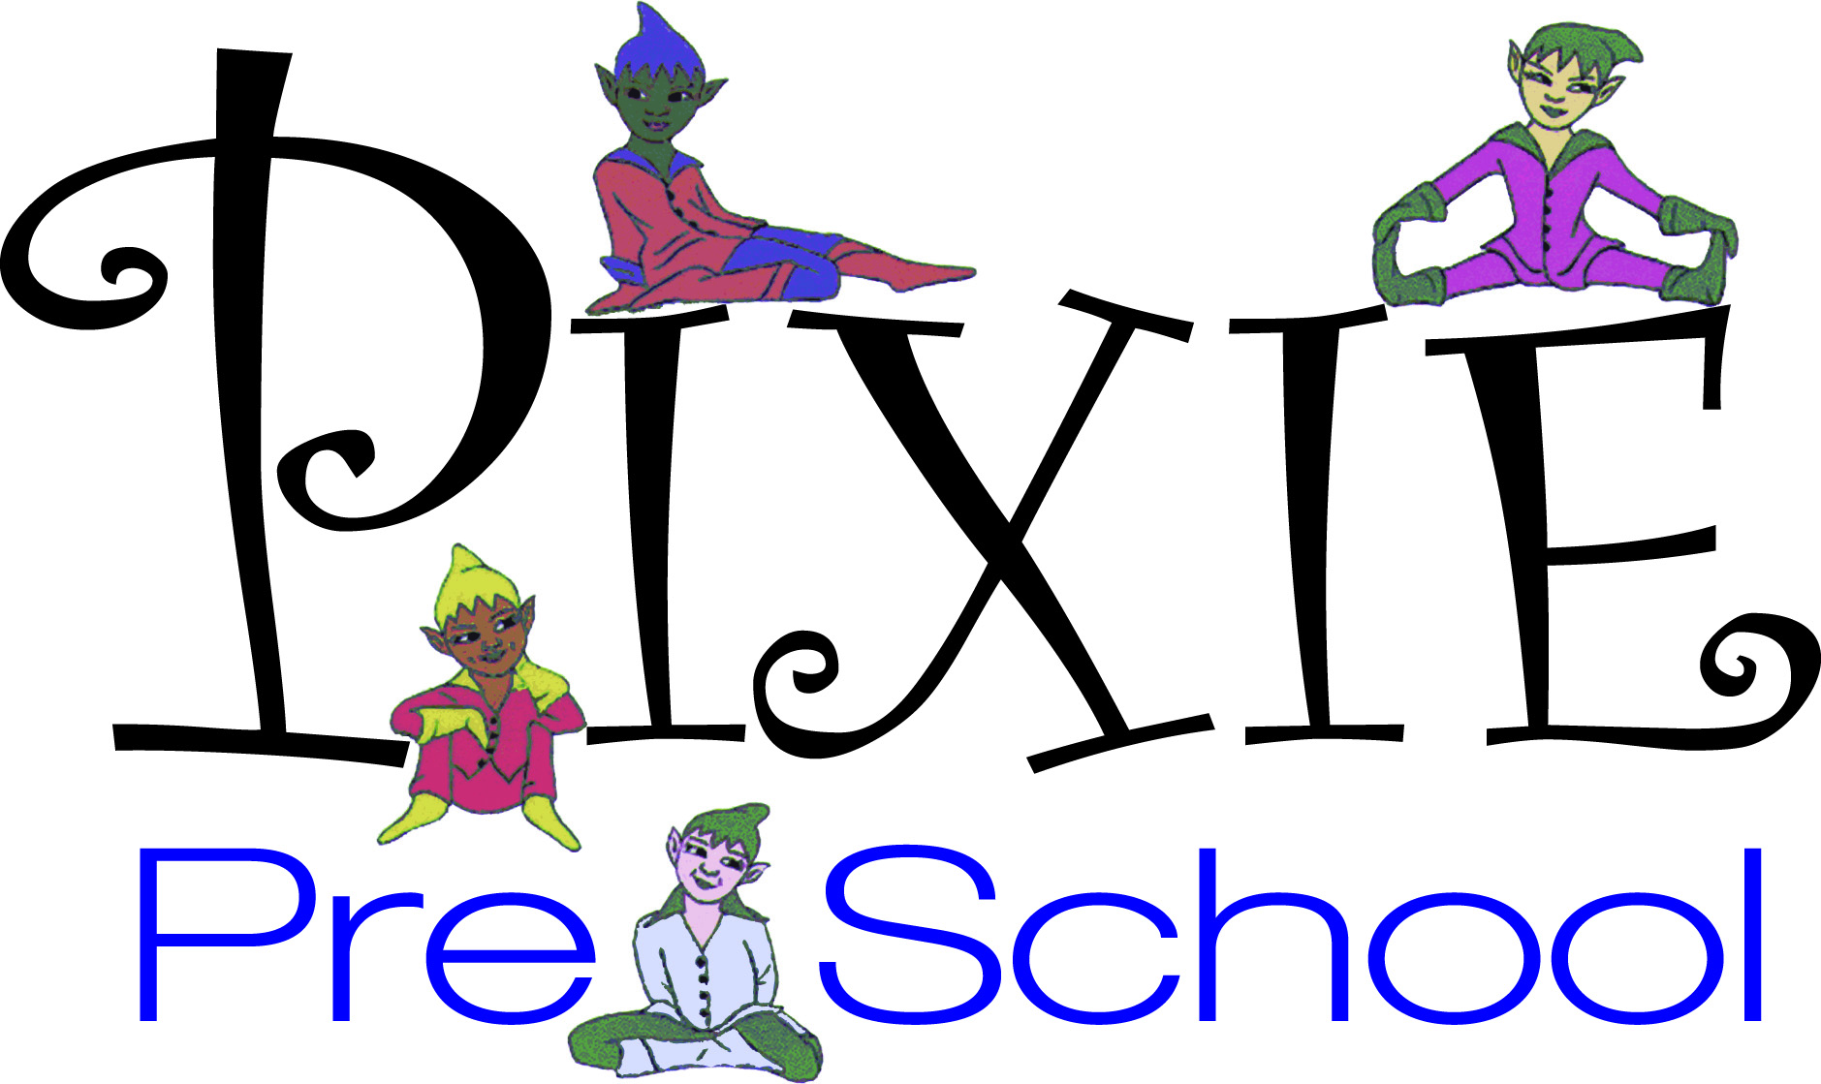

Dear Parents,
Pixie Pre-School is proud to announce that we are entering our 49th year of providing children a year round safe, caring environment where they can develop an excitement about learning. We are a non-profit preschool located in Spotswood dedicated to having each child feel good about themselves and school. Our programs provide toddlers and preschoolers with many learning experiences and are designed to enhance social skills, verbal communication, emotional growth, intellectual awareness, and strengthen physical capabilities. These programs teach the skills that children need for school and life.
Pixie Preschool maintains high standards with an excellent educational base for children two years to six years of age. Our experienced & nurturing faculty have been teaching here for up to 30 years and are the heart of our program.
We invite you to follow us on Facebook, Instagram , twitter & Pinterest for more information please call, email or stop by between the hours of 7:00am -6:30pm.
Providing unmatched educational nurturing in a traditional nursery school setting for over 48 years.
Learning and Fun rolled into one
429 Main Street
Spotswood, NJ 08884
732-251-3130
admin@pixiepreschool.org

