Week 1: 7/6 - 7/9 Party in the USA- This week will be all about our country! Red, White, & Blue, Stars & Stripes! We will celebrate all the reasons why we love the U.S.A.! Goldy’s Ice Cream Truck will visit today!
Week 2: 7/12 - 7/16 Color Me Crazy- Campers will create with all kinds of crazy art mediums as well as use different materials to express their artistic abilities. Mad Science Demonstration!!
Week 3: 7/19 - 7/23 Holiday Hullabaloo- Who doesn’t love the holidays? What could be better than celebrating them all in a row!!! We will celebrate a summer version of a different holiday each day this week!! YOBOO yoga Bootcamp class today!
Week 4: 7/26 - 7/30 Everyday Hero’s- This week is dedicated to our everyday heroes! We couldn’t be more thankful for all they do. We have some very special visitors in store for our campers this week! We will be getting a visit from all our local heroes.
Week 5: 8/2 - 8/6 Beach Boogie- Our Pixie Beach pals will be celebrating everything we love about the beach! Sand and sandcastles, Beachy snacks, water and sunshine!! Mr John the Music Man will join us for some music!
Week 6: 8/9 - 8/13 Everything Disney- This will be the happiest week on earth at Pixie. We use some of our favorite Disney characters for inspiration in arts and crafts, science, games and gross motor skills. High Touch High Tech is coming with some Cool Coastal Science experiments.
Week 7: 8/16 - 8/20 Dinosaurs & Unicorns- Campers will explore fact and fantasy learning about different prehistoric creatures that roamed the earth as well as create some fantastic creatures of their own. Muscle Man Mike the Magician will be doing his Magic show!
Week 8: 8/23 - 8/27 Circus Week- Join us this week for some clowning around as we play carnival games, do crafts and learn about circus animals. It’s sure to be a magnificent time! Goldy’s Ice cream is visiting!

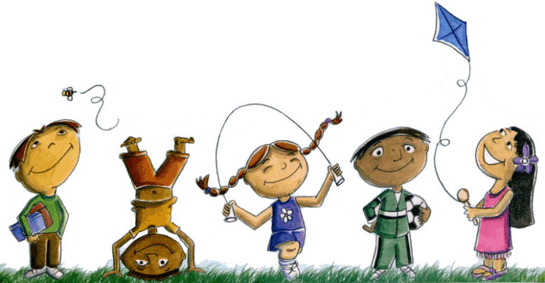
Flexible schedules and affordable weekly rates available call, email, or send a Facebook message for more information. Limited space available 429 Main St. Spotswood, N.J. 08884 732-251-3130 admin@pixiepreschool.org


