Lunch Reminders
We are a PEANUT SENSITIVE school
No items with peanut or tree nuts for the safety of children with allergies. Includes lunches, birthday and holiday snacks.
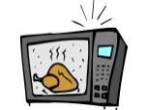 Heat ups only
Please no food that needs to be prepared or mixed, including easy mac & frozen meals.
Pixie Pizza & Dino Chicken days & 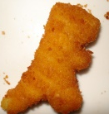
Pizza & Chicken lunch is an option each day just let your child’s teacher know and provide $3 in an envelope with first and last name the morning of.
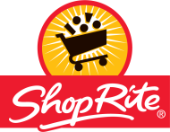 Shoprite Gift Card Fundraiser
At any time you can buy a ShopRite gift card from pixie in denominations of 5,10,20,50 & 100 and Pixie earns 5% back for our school. See Ms. Kim

