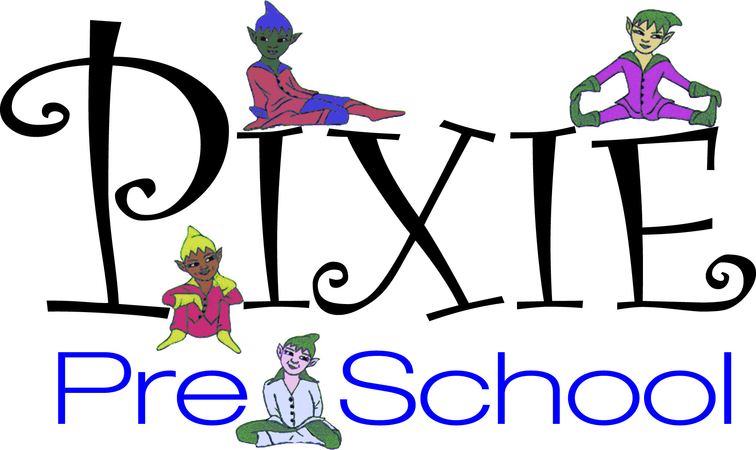

429 Main St. Spotswood, NJ 08884
732-251-3130
admin@pixiepreschool.org

Dear Parents:

Occasionally our school staff or approved visitors take pictures of or
record the children. These pictures may be used in our Newsletter or to
publicize and promote school activities or events. Pictures may appear in
local newspapers or school brochures. No additional notice may be given
of picture-taking sessions.

A form is attached for parental approval/release for photographs.
Please sign and date the attached form and return it immediately to your
child’s teacher. No photos or video will be taken of children whose parents
do not grant permission.

Sincerely,

PIXIE PRE SCHOOL

____I DO GIVE PERMISSION FOR MY CHILD TO BE PHOTOGRAPHED OR VIDEOTAPED WHILE AT PIXIE OR ON A PIXIE SPONSORED FIELD TRIP FOR
PURPOSE OF PROMOTING PIXIE AND ITS ACTIVITIES.

____I DO NOT GIVE PERMISSION FOR MY CHILD TO BE PHOTOGRAPHED OR
VIDEOTAPED WHILE AT PIXIE OR ON A PIXIE SPONSORED FIELD TRIP FOR
PURPOSE OF PROMOTING PIXIE AND ITS ACTIVITIES.

PARENT/GUARDIAN SIGNATURE________________________DATE_________________

