16th note short fills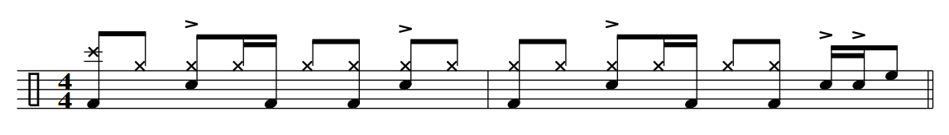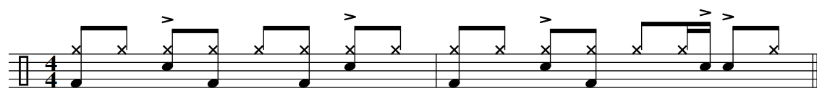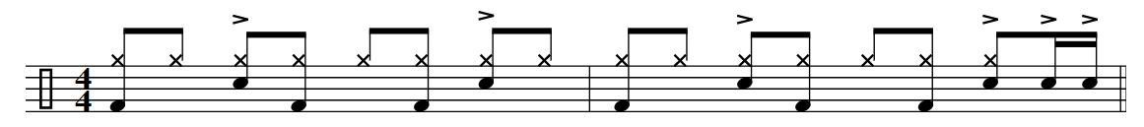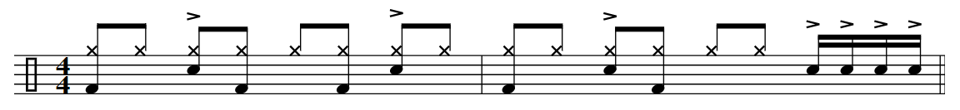

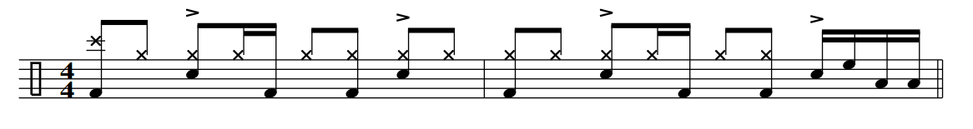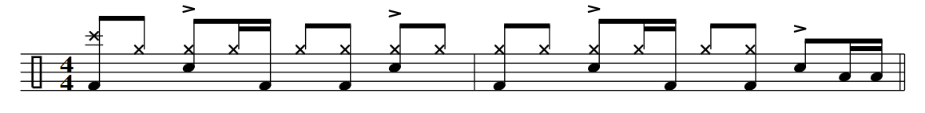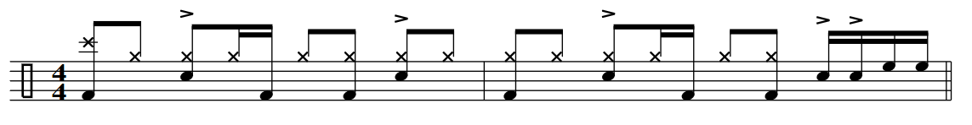

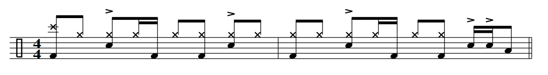

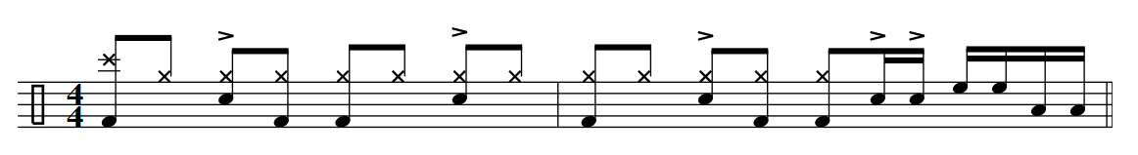

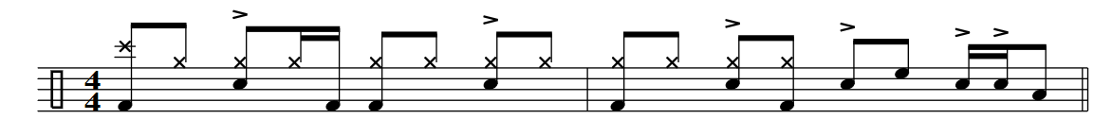

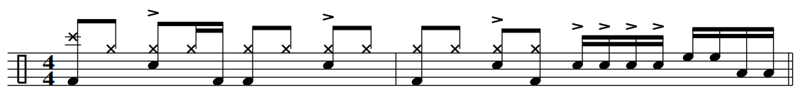

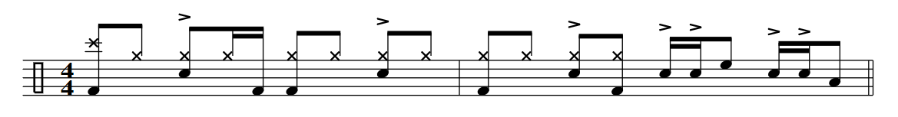

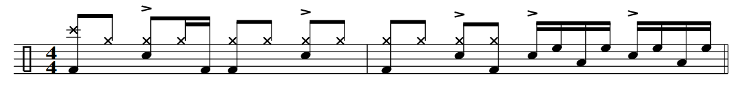

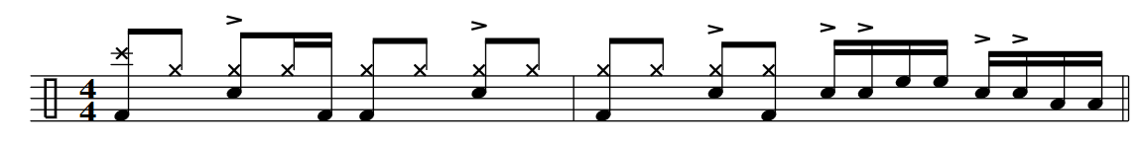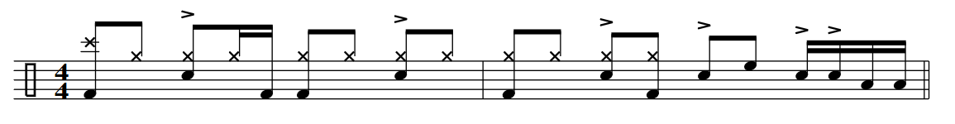

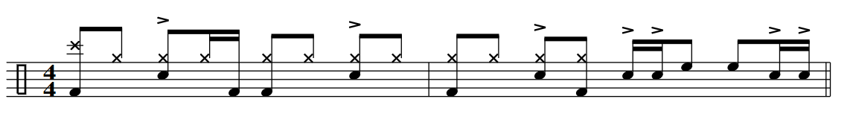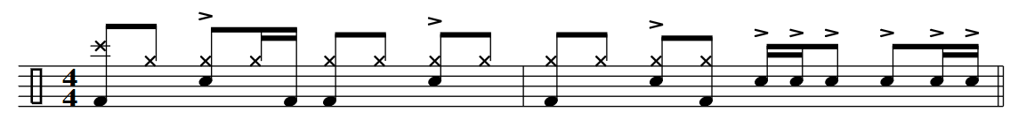

Fills and Drills…

& a fills… 

4E&A…

New Stuff

