2and4 Drums

By Demitri Mannos

Pdf version of 2and4 Drums available at:

[www.2and4drums.com](http://www.2and4drums.com)

Here we go…

Hi-Hat

Tempos: 70, 86, 90, 96, 110, 128, 60. 50

1/4 Notes…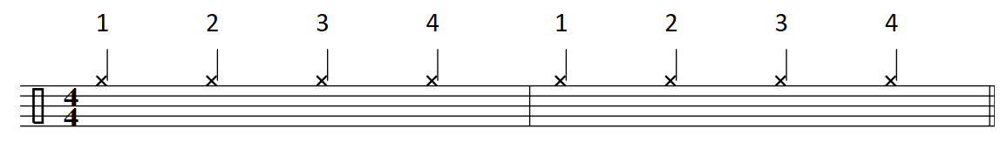Shank Tip…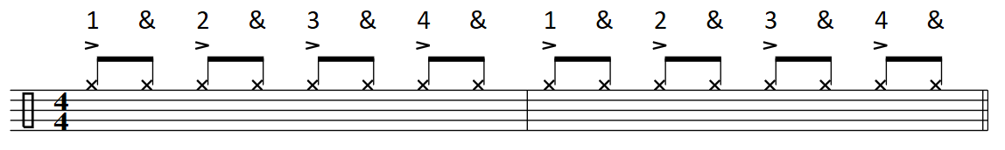Shuffle… 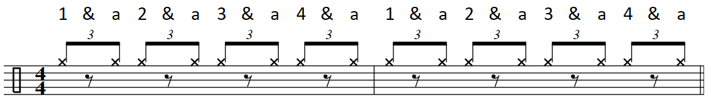 One Hand 16th Notes… 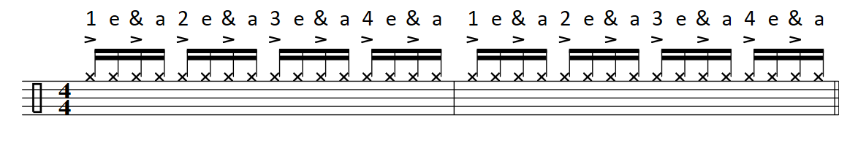Two Hand 16th Notes… 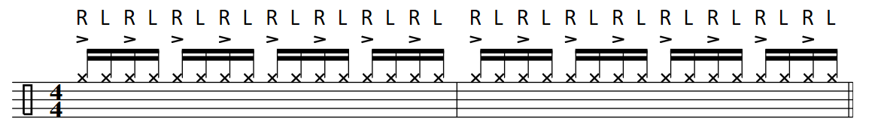Hi-Hat w/Foot…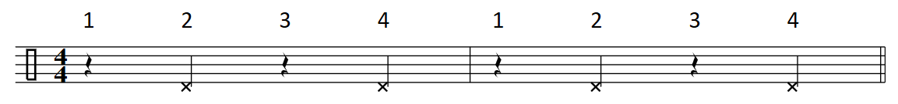Open Hi-Hat… 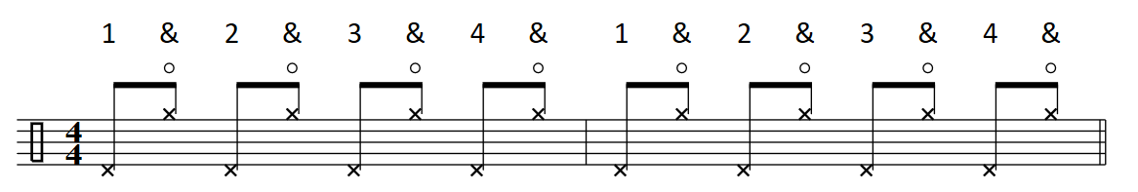

Snare

2and4…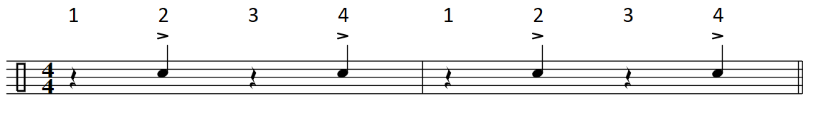Flam…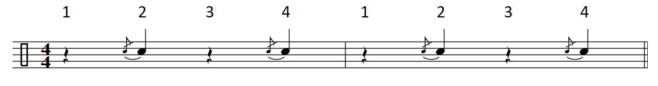Ghost Note…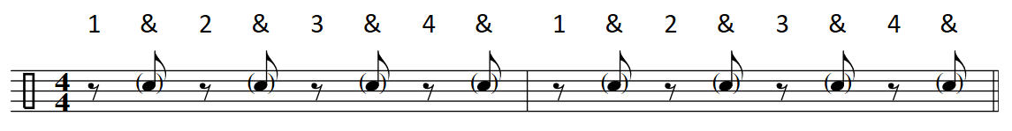Cross Stick… (X Stick)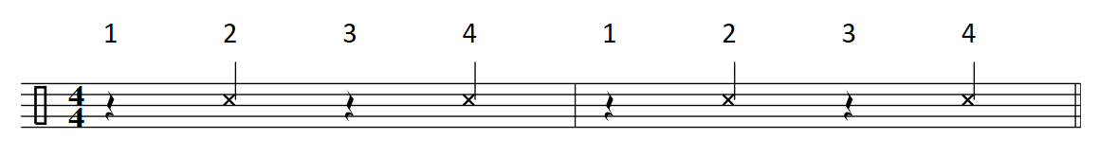Buzz…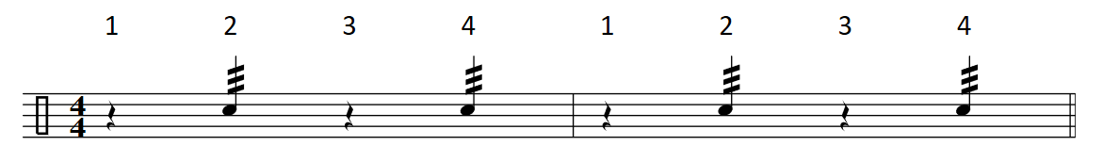

Kick

Tempos: 70, 86, 90, 96, 110, 128, 60.

8th Note Kick Drum Mini Grid… 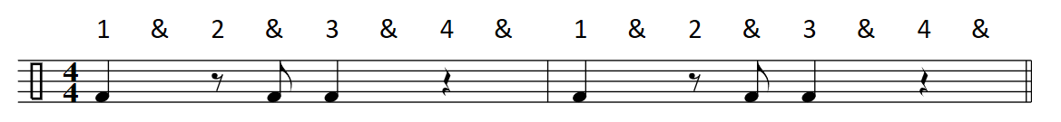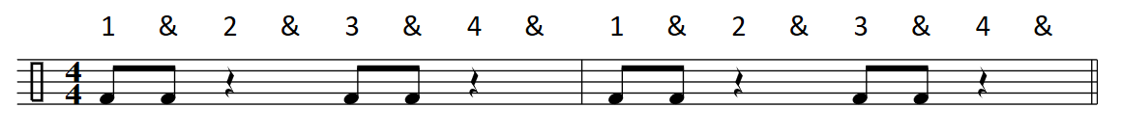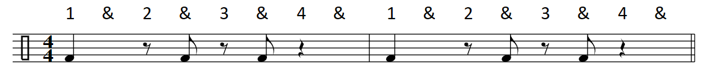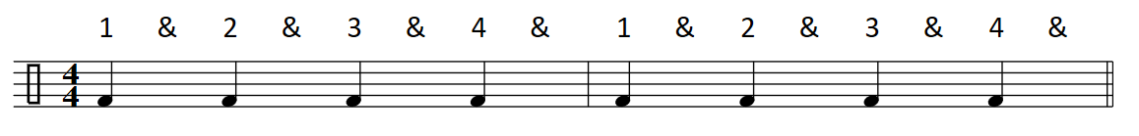

Skeleton Clave’…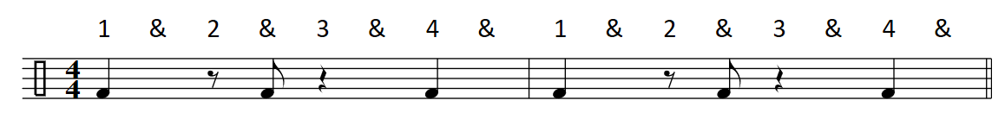

Ride Cymbal

Ting Ding A’ling… 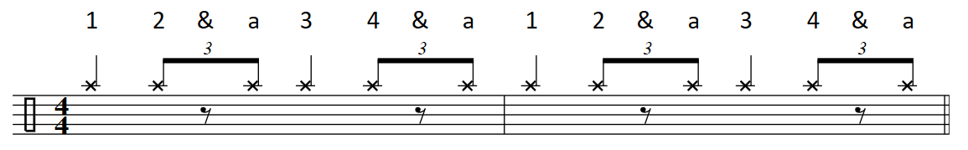

Bell/Ride… . 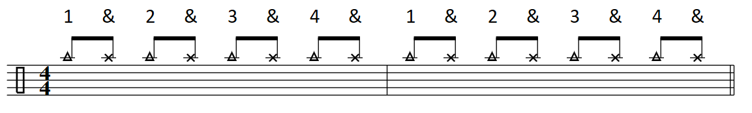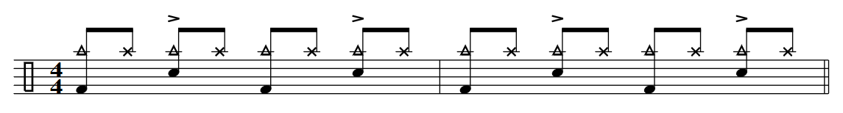

Ride/Bell… 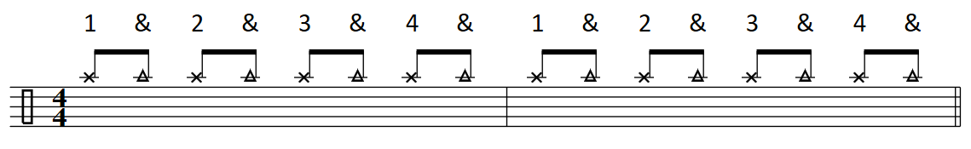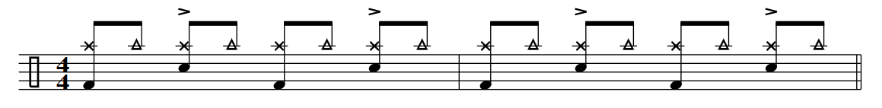

16th Note Ride Pattern…

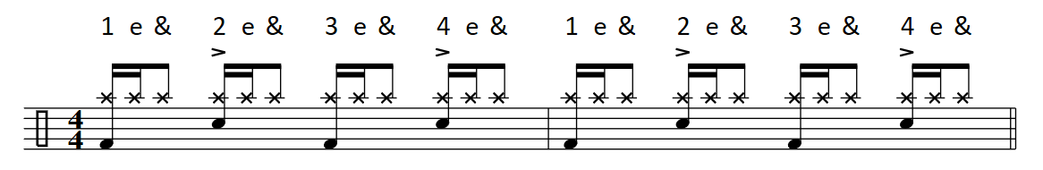

Toms and Floor Tom

Rack Tom(s)…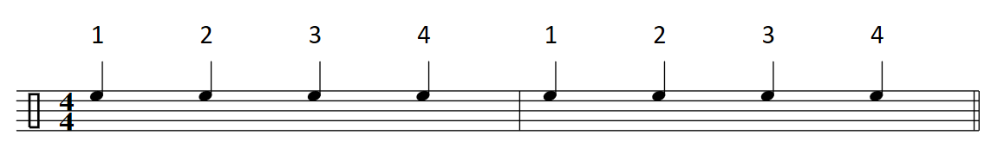Floor Tom(s)… 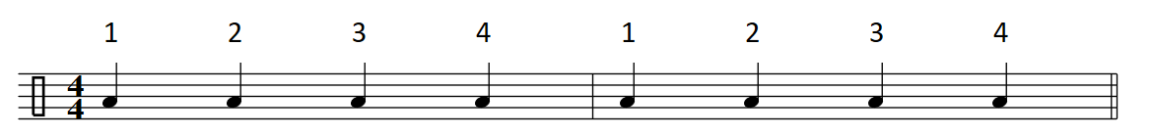

Getting Around the Toms… 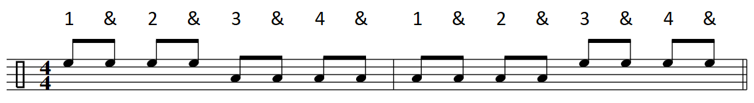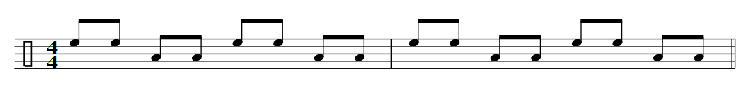

Double Stops… 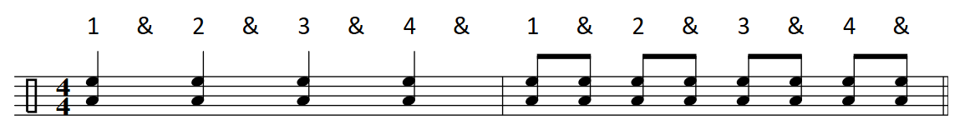

Tribal!…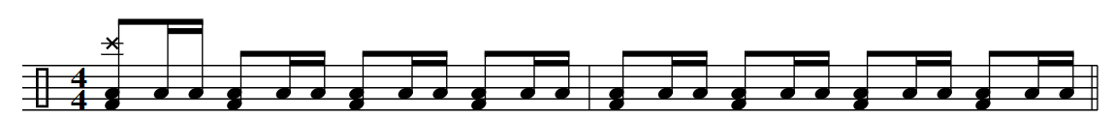

Tribal! #2…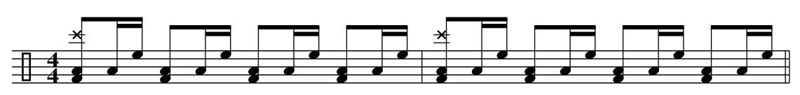

Subdivision Grid

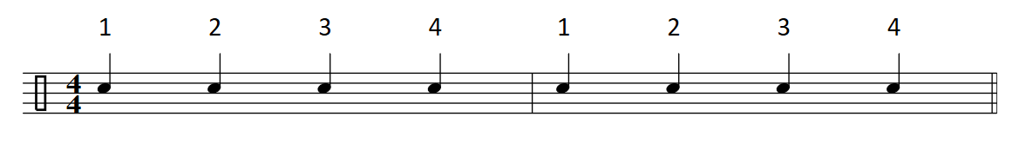 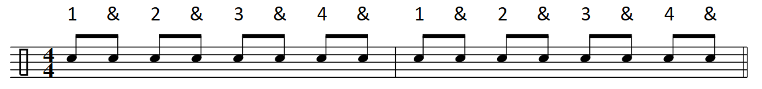 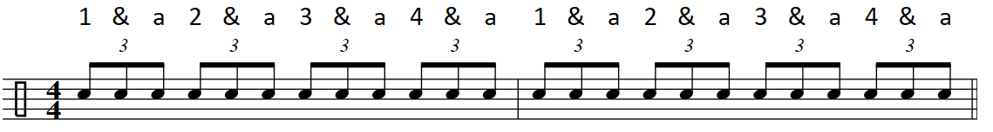 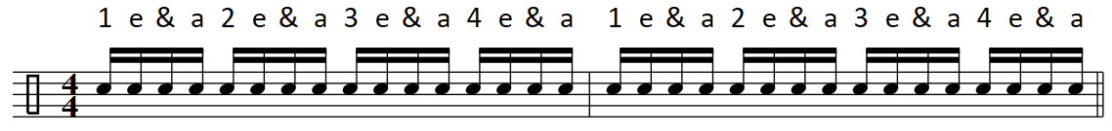 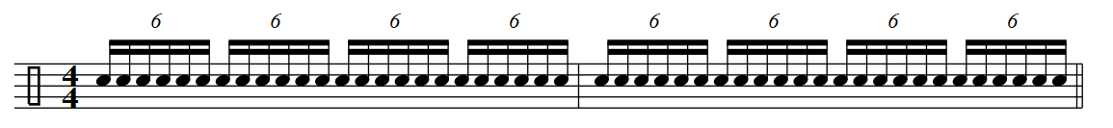

With a Pulse… “A rythynm without a pulse, doesn’t have a purpose.” 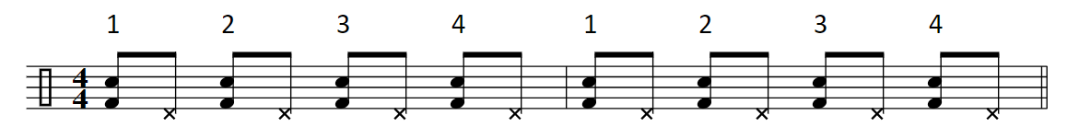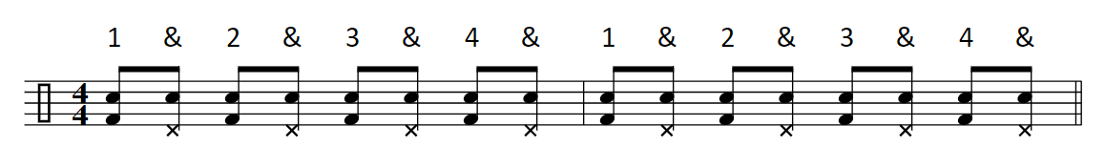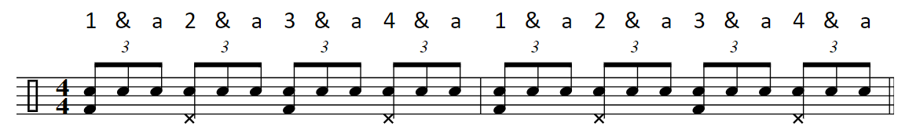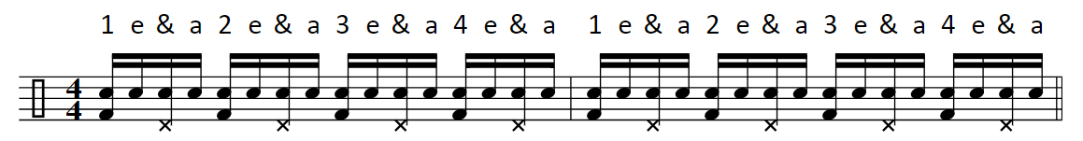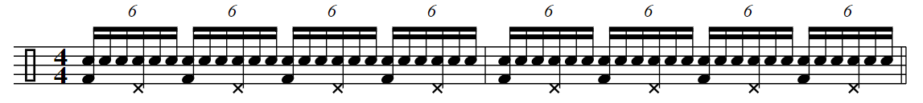

8th Note Hi-Hat Grooves

Tempos: 70, 86, 90, 96, 110, 128, 60

Shank Tip… 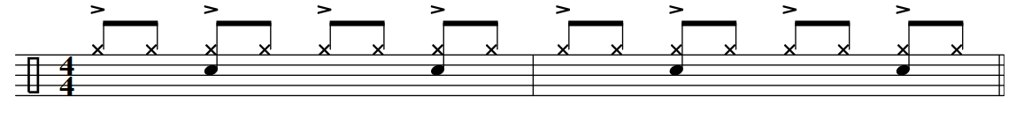

Tip Shank…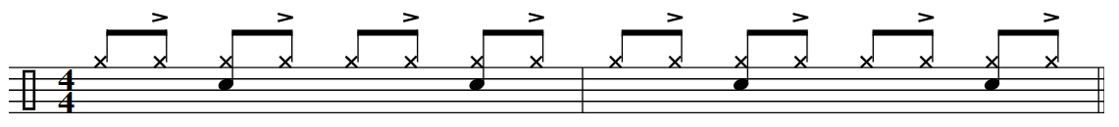4 on the Floor… 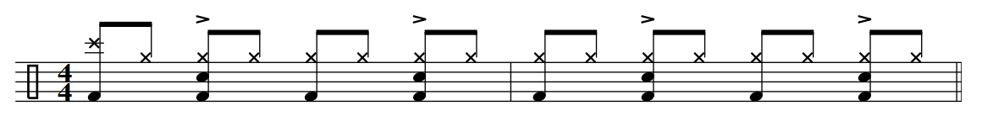

4 Top…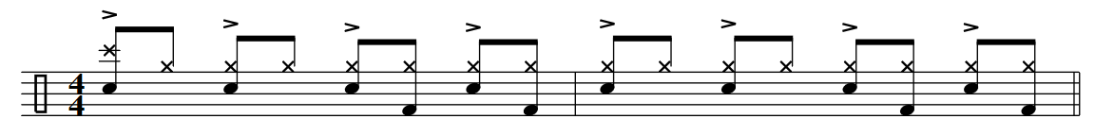

Surf City…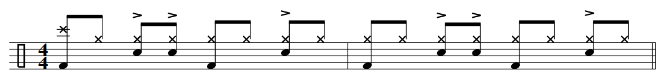

Funky Drummer…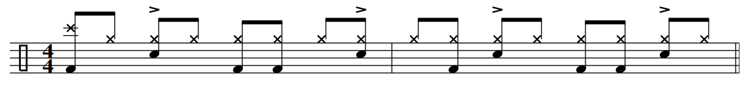

1. 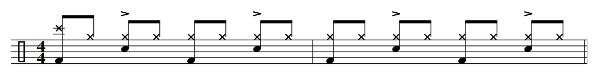2. 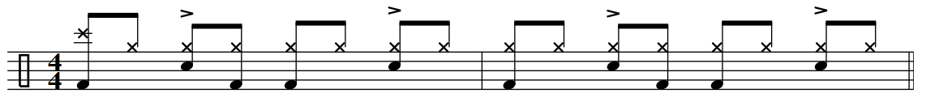3.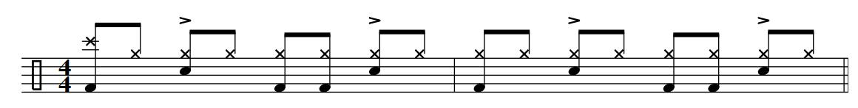4. 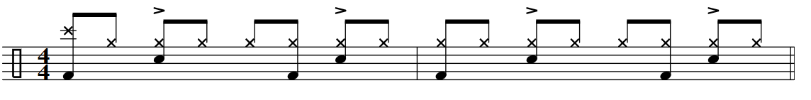5

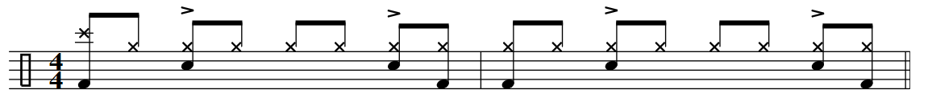6.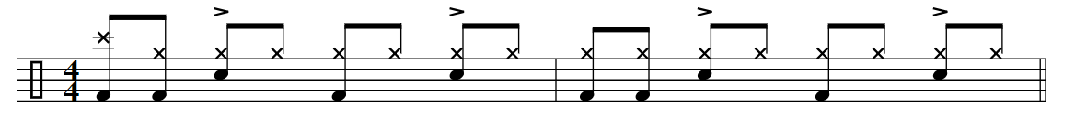7.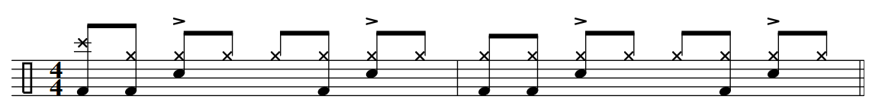8.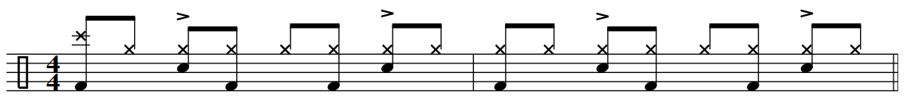

9.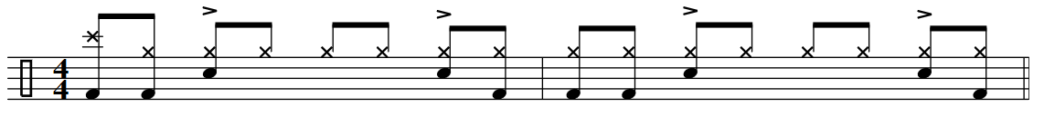10. 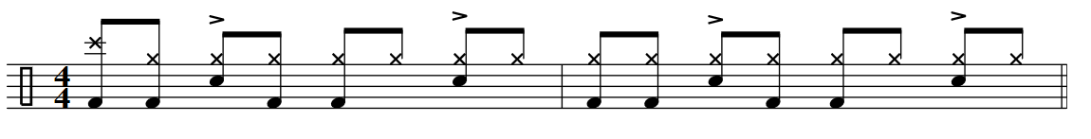

11.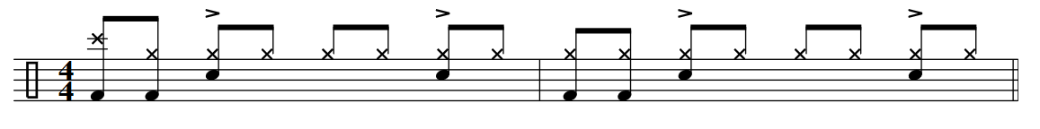12.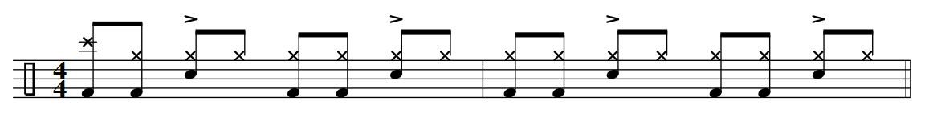13. 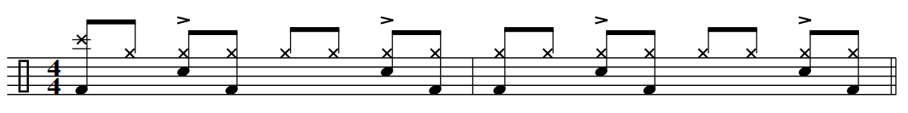 14. 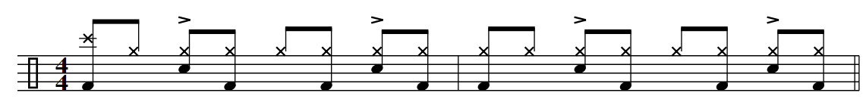15. 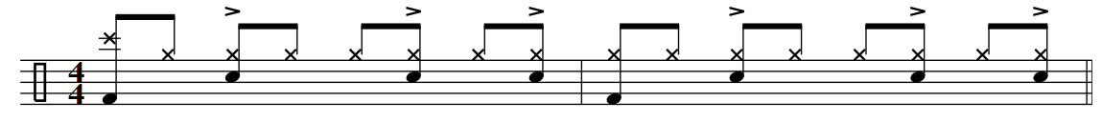16. 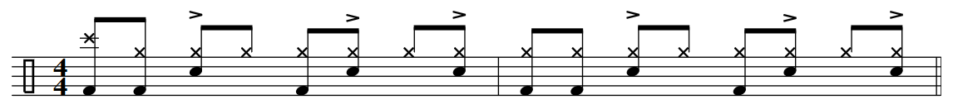

17. 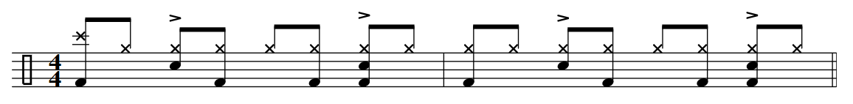18. 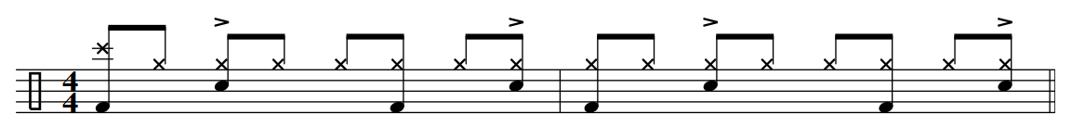

19. 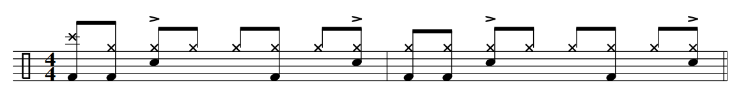20. 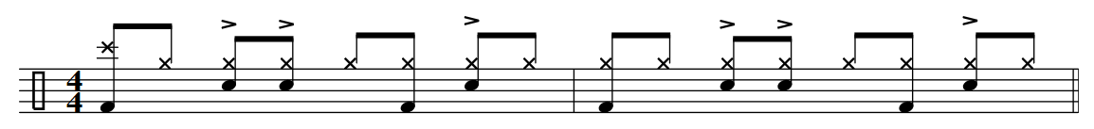

21. 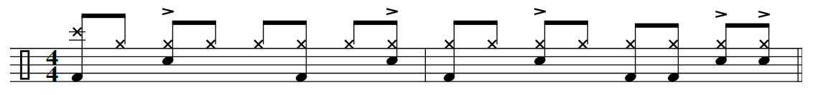

22. 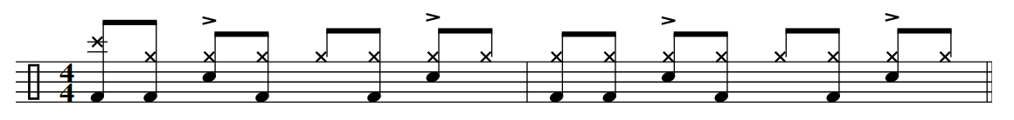

Quarter ¼ Notes

Quarter Note Limb Grid

Right Foot: Kick. Left Foot: Hi hat. Right Hand: Floor Tom. Left Hand: Snare.

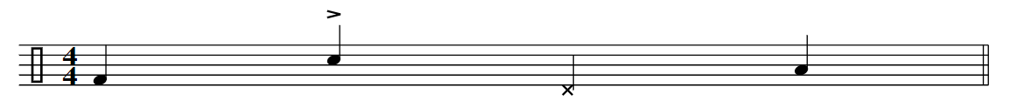

Right Foot: Kick. Left Foot: Hi Hat. Right Hand: Hi Hat. Left Hand: Snare. 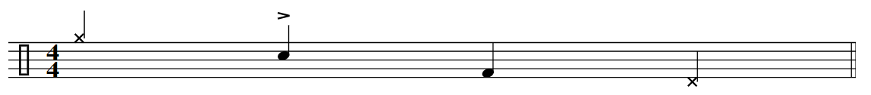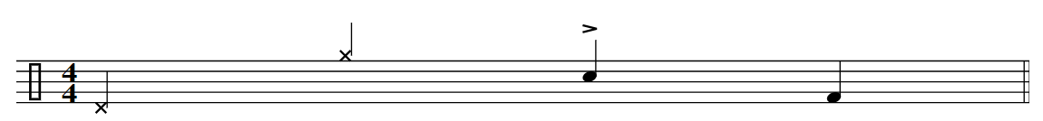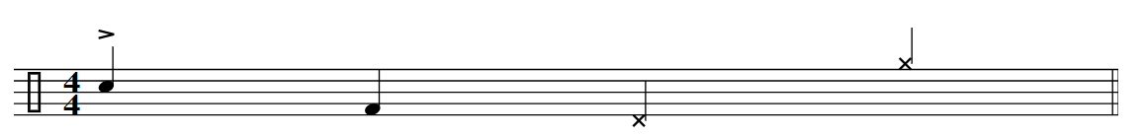

1. 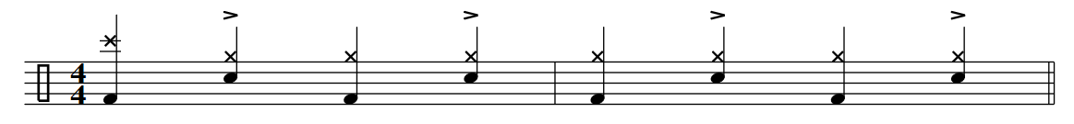2. 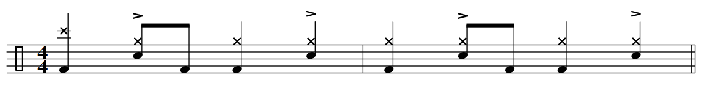3. 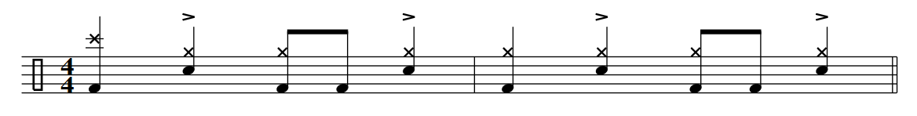4. 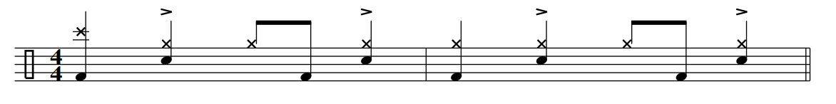5. 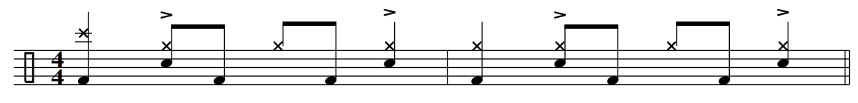6. 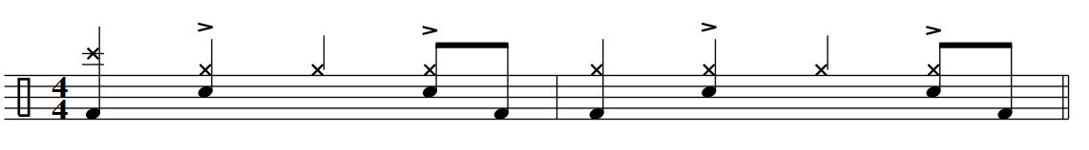7. 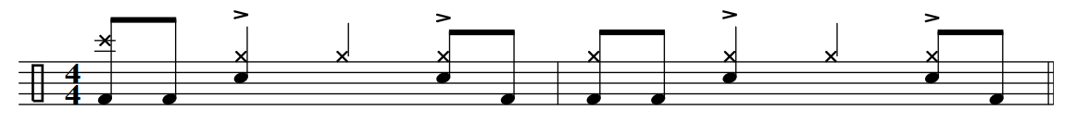8. 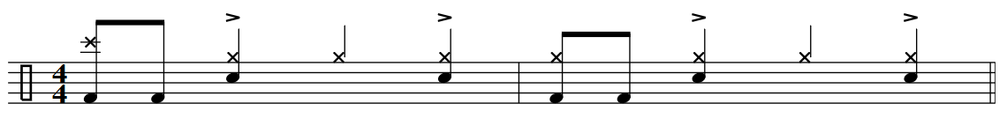

9. 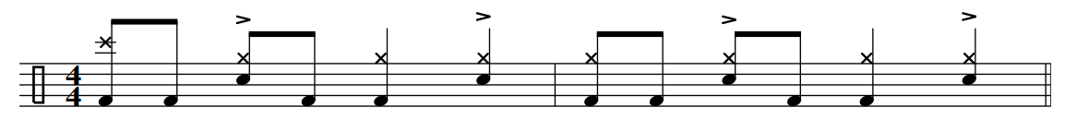

10.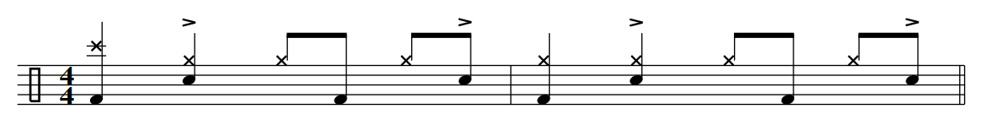11. 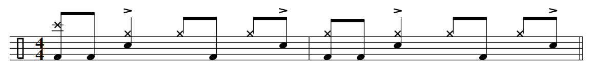12. 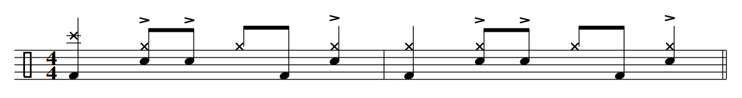13. 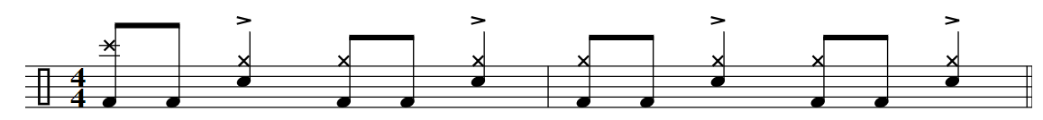

14. 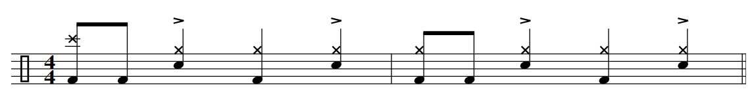

8th Note Short Fills

Tempos: 70, 86, 90, 96, 110, 128, 60

1.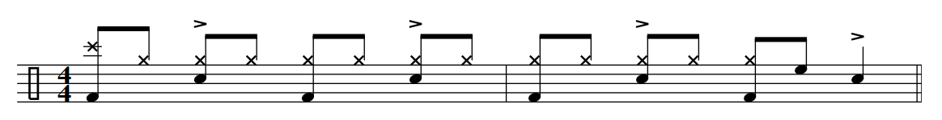2.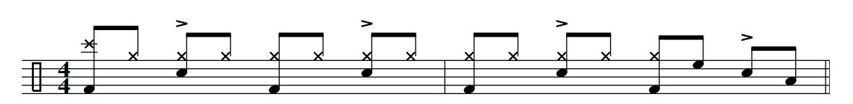3.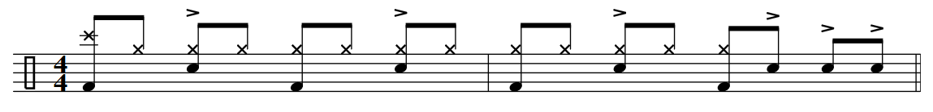 4.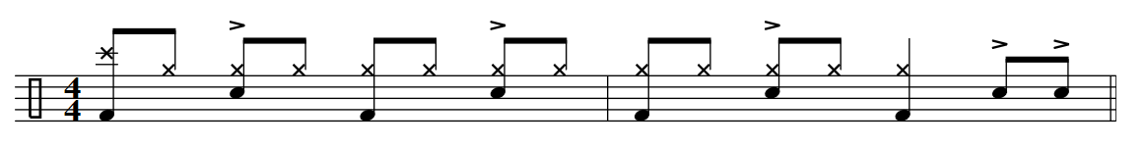

5. 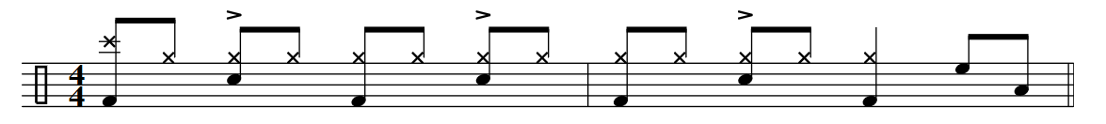

6. 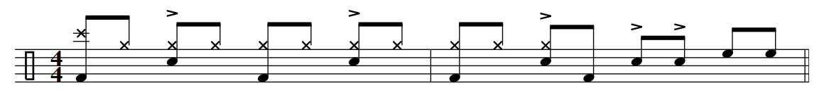

8thNote Long Fills

Tempos: 70, 86, 90, 96, 110, 128, 60.

Around the kit…

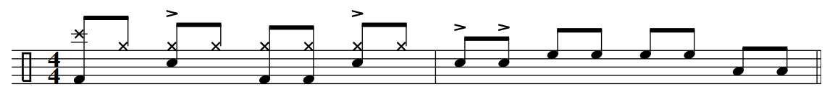 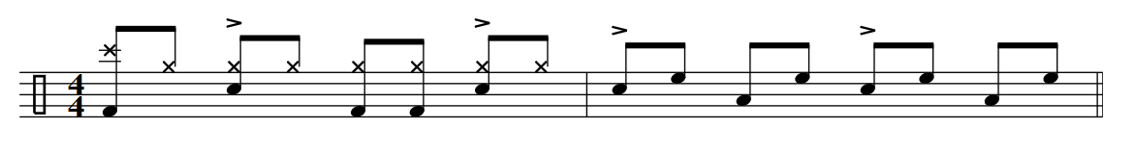

Hand / Foot Combo… 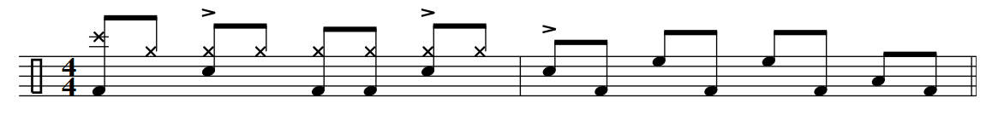 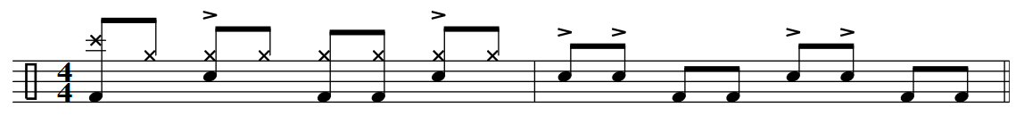

1. 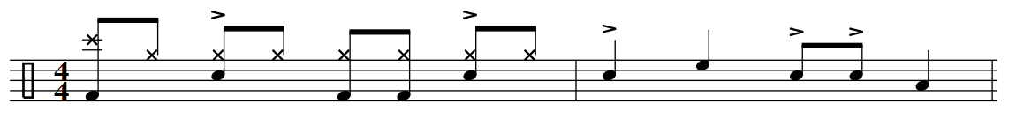2. 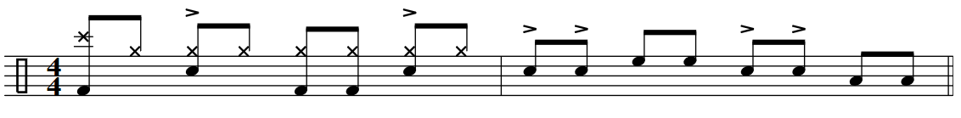3. 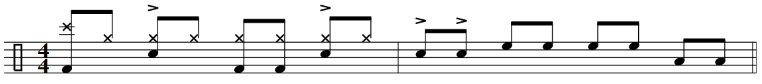4. 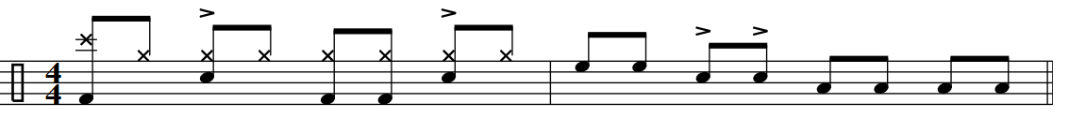5. 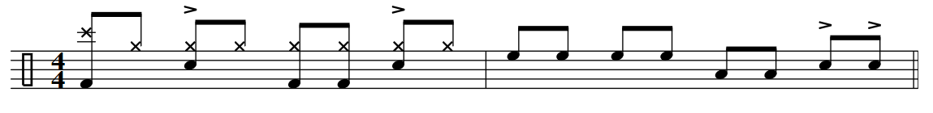6. 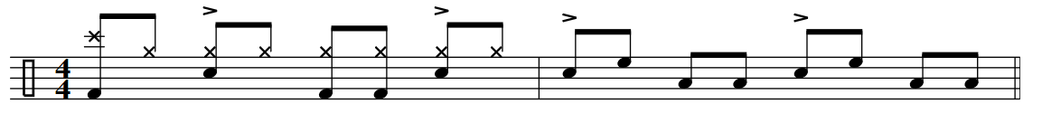7. 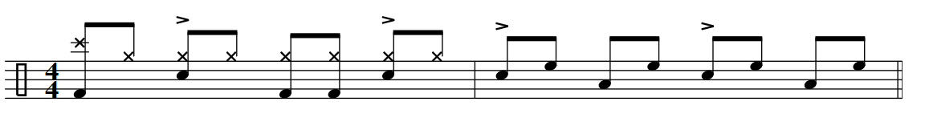8. 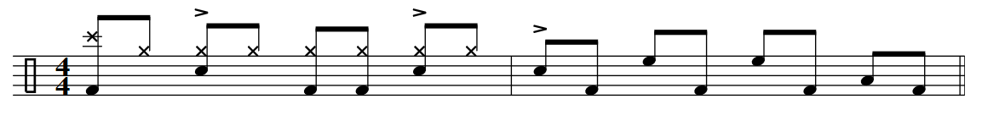9. 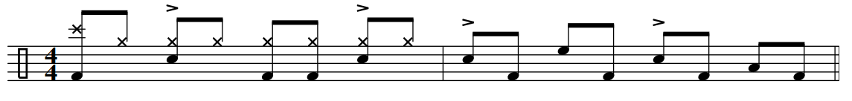

10. 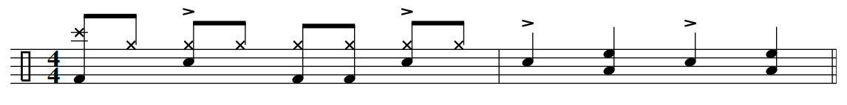11. 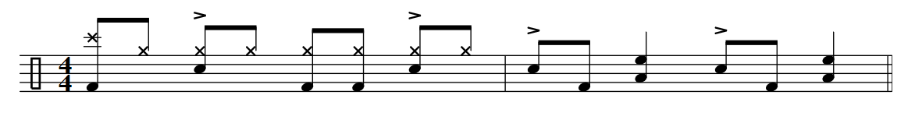12. 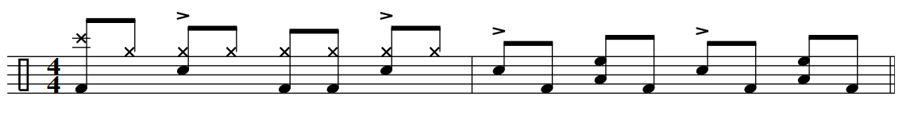13. 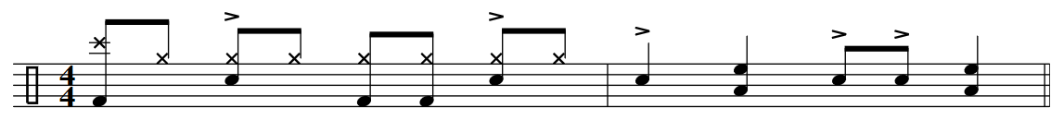14. 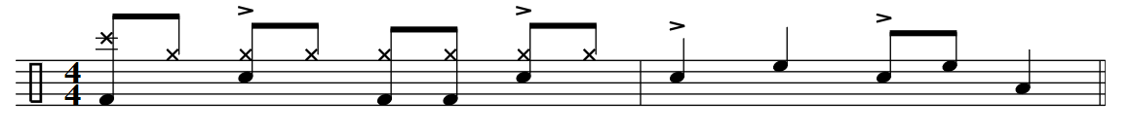15.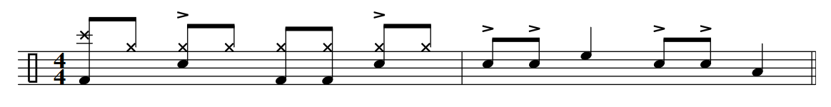16.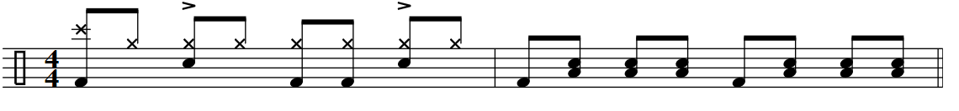

17.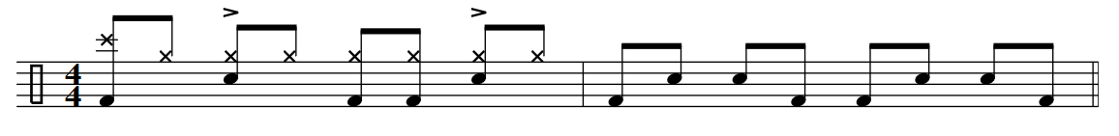18.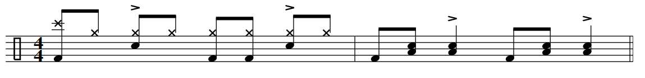

19. 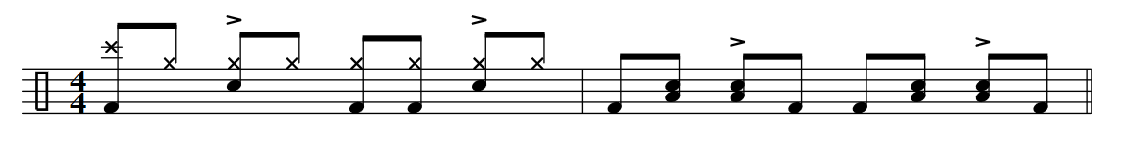 20.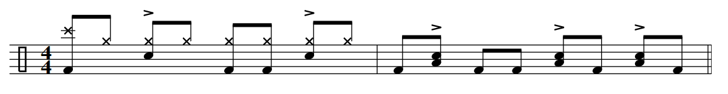

21. 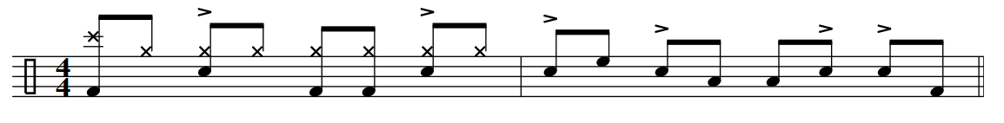

22. 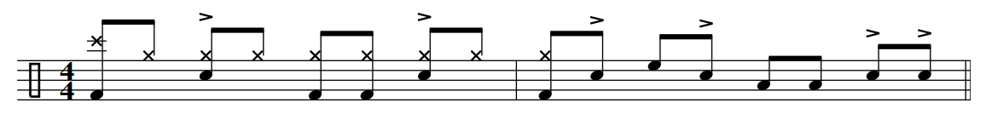

8th Note Grooves with Hits

1.

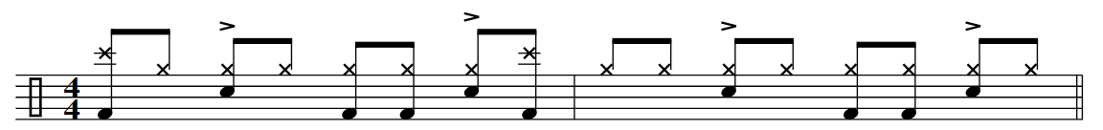

2.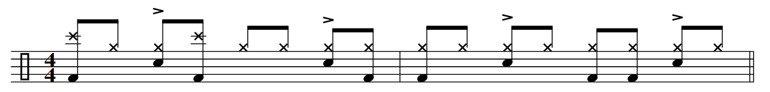

3.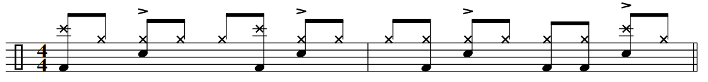

4.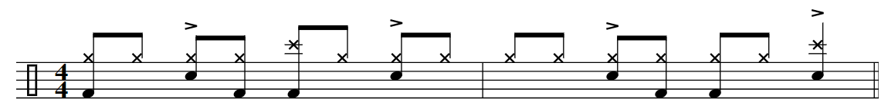

5.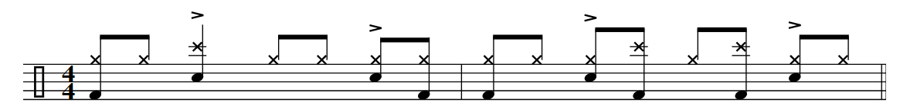

6.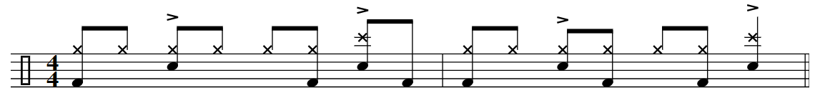

7.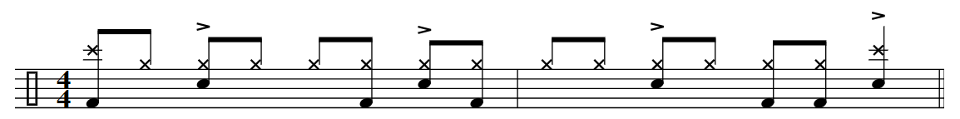8.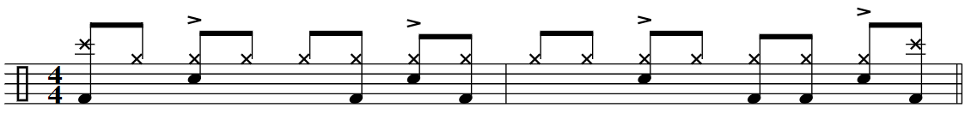

Flam / Kick

Tempos: 70, 86, 90, 96, 110, 128, 60.

Grooves…

1.2.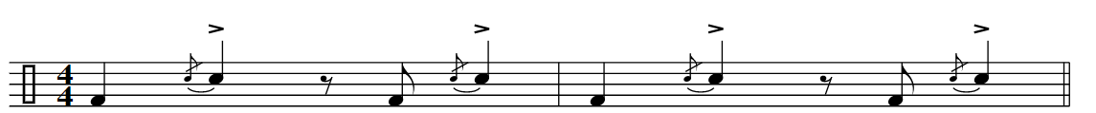3.4.5.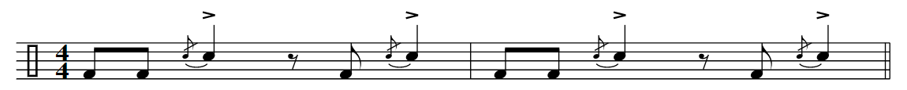6.7.8.9. 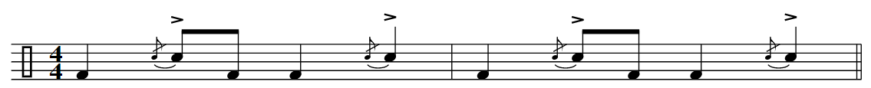

Fills…

1.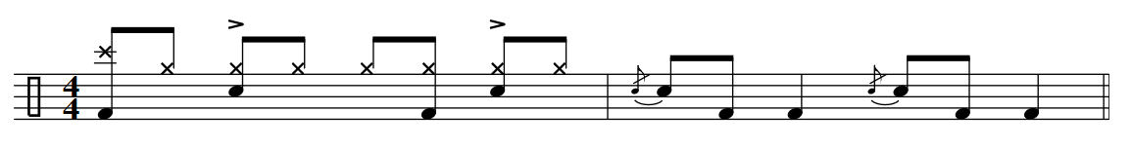2. 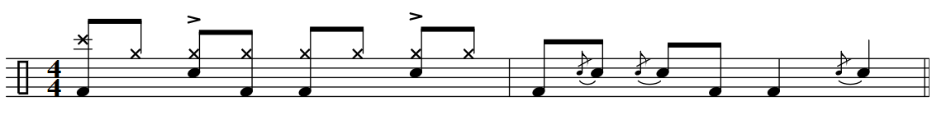3.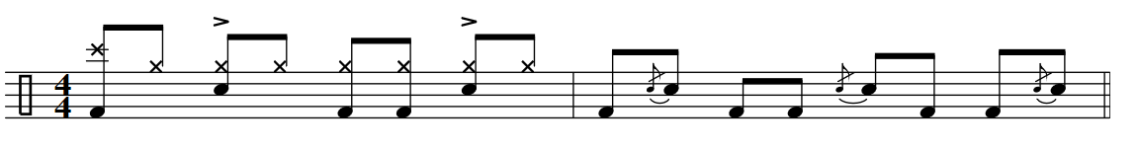4.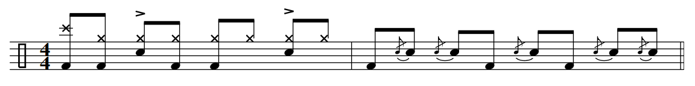5. 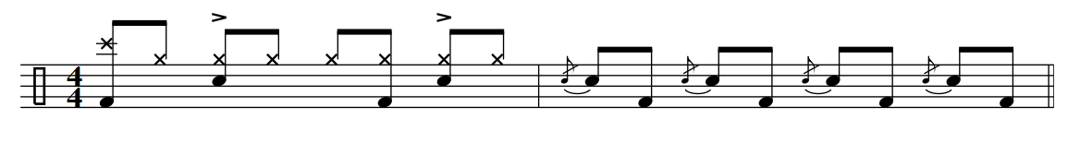6. 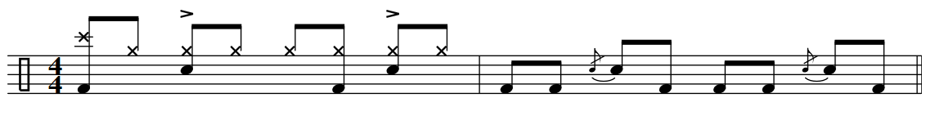7. 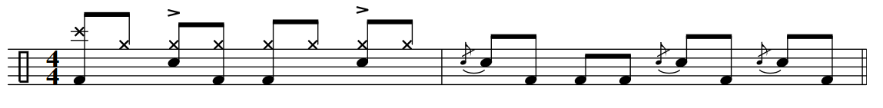8.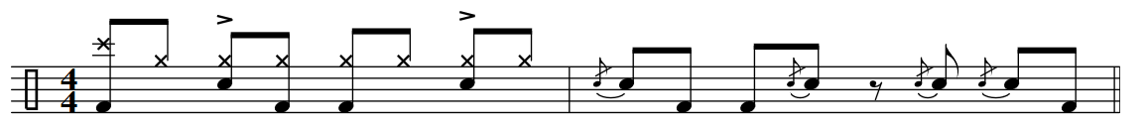9. 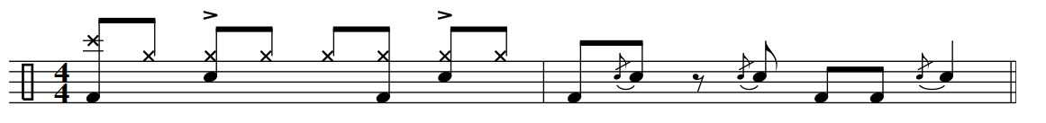

10.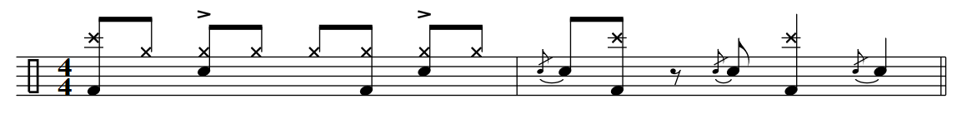11.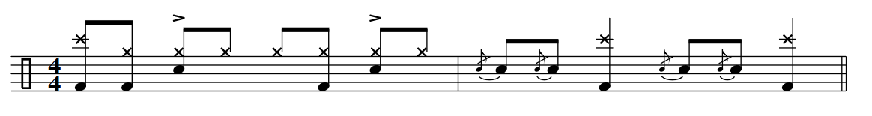12.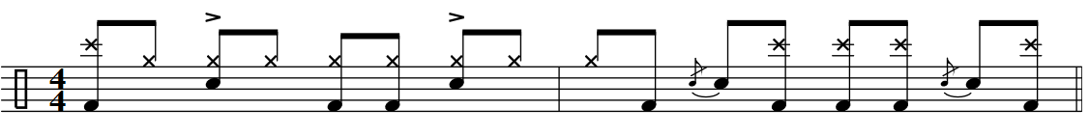13.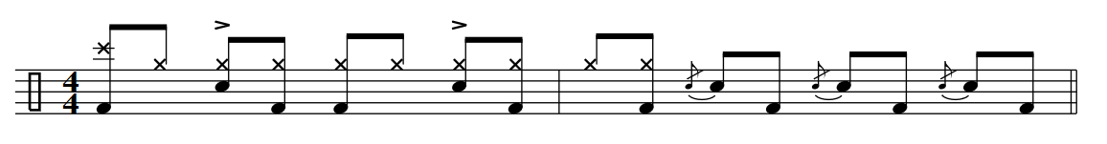14. 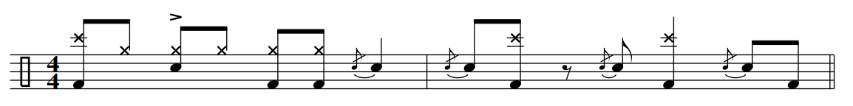15.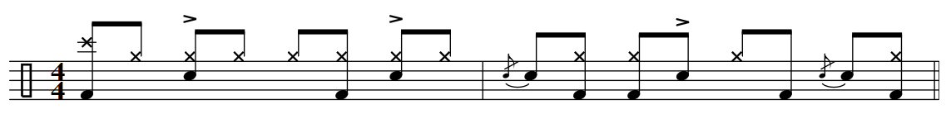16.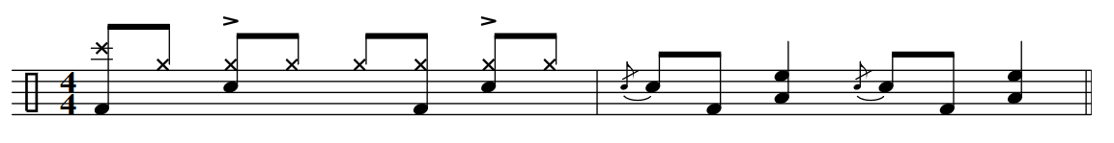17. 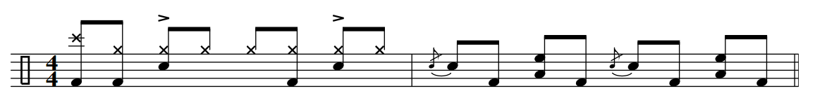

18.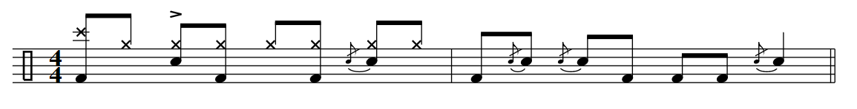

19. 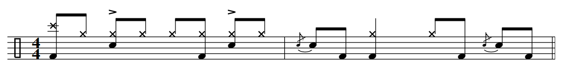

8th Note open Hi-Hat Grooves

Tempos: 70, 86, 90, 96, 110, 128, 60.

The Process

Up-Beat Open Hi/Hat… 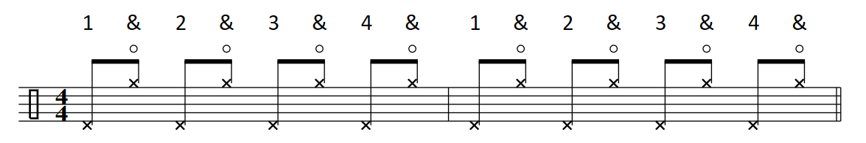 Snare 2/4… 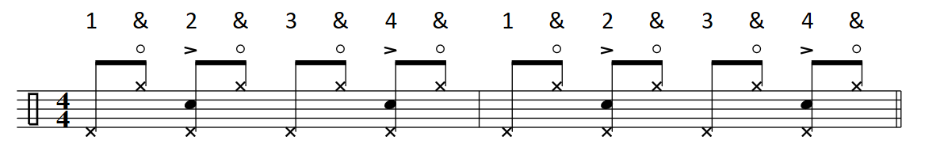 Kick 1/3… 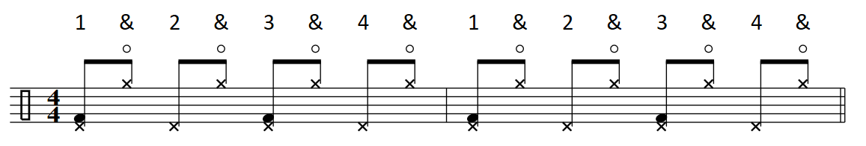

Disco Inferno… 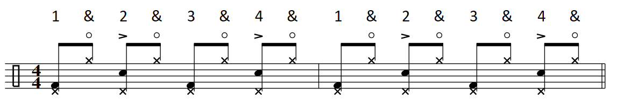

1.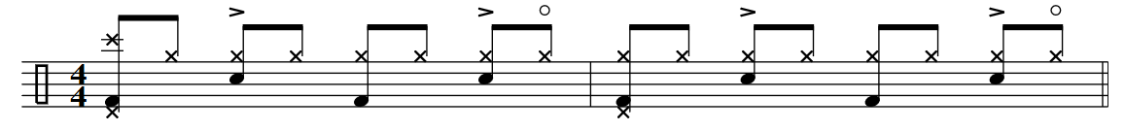2. 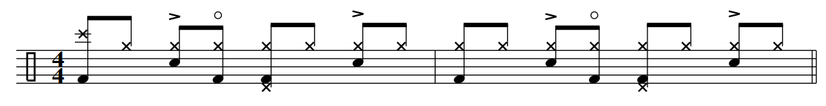3. 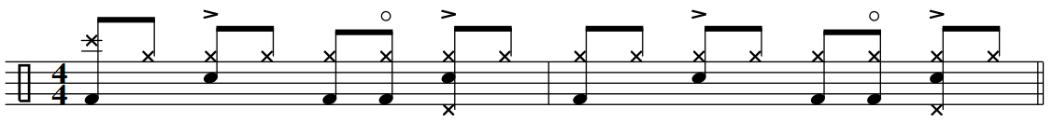4. 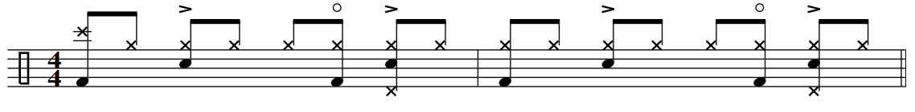5. 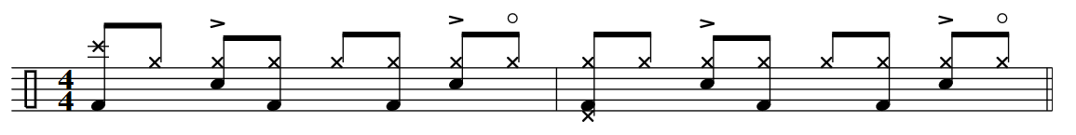6. 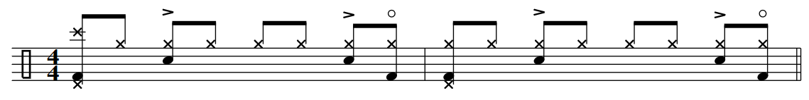7. 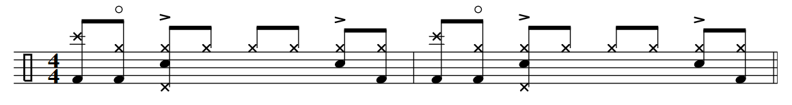8. 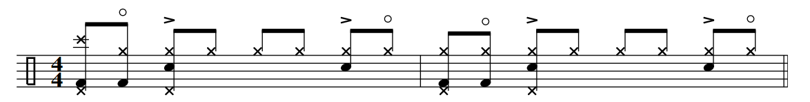9. 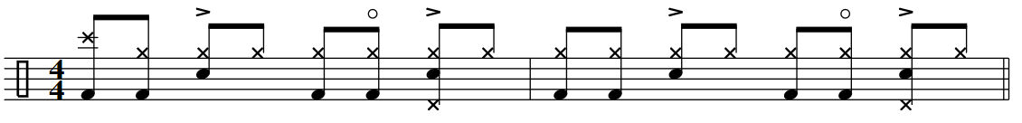

10. 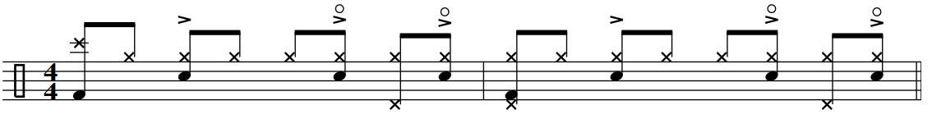

11. 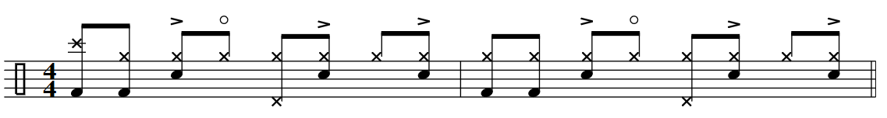

12. 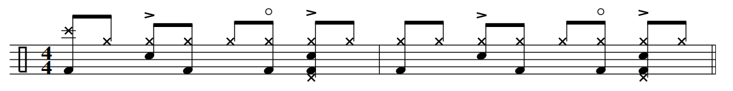

13. 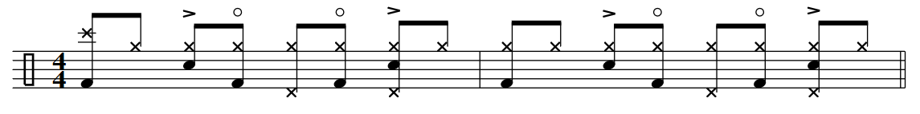

8th Note Grooves with Hits

Tempos: 70, 86, 90, 96, 110, 128, 60

.1.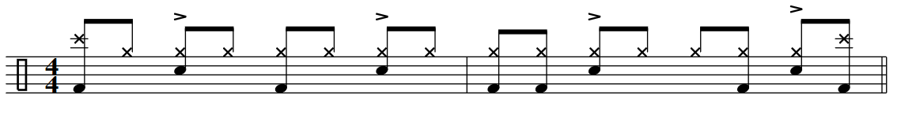2.

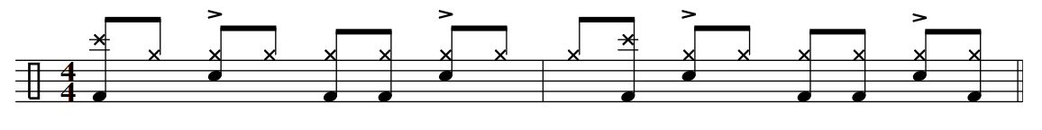3.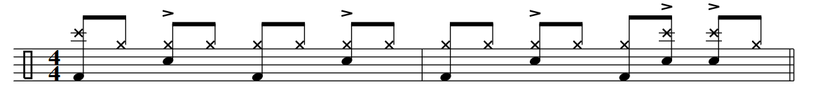4.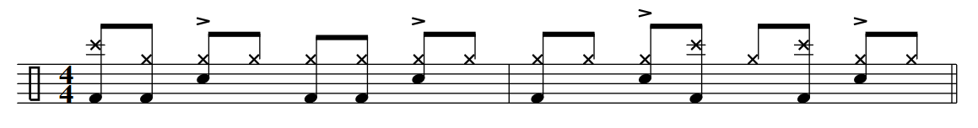5.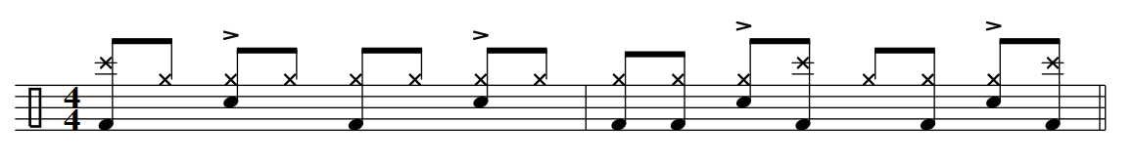6. 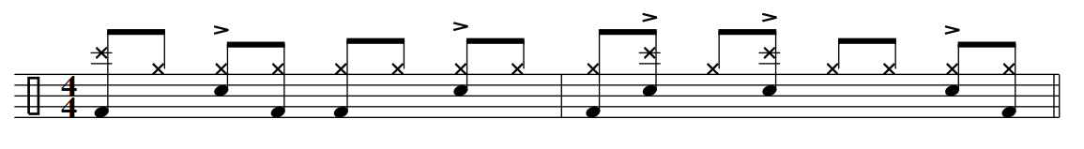

7.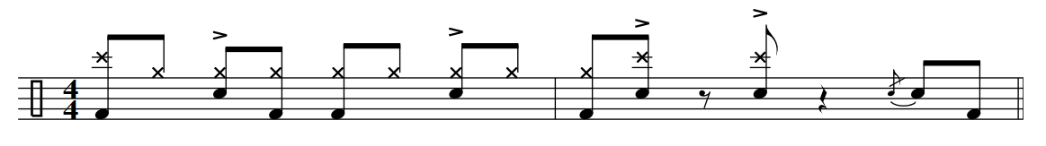

Single Hand 16th Note Hi-Hat Grooves

Tempos: 46, 52, 65, 76,

The grid…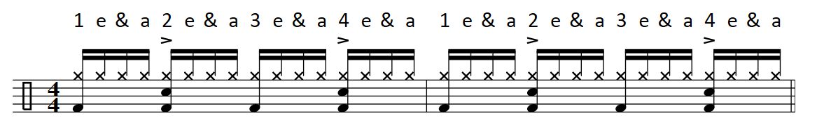 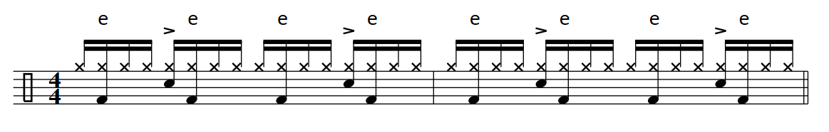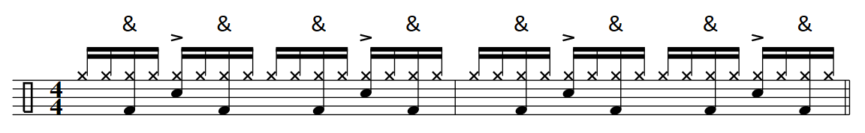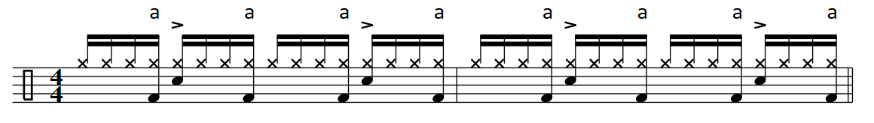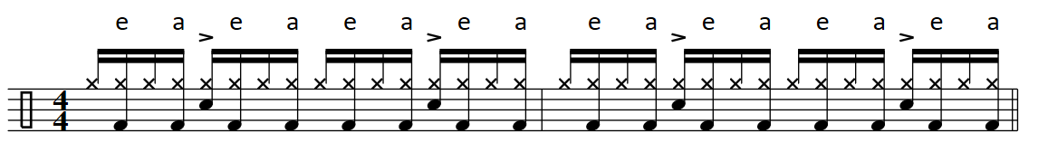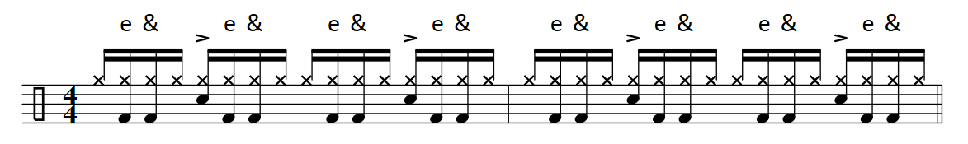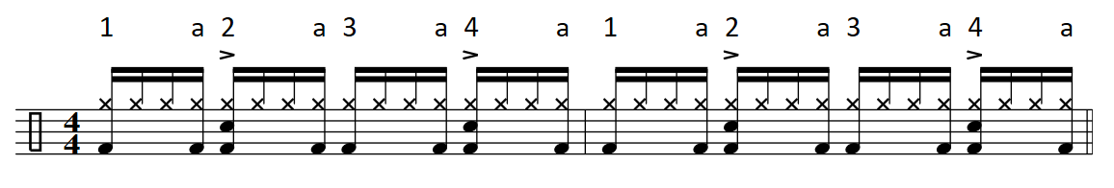

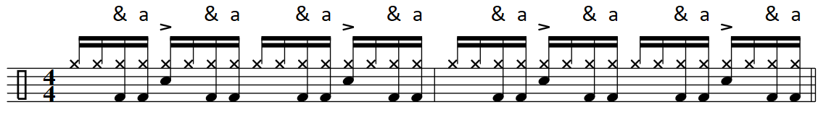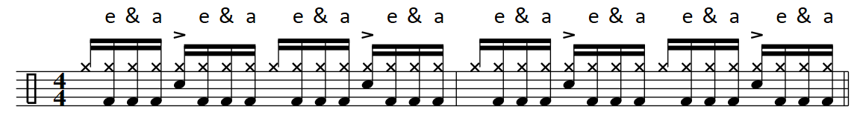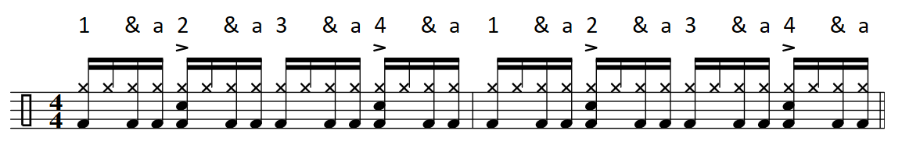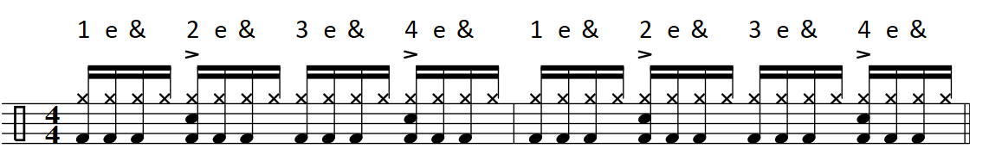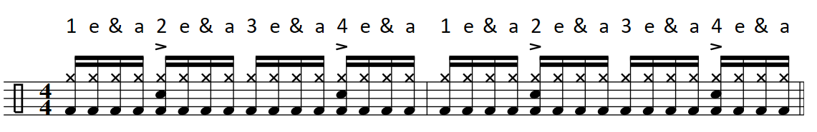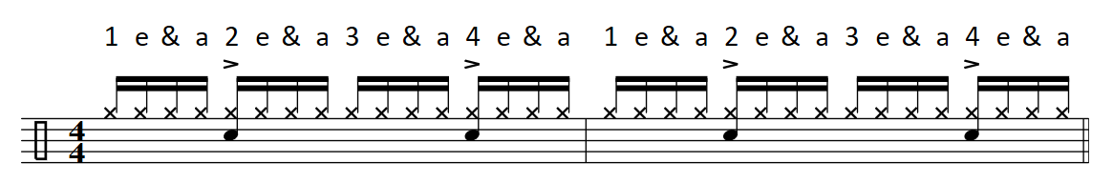

1.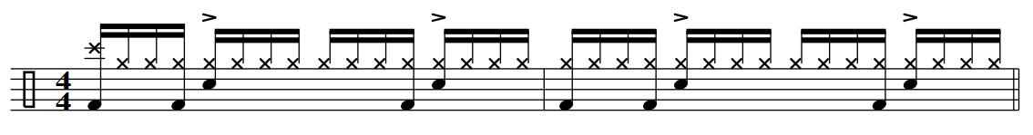2.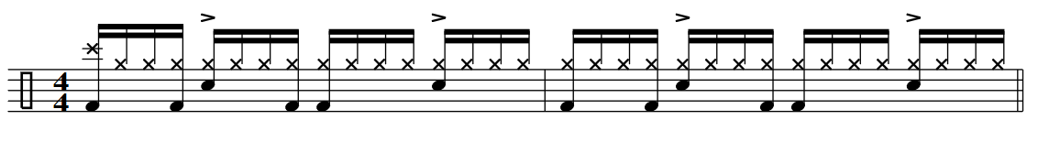3.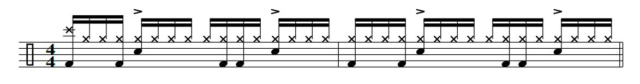4.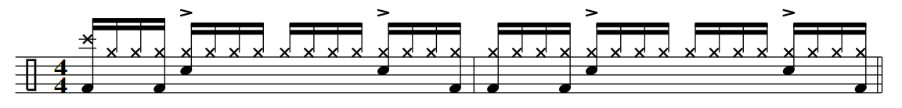5.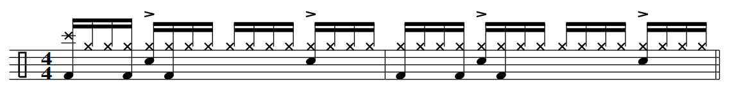6.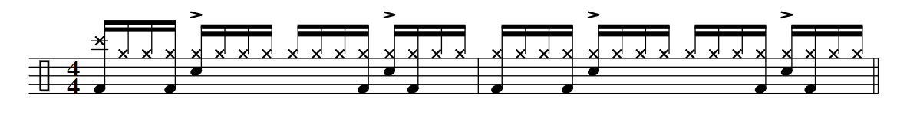7.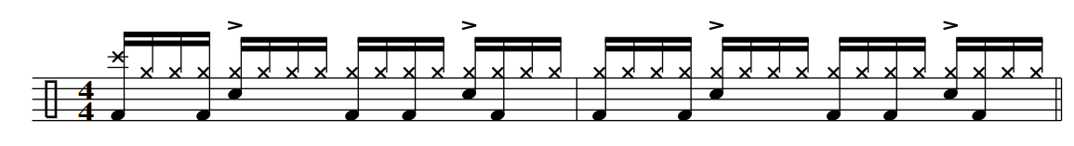8.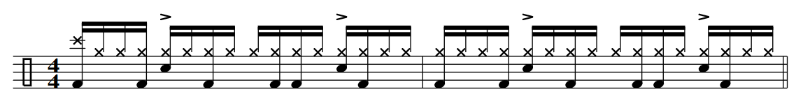

9.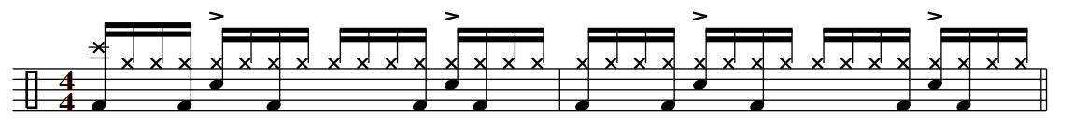

10.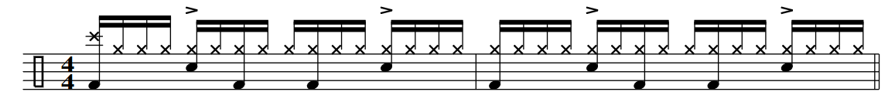11.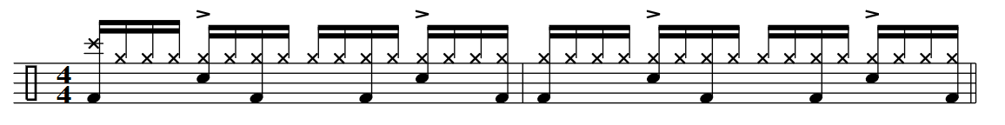12.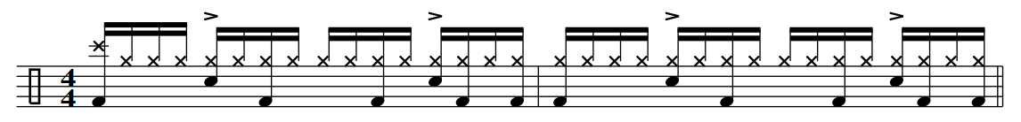13.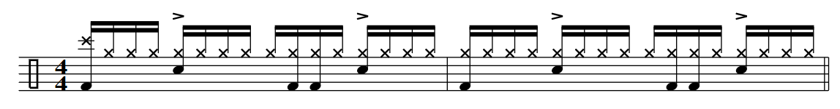14.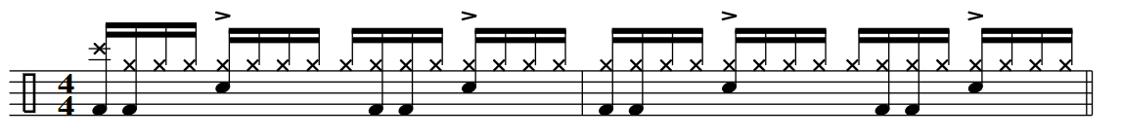15.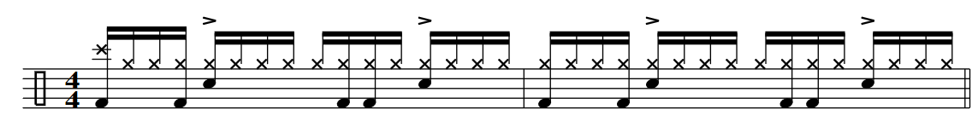16.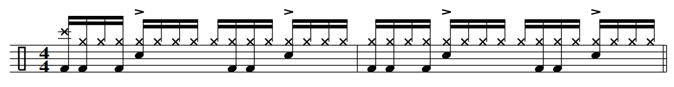

17.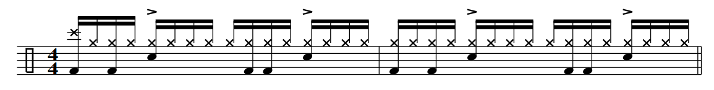

18.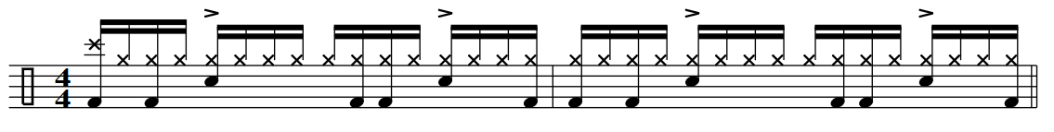19.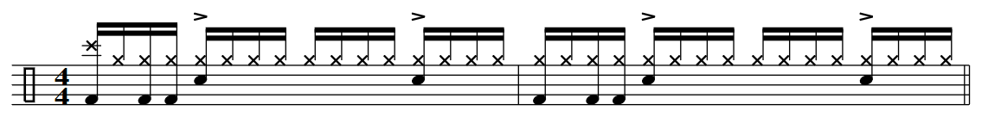20.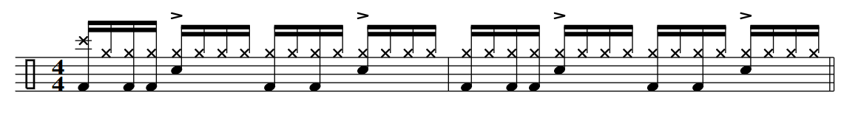21.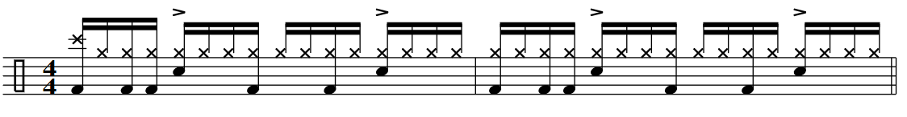

16th Note Grooves 8th Note Hi-hat

Tempos: 50, 62, 76, 87, 90, 96, 100

The Process

16th Note Mini Grid…

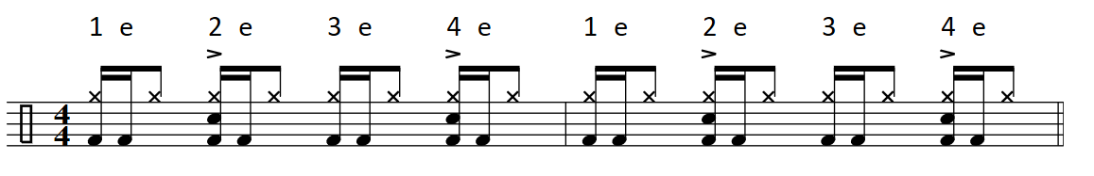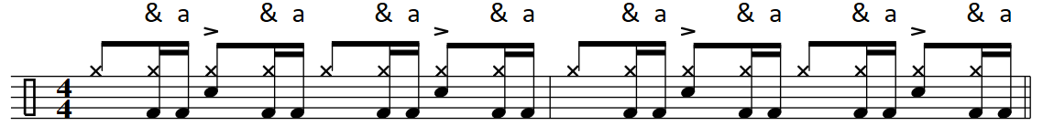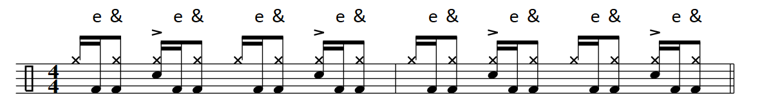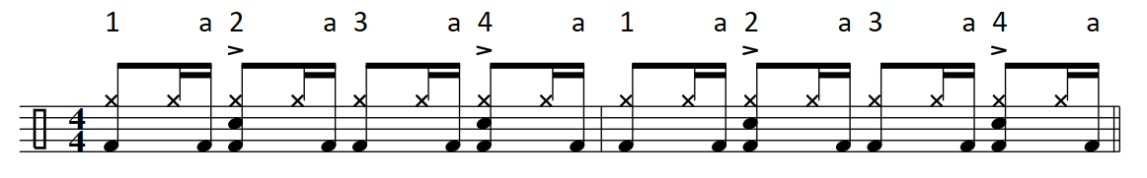

1.

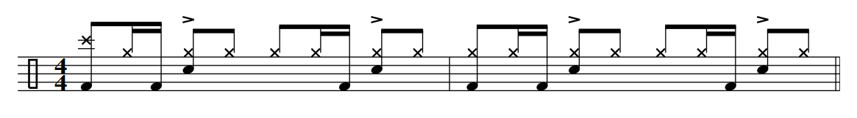2.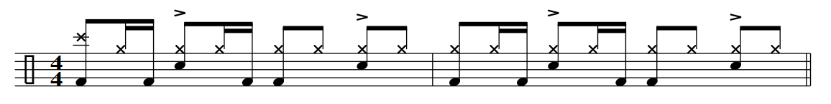3.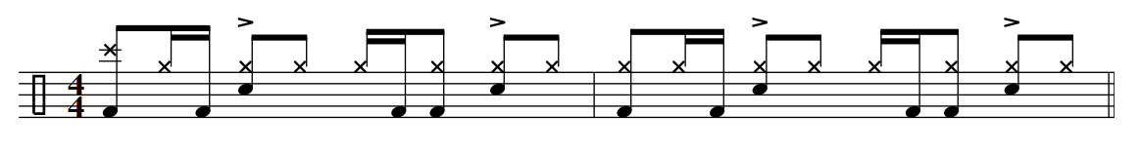

4.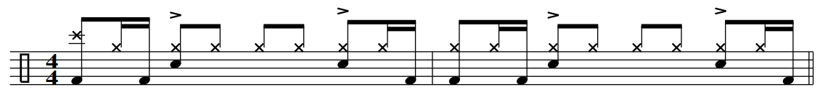5.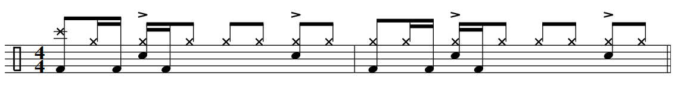6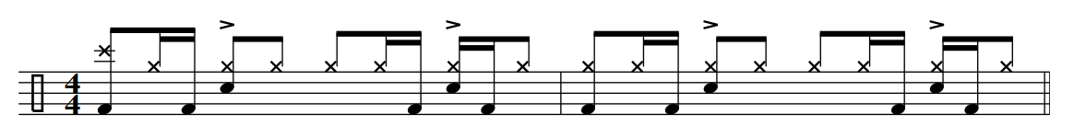7.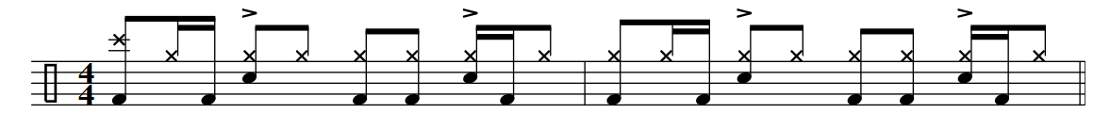8.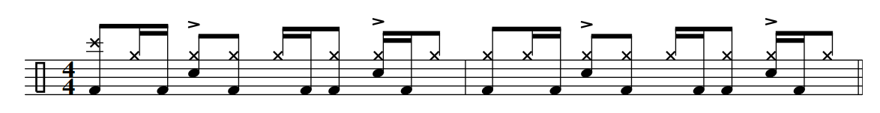9. 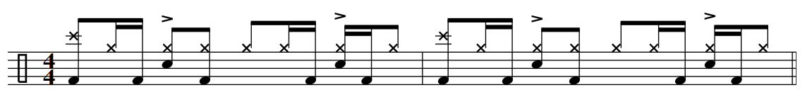

10. 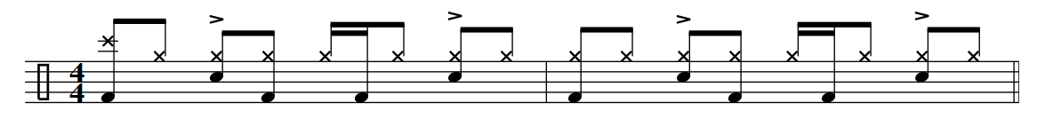

11. 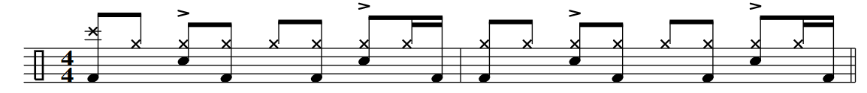

12. 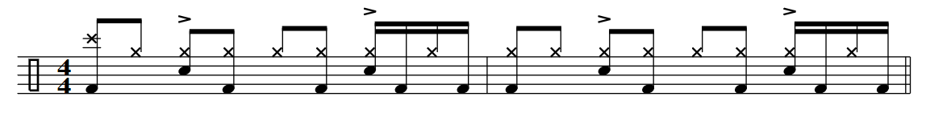

13. 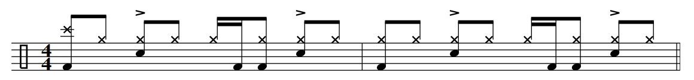

14. 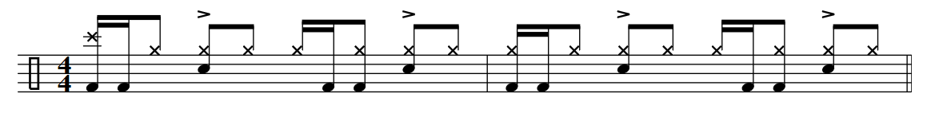

15. 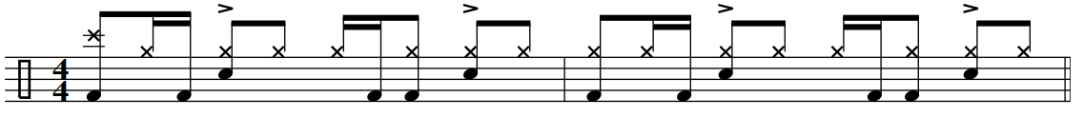

16. 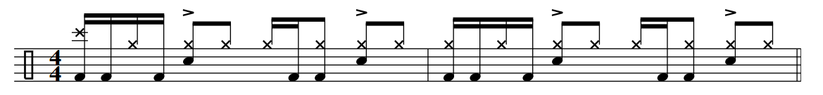

17. 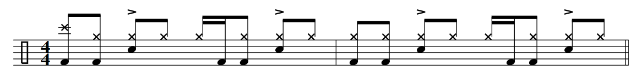

18. 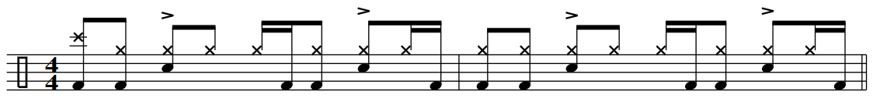

19. 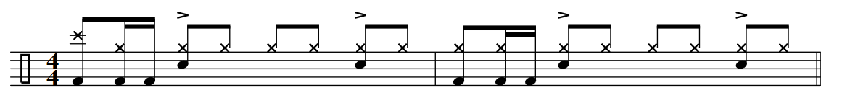

20. 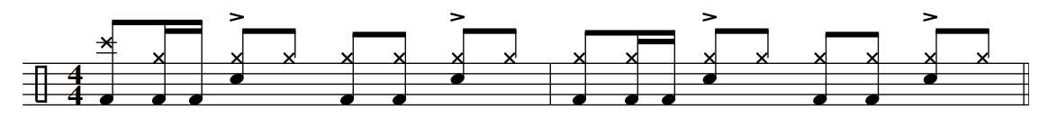

21. 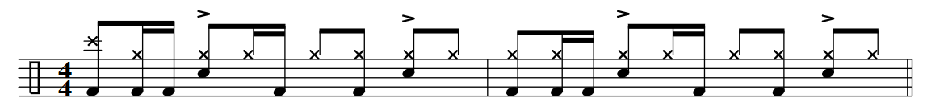

22. 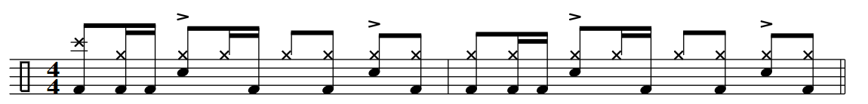

23. 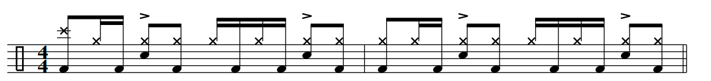

24. 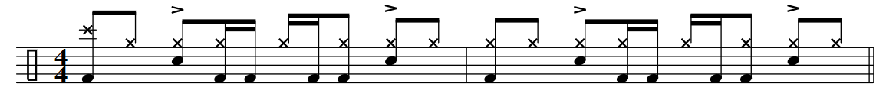

25. 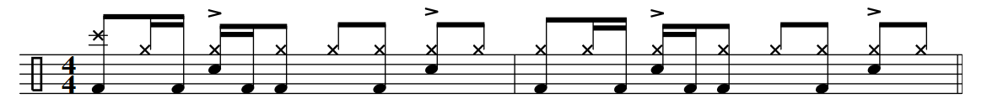

26. 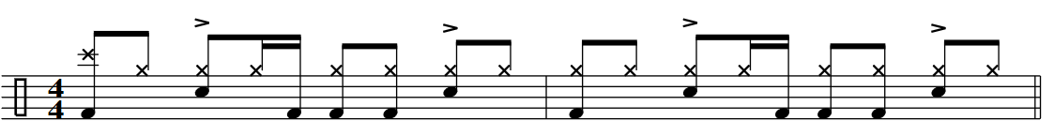

27. 

28. 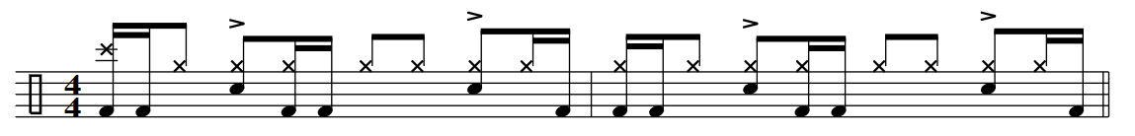

29. 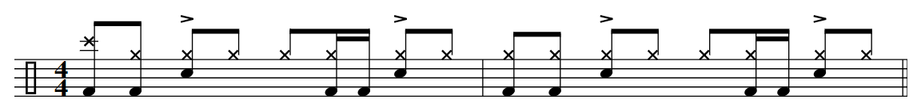

30. 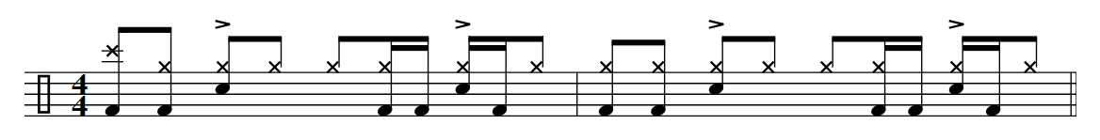

16th note short fills

Tempos: 70, 86, 90, 96, 110, 128, 60.

1. 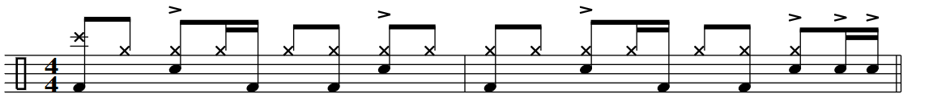2. 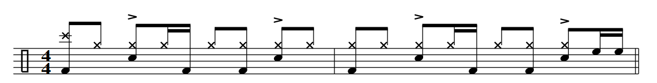3. 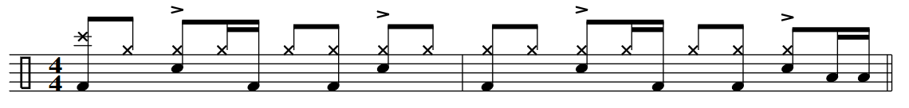4. 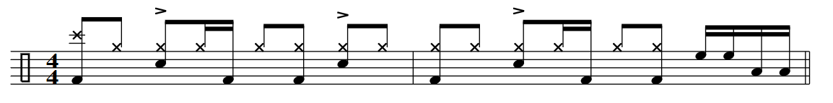5.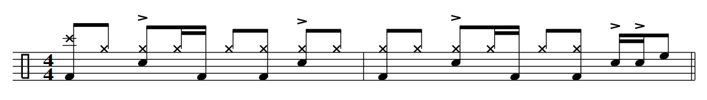6.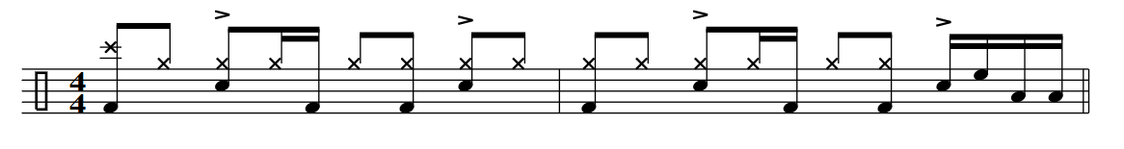7. 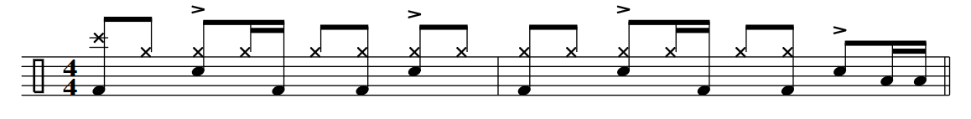8. 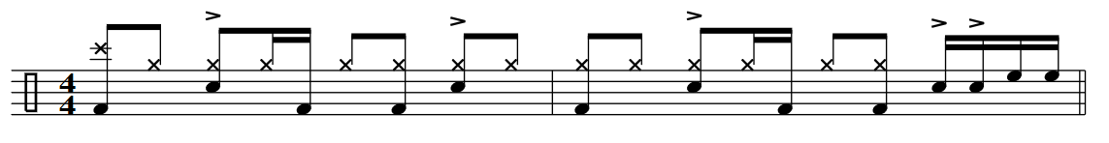

9.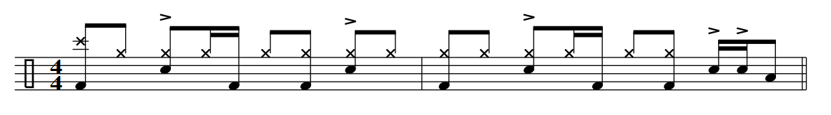10. 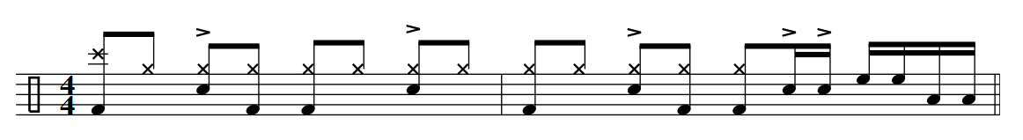11.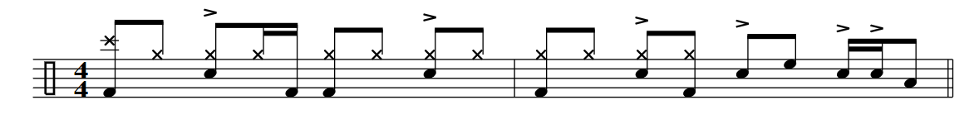

12. 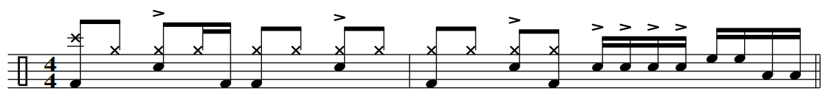13. 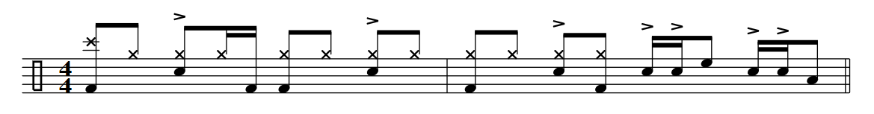14. 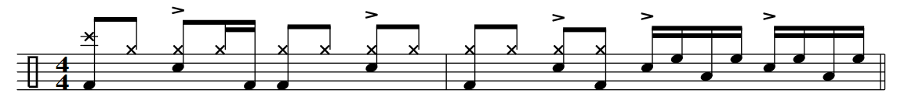15. 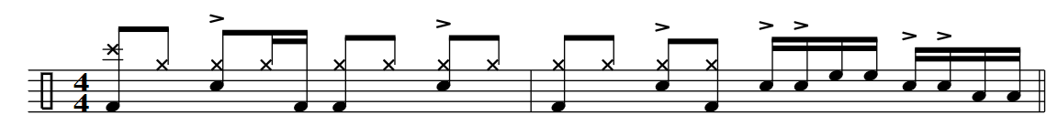16. 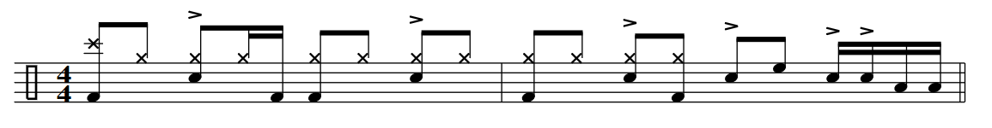

17.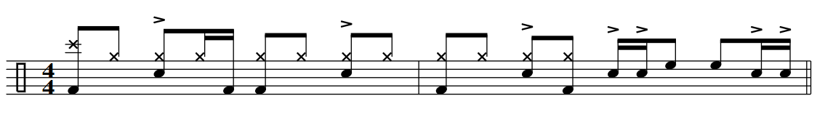18.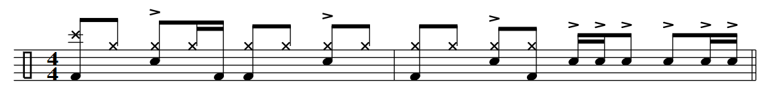

19. 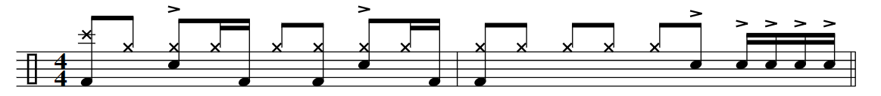

16th Note Two Handed Hi-Hat Grooves

Tempos: 66, 74, 86, 95, 110, 115, 50

Lock it Down…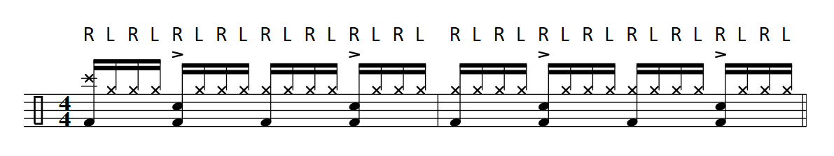Right Hand, Shank Tip Left Hand, Tap Strokes…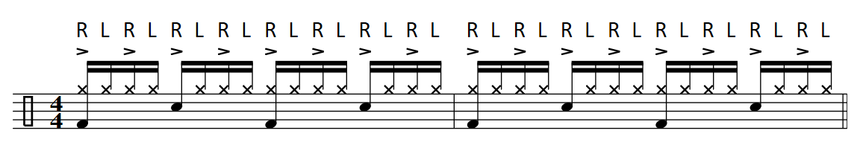

Up Beat Mini Grid… Get the left hand comfortable playing notes with the right foot. Two Hand Hi-Hat…

Tempos:50, 62. 76, 87, 95.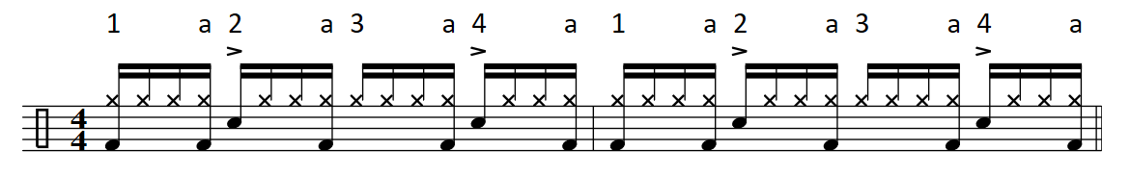 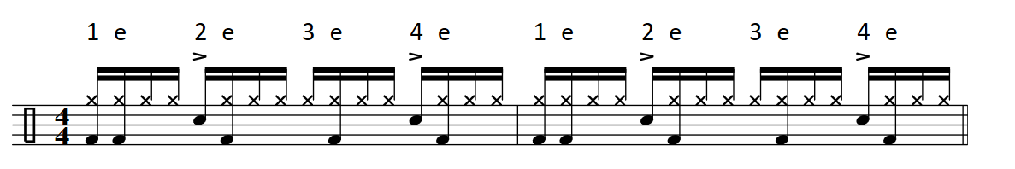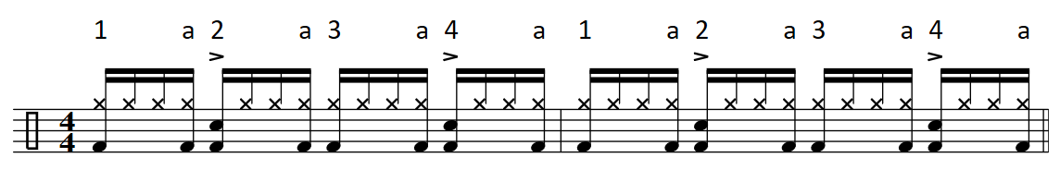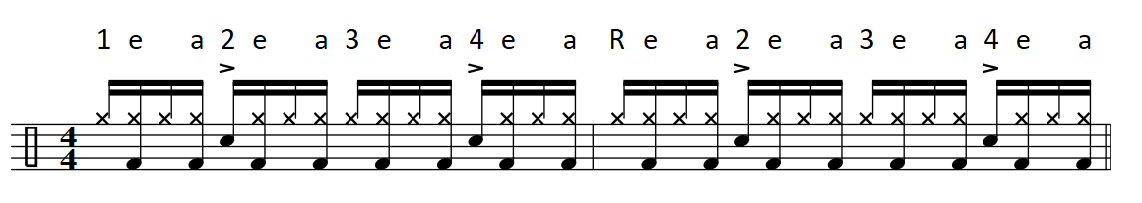

1.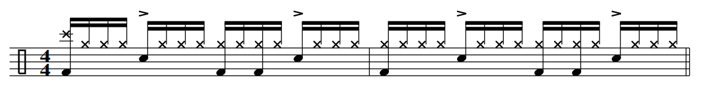2.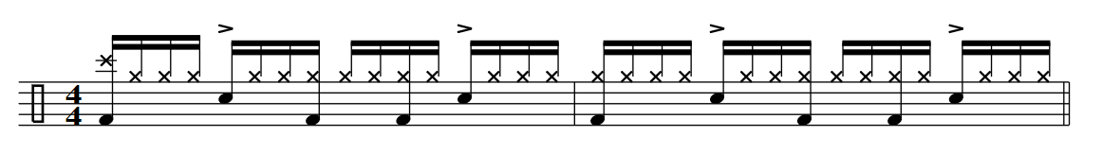3.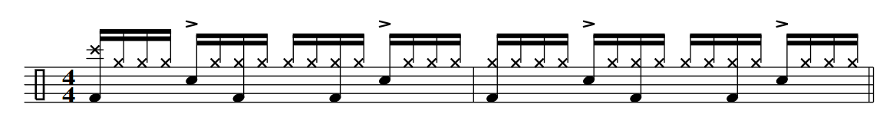4.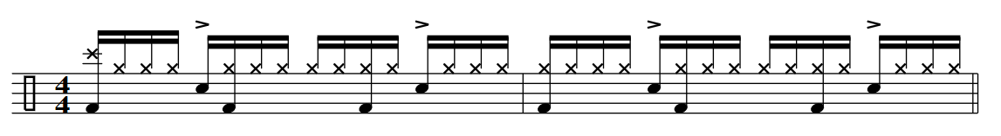5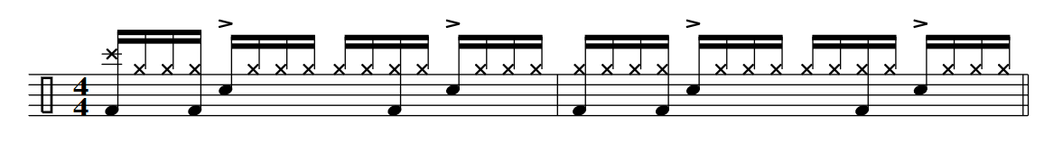6.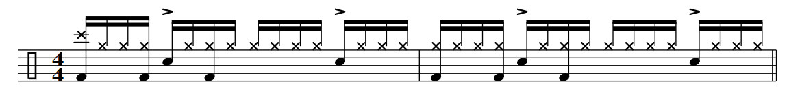7.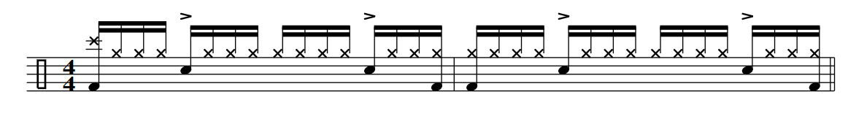8.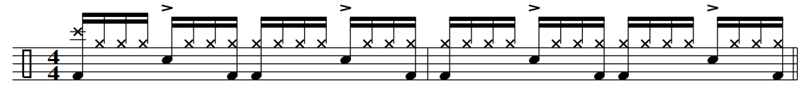

9.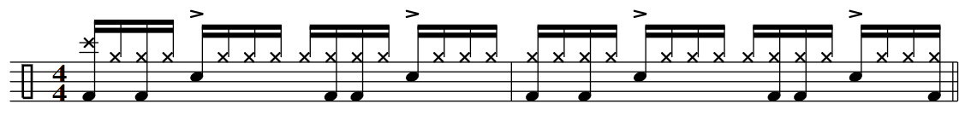10.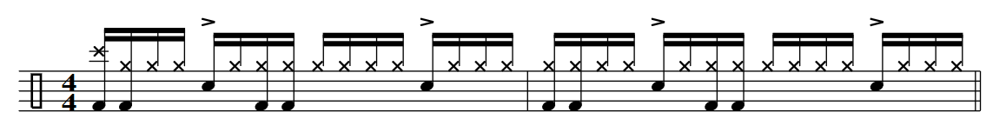11.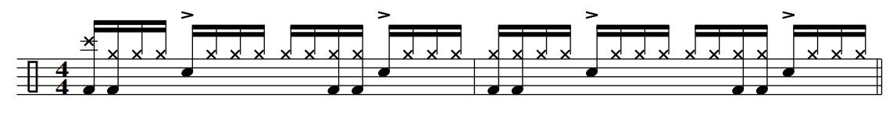12.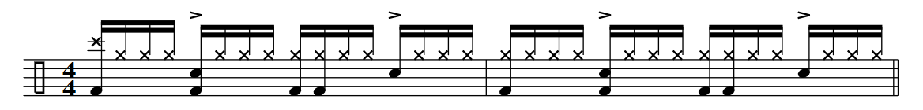13.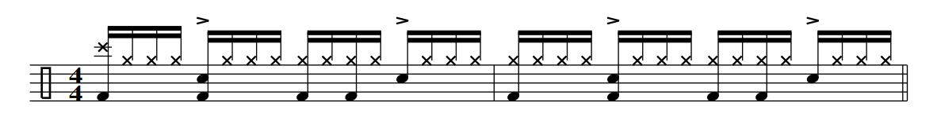14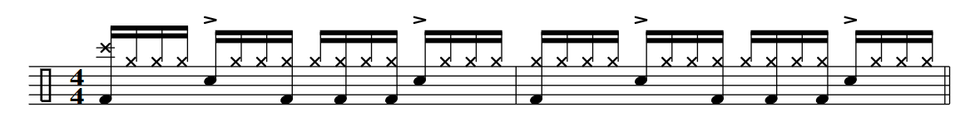

15. 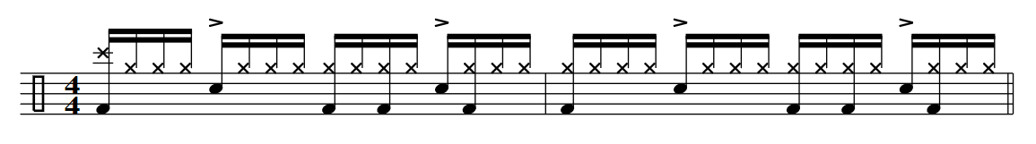

16. 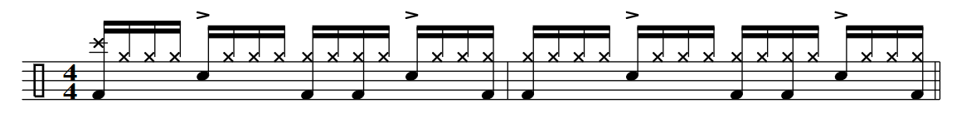

17. 

18. 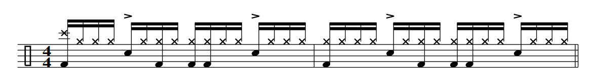

19. 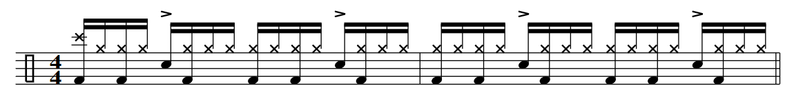

20. 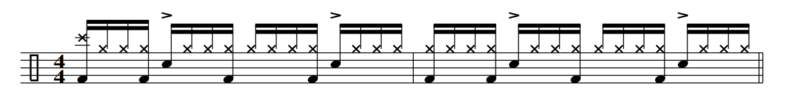

21. 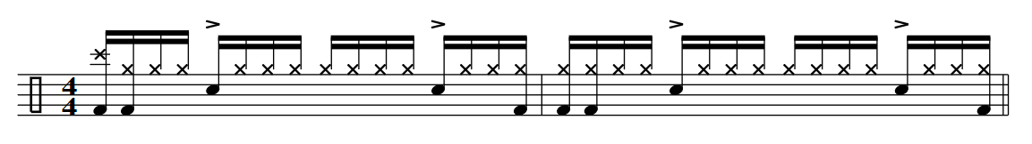

Two Handed 16th Note Grooves w/open Hi-Hats

Tempos: 66, 74, 86, 95, 110, 115, 50

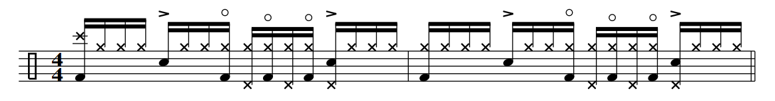

Tasty Grooves

1.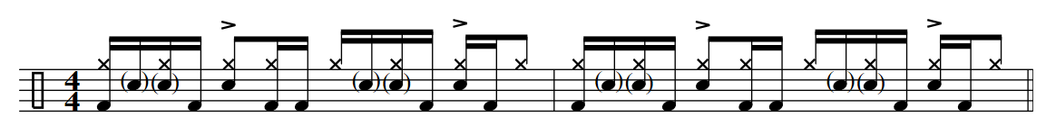2. 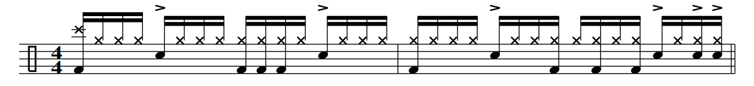3.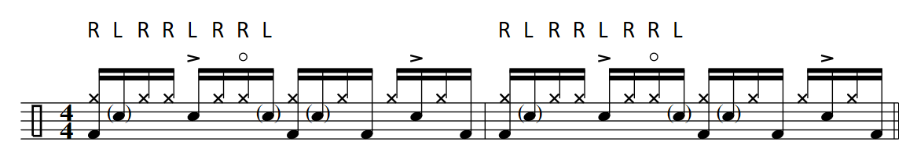4. 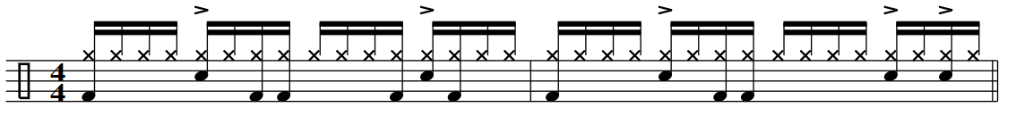5.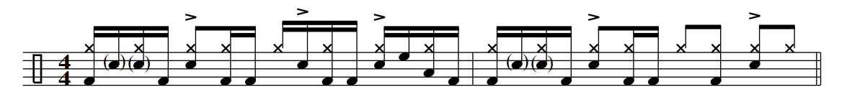6. 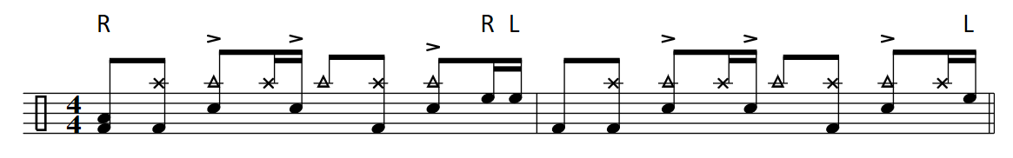7. 