8th Note Stickings

Tempos: 70, 86, 90, 96, 110, 128, 60.

Essential

Up Down Technique…

“Down” Plays an accented note, and sets up a non-accented note.

“Tap” Plays a non-accented note, and sets up a non-accented note

“Up” Plays a non-accented note, and sets up an accented note

“Full” Plays an accented note, and sets up an accented note.

DOWN TAP UP FULL DOWN TAP UP FULL DOWN TAP UP FULL DOWN TAP UP FULL



DOWN UP TAP DOWN UP TAP DOWN UP TAP DOWN UP TAP DOWN UP UP DOWN 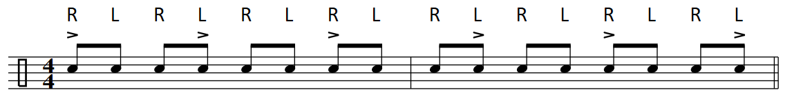

Skeleton Clave’…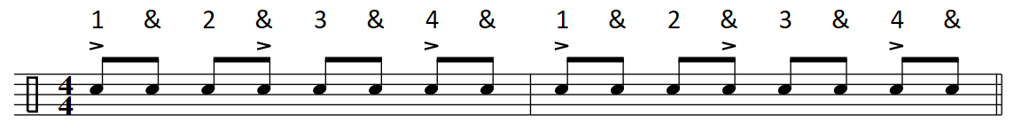

Second Line…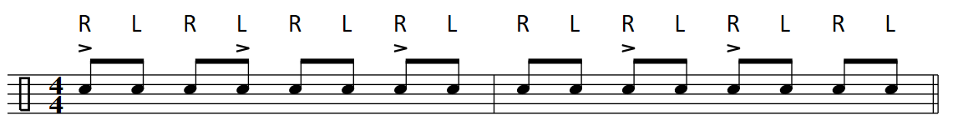

1. 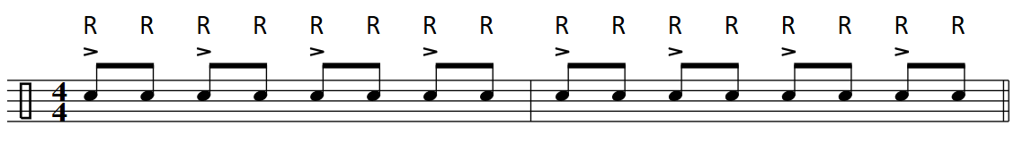2.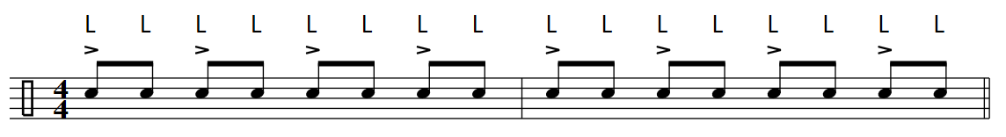3.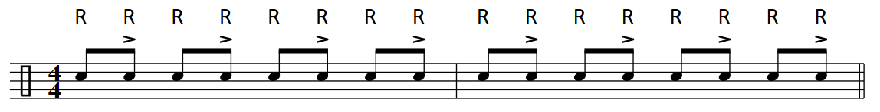4.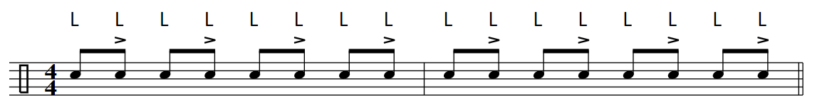5.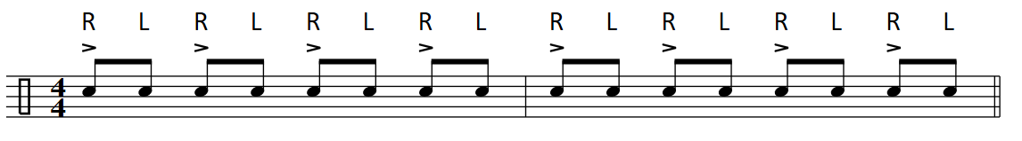6.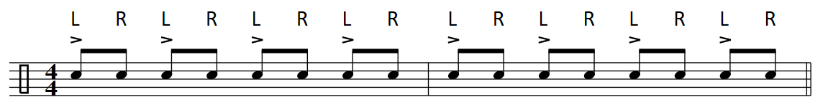7.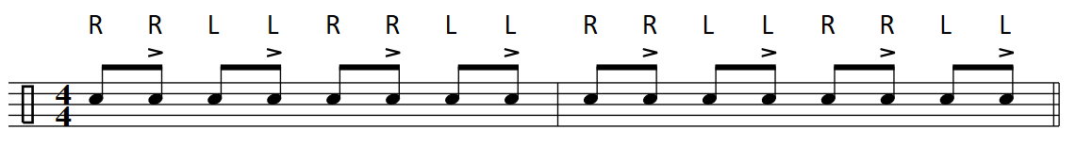8.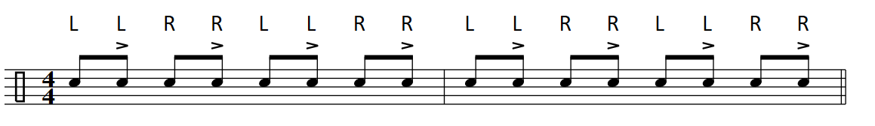9.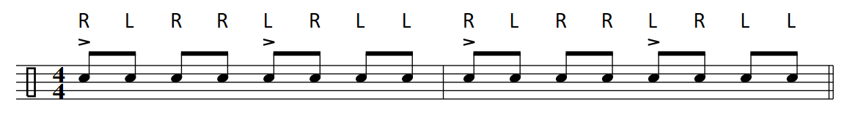10.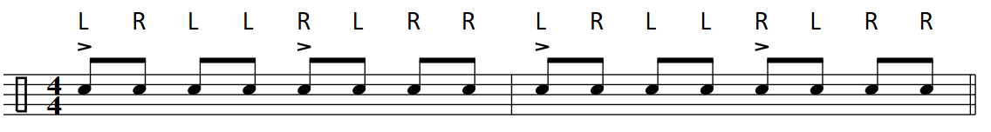11.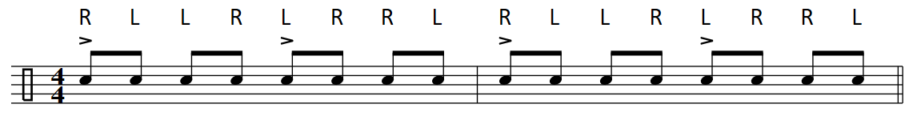12.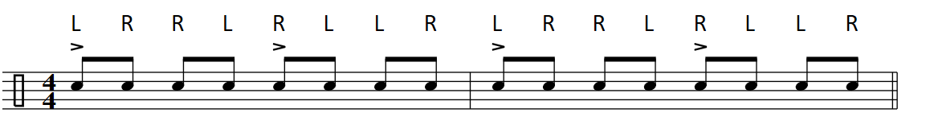13.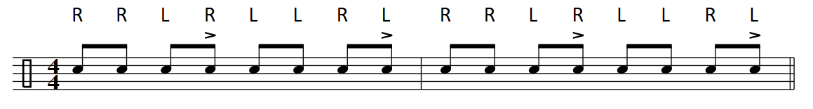14.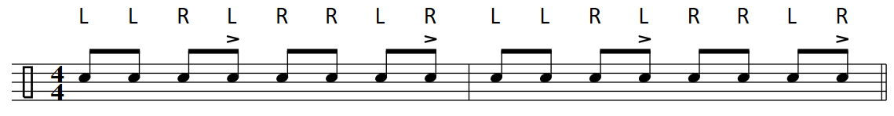15.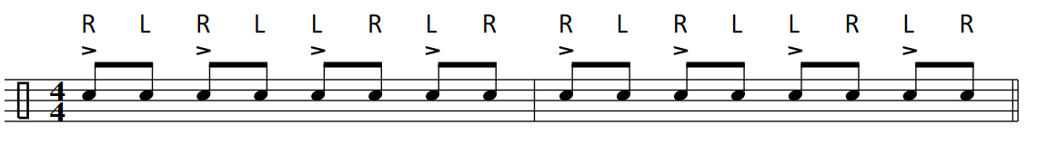16. 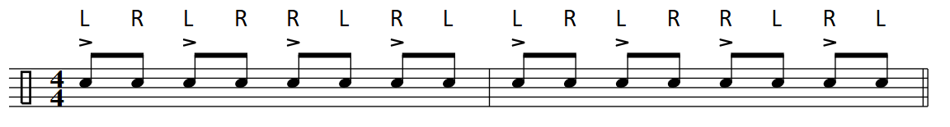17. 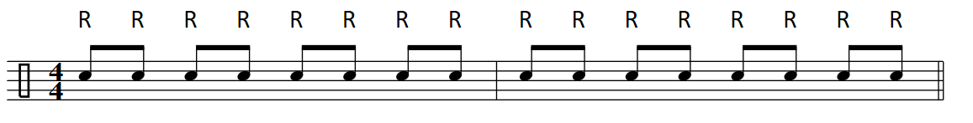18. 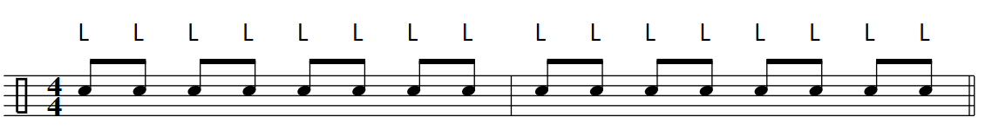

1.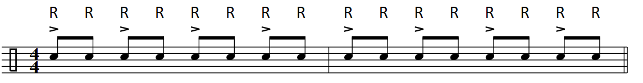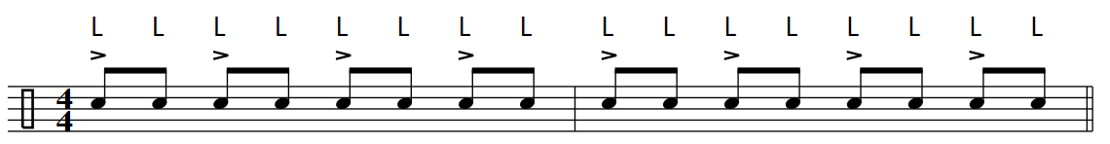



2. 



3.  



**4.** 



5. 



6. 



7. 



8. 



**9.** 

10. 



100661241749

1417