Archie Lessons:

Warm up:

2 Mins R L R L R L R L

2 Mins R R L L R R L L

2 Mins R L R R L R L L

Archie Signature Groove: 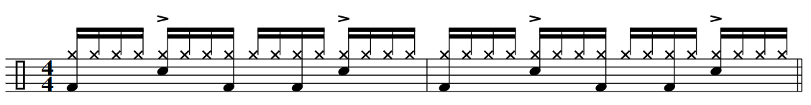

Archie Signature Groove with Fills:

Crash on the 1. Fill is Snare Snare Tom1 Tom1: 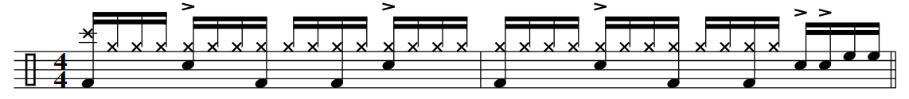

Fill is Snare Snare Tom1 Tom1 Tom2 Tom2. Go very slow and read each note cafrefully. This is a tricky one. 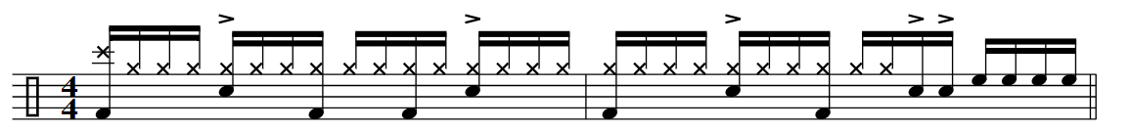

Fill is Tom2 Tom2 Floor Floor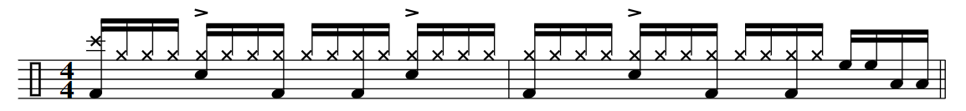

JAM:

Play what ever you want for at least 5 minutes. It doesn’t matter what you play just PLAY 😊 Create and explore different ideas you come up with and try to remember things that you played that you thought sounded cool. Go get em buddy!!

Remember to Tally up the days you practice and see how many days in a row you can get.

Days Practiced:

Grooves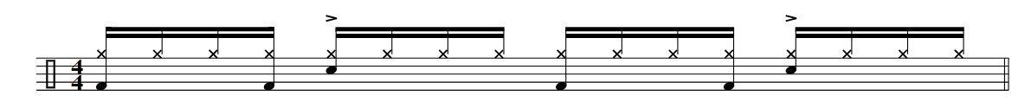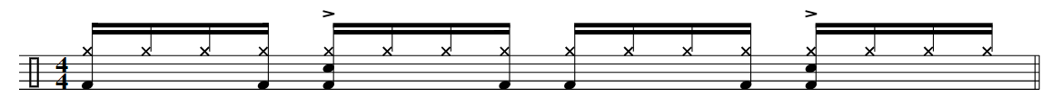

Fills and Drills

Accented Sticking patterns



