**Erik Lessons**

Shuffles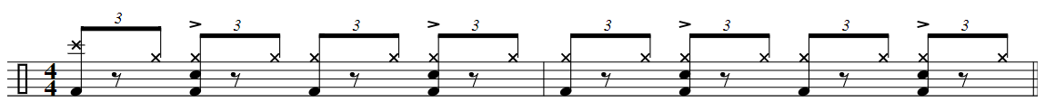

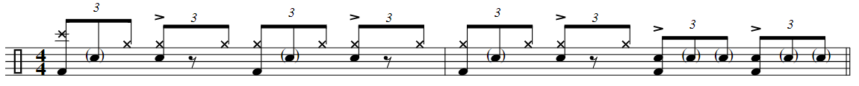

Go your own way fill

Grooves with hits…

4 on the floor



Ghost note…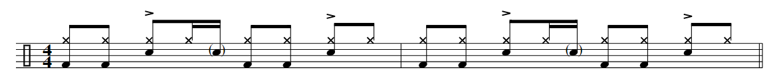

“A rhythm without a pulse, doesn’t have a purpose.” All stickings RLRL

New Snare Fills