New 1

A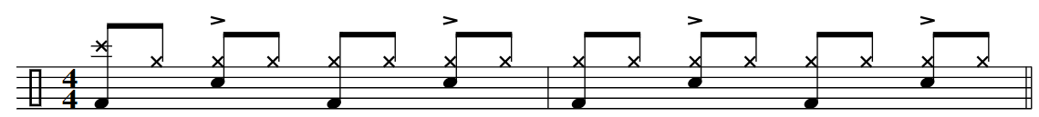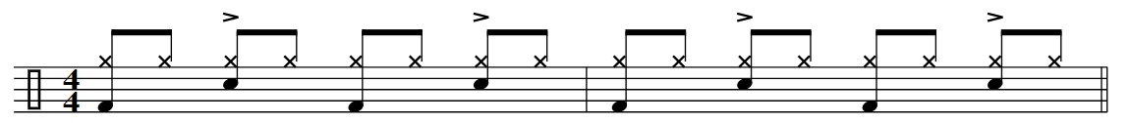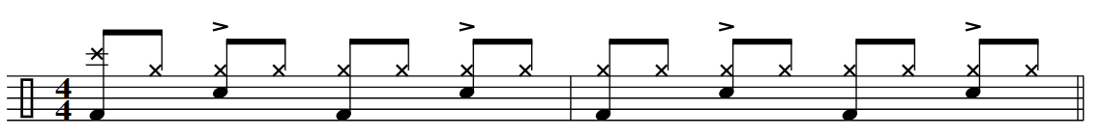­ 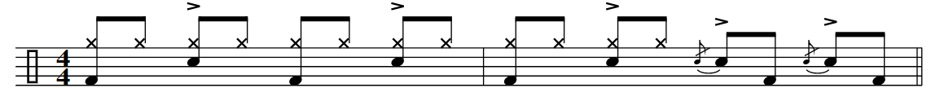

B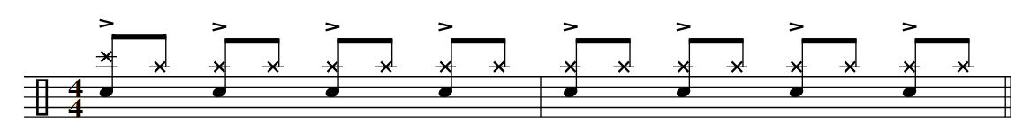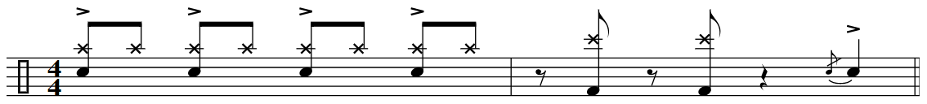

TURN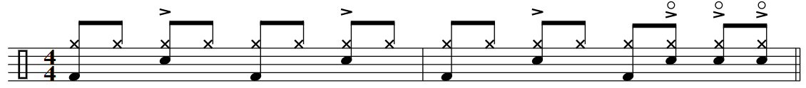

END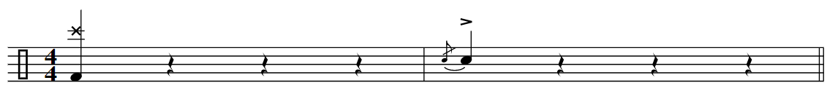

NEW SONG 2

A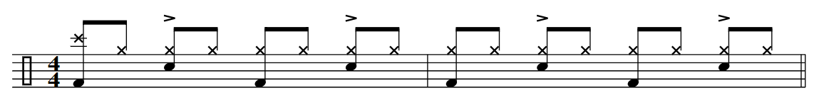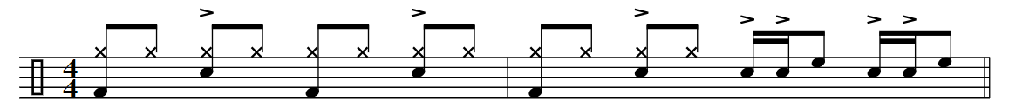

B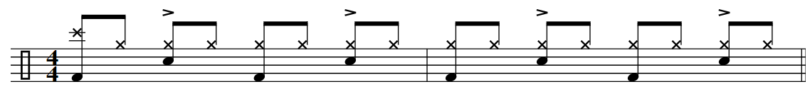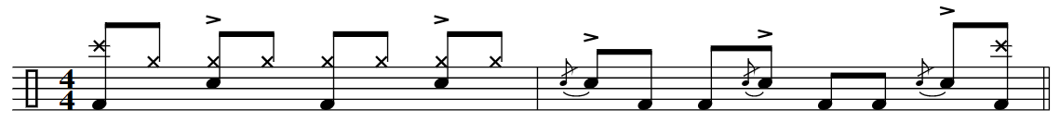

TURN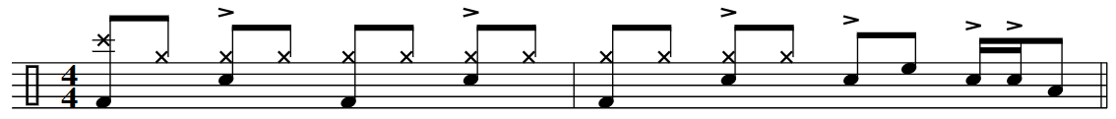

DRUM BREAKS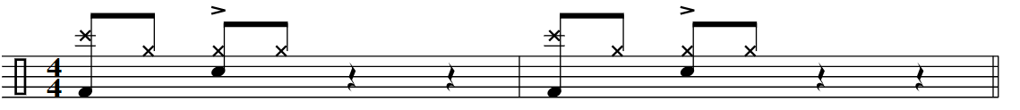

OUT