Aidan





Ryder

Ryder

Ryder

Eli

Zach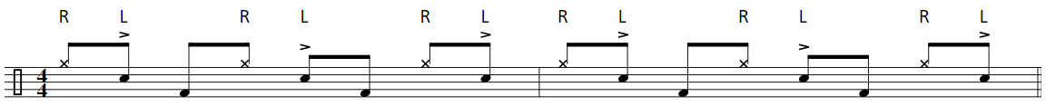

Jacob

Bodhi

Jay

Kenzie

Calvin

Calvin

Calvin 

Jacob

Jay

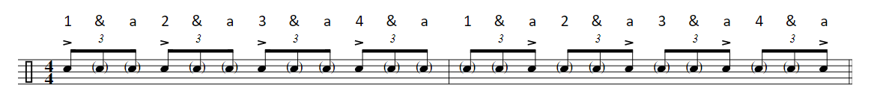

Ryder

David

Matt

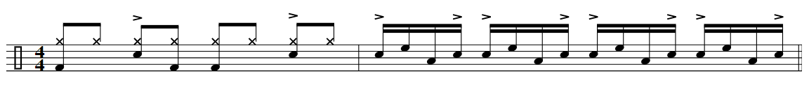

David 

Zach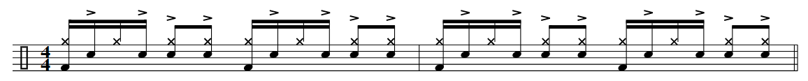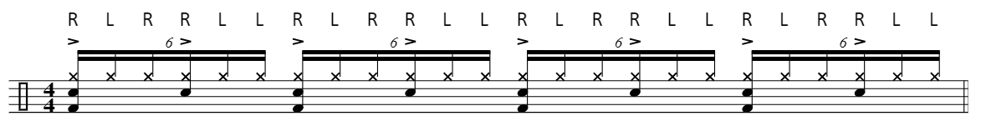

Aidan

Matt

Archie 

Bobby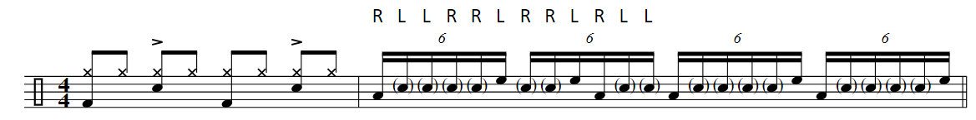

Erik

Jacob 

David. Flam the floor tom on beat 4 of bar 2 

Erik

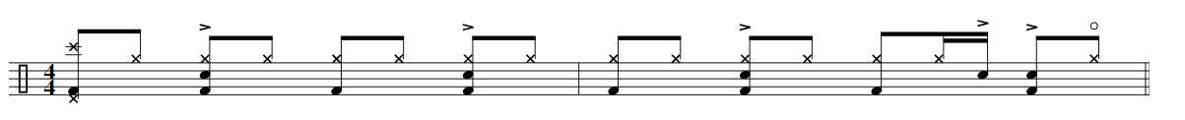



Kenzie 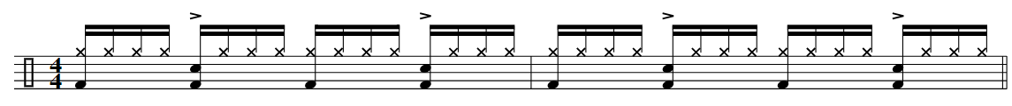

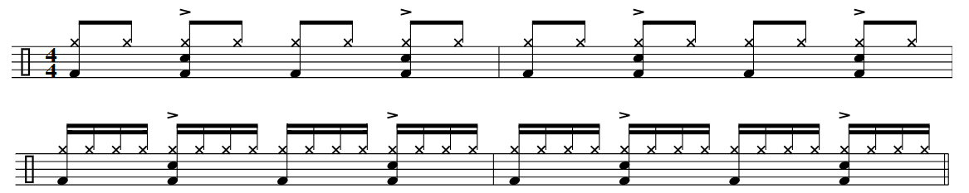

Jacob 

Calvin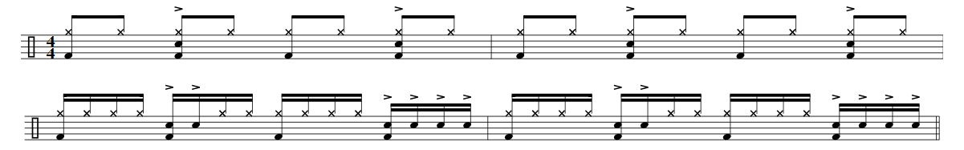

Auggie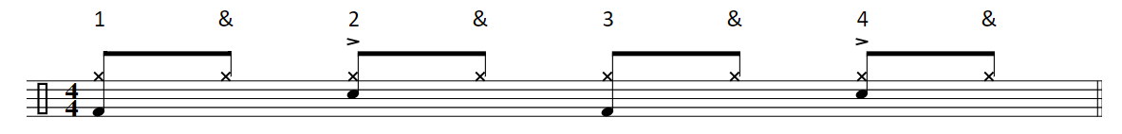

Meter

The Fill

Matt