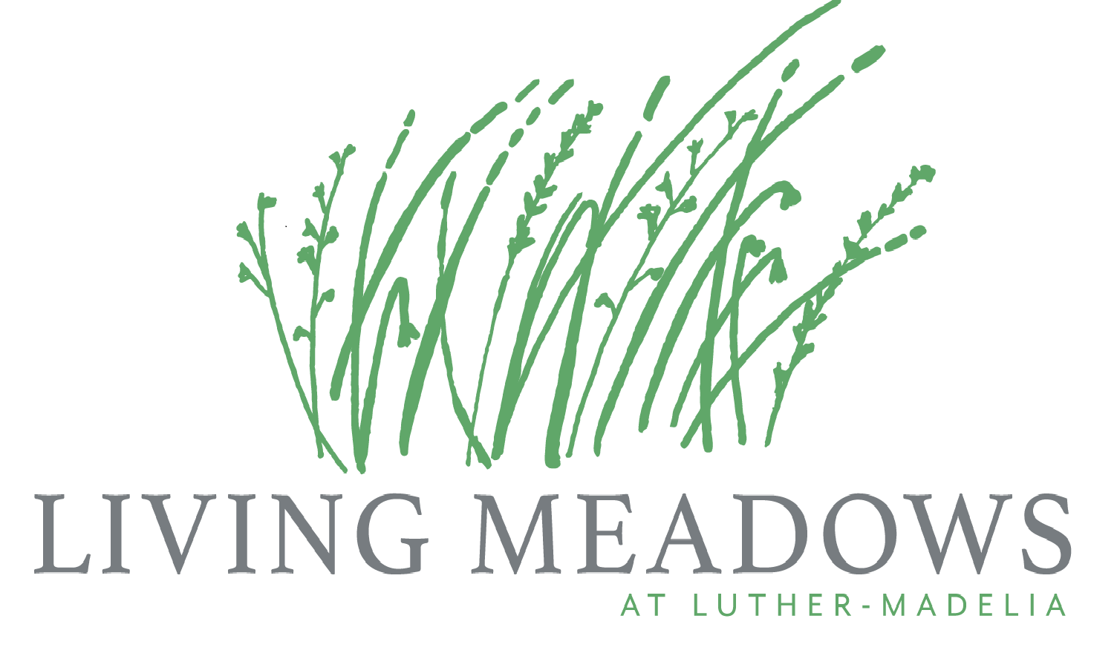
2019 Health Care Career Scholarships
Applications for the 2019 scholarships are due to
Living Meadows by Friday May 3,, 2019 at 5:00pm.

Scholarship Goals:
- Encourage health related careers among southern Minnesota Lutheran youth

Number of Scholarships:

- 7 - $500 scholarships for students in the Living Meadows service area including but not limited to Madelia, Lake Crystal, Amboy, Butterfield, Odin, St. James, New Ulm, Hanska, Truman and Trimont.

Eligibility Requirements:

- High School seniors or current college students from LM Service Area enrolled in or planning to enter an accredited college to pursue a career in health care.
- A scholarship preference will be given to active youth members in one of the Lutheran congregations that support Living Meadows.

Qualifications:

- Applications will be reviewed with a focus on the students’ goals and aspirations and academic record.
- GPA and relevant classes
- Participation in school, church, community and volunteer activities
- All students must submit an application and personal statement sharing their goals in health care.

Awarding Scholarship:

Applications for the 2019 scholarships are due to Living Meadows by May 3, 2019 at 5:00pm. The Living Meadows Scholarship committee reviews all scholarship applications and selects a recipient and alternate. Scholarship recipients and alternates will be notified by May 17, 2019.

Should there be no qualified applicants for an award, the committee may opt to forego selection until the following year.

Procedure to Claim Scholarship:

Scholarship recipients must enter college within one year of being awarded the scholarship. Failure to do so will disqualify the recipient.
After the completion of the first semester of health care study, the scholarship recipient must provide a copy of the grade transcript to Living Meadows to process the scholarship award. A reminder will not be sent.

Return application packet and all official grade transcript(s) to

Living Meadows Community Relations Department
Attn: Founders Fund Board
221 6th Street Southwest, Madelia MN 56062
Phone (507) 642-3271 Fax (507) 642-8676

If you have questions contact:

Living Meadows Administrator
Dawn Campbell
(507) 642-3271

