Hi Competitors/Drivers 5/2/20

A reminder to you all of the new Frontal Head Restraint device (such as a HANS device) requirements that came into effect Jan.1 2020, although this information has been available for some time on the Motorsport Australia (CAMS) website I feel it worthy of a reminder and clarification.

The new requirements now apply to all competitors in Speed Events and include the vehicles listed below:

The drivers of any First category vehicle (open wheelers) e.g. Karts, F/Vee through to F/5000 must wear a FHR device.

The drivers of any other vehicle that has been issued with a Motorsport Australia (CAMS) Vehicle Log Book.

I would also like to point out that only approved helmets can be fitted with a FHR Device as no drilling of holes is permitted to attach the posts to any helmet without the correct compliance eg.it is forbidden to attach HANS posts to a helmet which has a 1698 compliance, this is just one example.

The above rules are applicable to all “SPEED EVENTS” conducted under a Motor Sport Australia (CAMS) permit. These include events such as Sprints, Super Sprints, Hill Climbs, Autocross, Drifting and Short Circuit Touring Car events.

A full list of appropriate headwear etc. can be found on the Motorsport Australia (CAMS) website or manual.

Cheers
Rob Souter
Chief Scrutineer
SCMSA

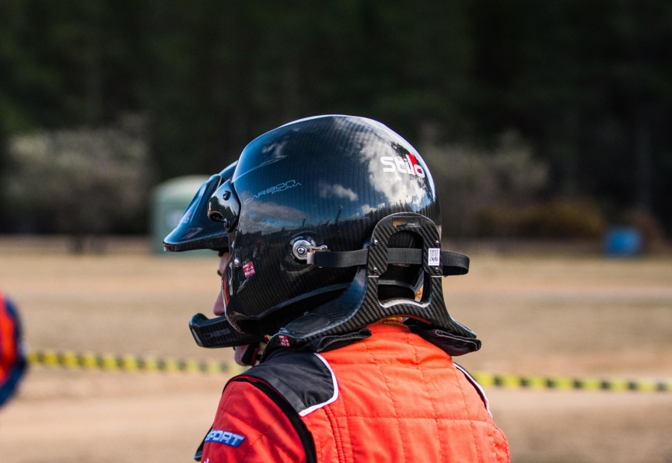
Frontal Head Restraints FAQs
What is a Frontal Head Restraint (FHR)?
A Frontal Head Restraint is a system designed to reduce injury by limiting forward head movement during periods of rapid declaration. Examples of these devices include the HANS device and the Simpson ‘Hybrid’ harness style device. It is important to note, for a FHR to be used in Motorsport Australia events, the FHR needs to be FIA compliant.
What are the benefits of a FHR?
A FHR is of most benefit in a frontal or rearward impact incident, however there is no type of incident in which the use of a FHR will be disadvantageous. A FHR system is designed to reduce injury by limiting forward head movement during periods of rapid declaration. In doing so, the risk of serious spinal cord injury at the level of the neck, which can result in quadriplegia or death, is greatly reduced.
What is the cost impact?
FHRs have been on the market for a number of years and there are a wide variety of suitable options available from various manufacturers. Prices start from as low as $500, right through to $1600. As with helmets, competitors will ultimately choose a FHR that meets their requirements, and budget.
Why has this change been necessary?
There is a wide range of compelling medical evidence as to the effectiveness of FHRs, which has been analysed as part of the AIMSS Review into rallying and formed a key element of the recommendation. The World Rally Championship has mandated the use of FHRs for more than a decade, and reviews of incidents worldwide have demonstrated their value. Motorsport Australia has already recognised the value of FHRs in higher level events, so this change simply applies the highest standard of safety to Club and Multi Club level events.
Is my helmet compatible with a FHR?
The helmet must be equipped by the helmet manufacturer or agent with FIA homologated FHR fixation points and the helmet must be manufactured in accordance with one of the required standards. Providing the helmet meets these requirements, tether points for the FHR are able to be retro fitted.
Motorsport Australia recommends contacting your specific helmet supplier if you are uncertain, or require any further clarification on compatibility of your helmet. Many suppliers are offering competitive package deals for both a FHR and compatible helmet, so you may be able to upgrade your helmet at the same time.
We advise that you also refer to Schedule I in the Motorsport Australia Manual to ensure your harnesses comply with the requirements as listed in Type A, which will also be required from January 1, 2019, as a part of the overall implementation of FHRs.
Who can I contact to find more information?
If you need to discuss these changes with someone at Motorsport Australia, please call the Motorsport Australia hotline on 1300 883 959.

