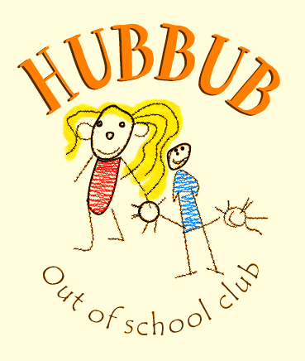
What’s the Hubbub?
Issue 1: 15th May 19

Welcome to the new Hubbub Newsletter. This will be a weekly recap on what has been happening at club over the last week, a chance to see some snapshots of activities and get to know about us as a club.

This week we have been enjoying science experiments
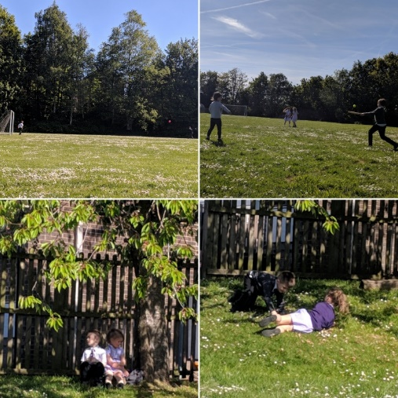
such as homemade lava lamps, making chocolate crispy

cakes and we ate more marshmallows then we should have done in our team building activity.

We also made the most of the beautiful weather by heading outside to play football, rounders and roll down grassy hills (amongst lots of other games).

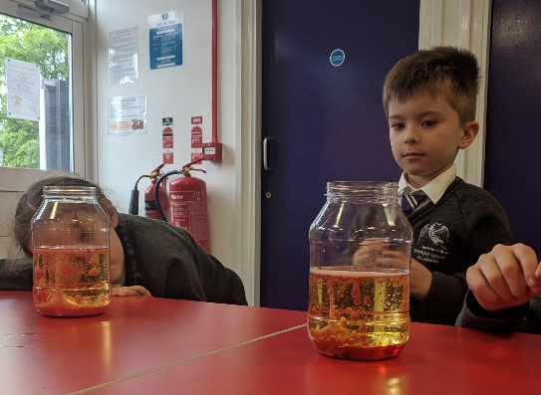

Rain or Shine?
We are in the wonderful time of the year where we can experience multiple weather changes in the space of a day. Please can all children bring a waterproof jacket with them
to all sessions so that no one is left in doors when we go
outside. Alternatively, if your child needs a top up of sun
cream please either provide one or see Liz & sign a
permission form to allow your child to use the club sun
cream.
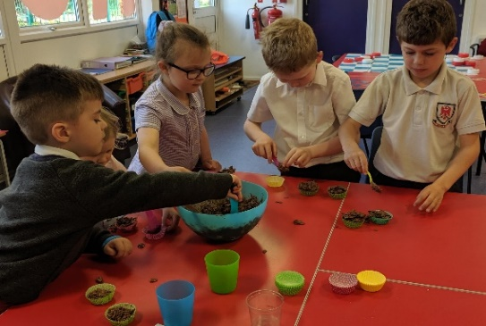
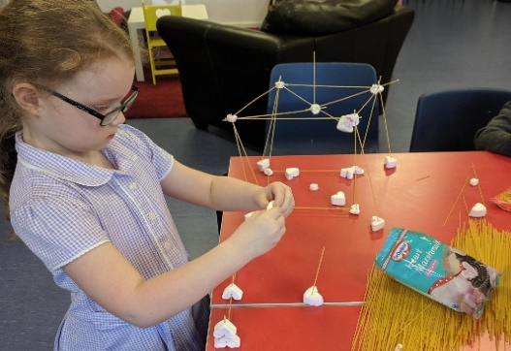
Learning Outcomes:
Making friendships and working within a team.
Understanding of the world through learning how to bake.
Developing maths skills by discussing measurements and volumes.
Exercising & learning about wildlife.

