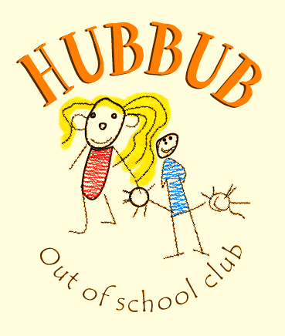
What’s the Hubbub?
Issue 2: 24th May 19
Plea for parent help: Have you got any spare sun hats, light rain coats or shirts that we can make a use of here at club? We would like to have a stash of hats/ raincoats so that all children can make use of our outside activities and we would like to use some adult shirts to cover up during messy play. Please speak to Liz if you think you can help.

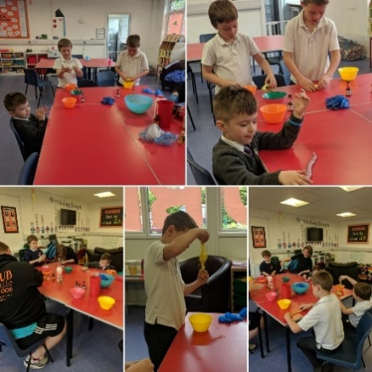
This week Liz has been on an online safety course, please keep an eye out in the next newsletter for some helpful links and information that will give you some guidance on how you can keep your families safe online at home.

The children have been requesting to have snack outside during this week so that they can enjoy the sunshine and we can spend as much time as possible outside.

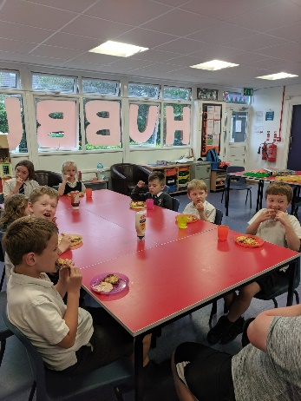
We have also focused on craft activities, making our own playdough and really enjoyed make your own foods such as macaroni cheese and pizza’s.

We provide these meals so we can take the time to teach the children how to make their own foods and the importance of healthy food choices.

Rain or Shine? Another reminder, to please provide a rain coat/ and or a sun hat when your children are at club. We do not want any children to miss out on any of our outdoor activities by not having either of these items.
Learning outcomes:
Children gained knowledge on why we make healthy food choices and have a sense of pride about the meals they make.

Playdough and craft activities can offer a sensory experience along with providing an activity that allows children to explore creative instincts.

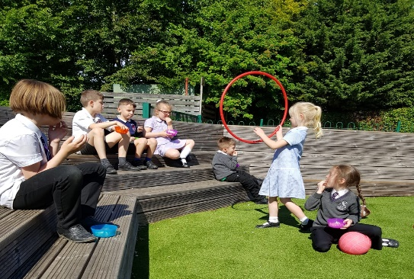
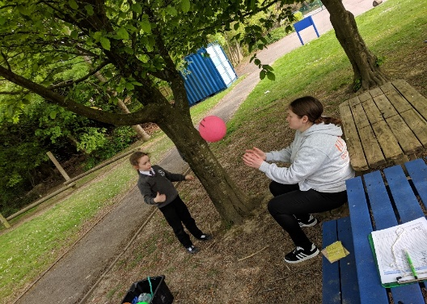
Next week is Half Term – I hope everyone has a lovely week. Don’t forget that we are open for all holidays and Inset days.

