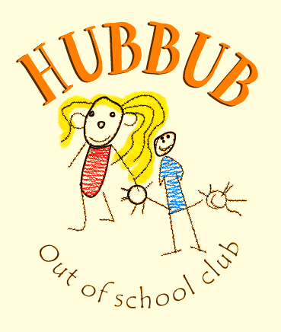***What’s the Hubbub?***

**Issue 3: 31st May 19**

**Wow, what a half term. We hope everyone else enjoyed their holidays as much as we did.**

**During this week we really enjoyed making new friends, baking lots of yummy treats, learning about different types of reactions during science day and had so much fun when we headed out on our pond dipping and bowling trips.**

**With the sun shining we also made the most of being outside by taking our rock paper scissors game out to the playground, lunchtime picnics in the climbing area and using chalks to decorate the playground and help create role playing games such as a McDonalds restaurant, a tunnel game and pokemon it.**

**Liz had hoped that this issue would be our online safety issue, but due to how busy we were over half term, she is going to put this together for the next newsletter.**

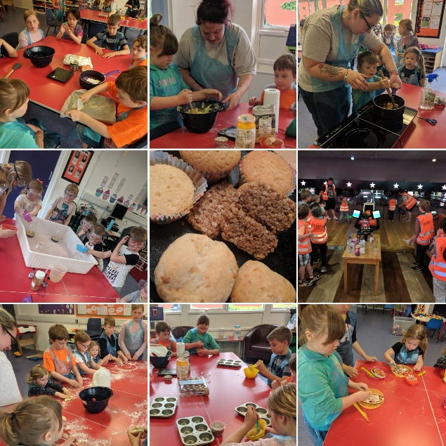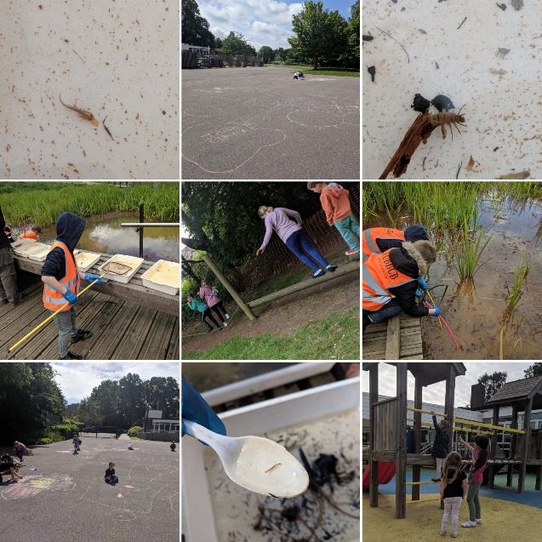

Following our recent loose parts training we are looking forward to implementing it within our forest school area next term. We feel that it is the best environment to introduce our new resources and start all the children creative juices flowing. We are excited to see how the children react to the new activities and what they choose to create with them.

‘Loose parts’ enable the children to access open ended play. By accessing different types of resources and materials they are able to create and observe a multitude of different outcomes. With adults taking a back seat to observe and aid when needed, the children can access a world of play that has no expected goals or outcomes and promotes freedom and independence in learning.

**Learning Outcomes:**

Maths- adding and subtracting, measuring weights and volume

Making friendships and supporting each other as a team

Making marks and using creative ideas to enhance role play

Learning about healthy eating and good food choices in a balanced diet.

