What’s the Hubbub?
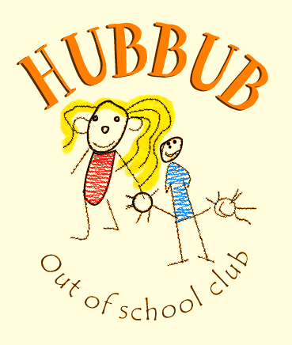
Issue 4: 21st June 19
Online safety at the club:
At the club we have limited access online with our devices. Our games consoles are not connected for internet use and our club laptop and Manager’s laptop are connected to the School’s internet. The internet provided has a protection and filtration system in place which safeguards and prevents any users from accessing any malicious or inappropriate materials or content. Our club laptop is signed out for use by a member of staff and that staff member supervises and guides the children in using it for homework purposes.
Online Safety at home:
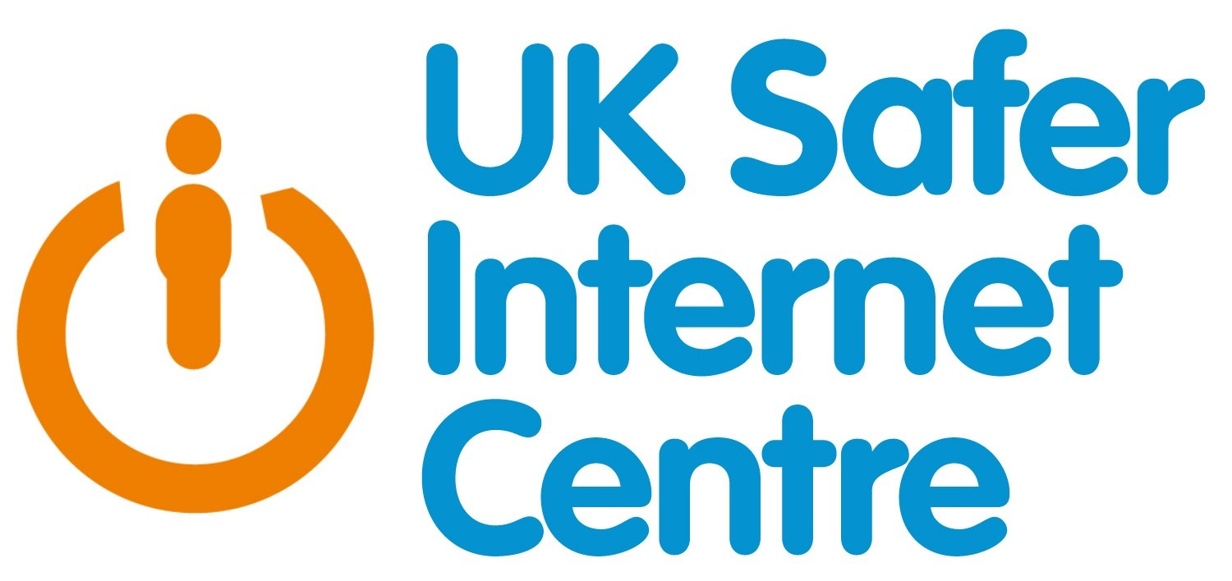
Most Internet providers have a parental control feature for your home broadband. These can be used to block certain websites or even to put a timer in place for when the internet can be accessed. Some devices also offer a similar function. Although having the filters and blocks in place can stop children from accessing inappropriate content accidently it is still important to teach our children how they can use and access the internet safely.
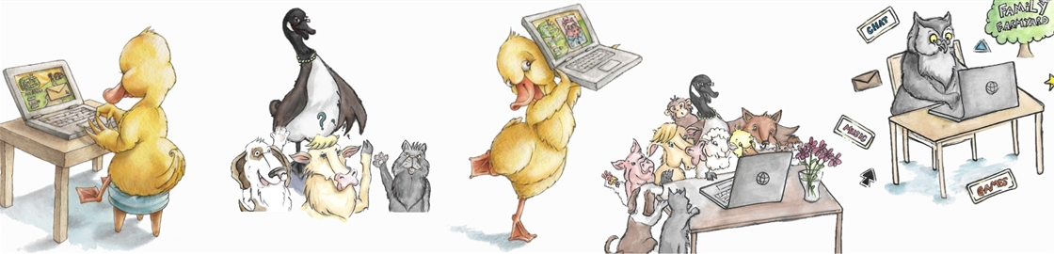
For younger children (3-7), there are books that can be used to help teach internet safety, for example the Digiduck and friends range can be accessed online and downloaded as an e-book or pdf, you can also buy it on amazon. Smartie the penguin is also an online story resource that provides guidance on cyber-bullying, pop up ads and inappropriate websites. For older children (7-11) the The Adventures of Kara, Winston and the SMART Crew, these cartoons illustrate 5 e-safety SMART rules and include a real life SMART Crew of young people, who guide the cartoon characters in their quest, and help them make safe online decisions.
All of these resources are fun and can be interactive with either their layout or prompting questions you can use to help with teaching the children about online safety.
There are some really good websites available for use with younger and older children, as well as to be used to get some more information for yourselves in order to promote safety online to the best of our capabilities. Usually teaching safety is much more efficient then banning online use altogether. – Links can be found at the end of the newsletter.

Concerns:
If you are concerned with anything your child has accessed or you suspect cyber- bullying or online abuse, there are places you can report this too. – We encourage you to come and speak to the manager if you are worried about the online access your children have at the club.
www.childnet.com/parents-and-carers/need-help
- www.childnet.com/resources
www.thinkuknow.co.uk/parents
www.parentzone.org.uk/vodafone-digital-parenting
www.internet matters.org
- www.internet matters.org/advice/digital-resilience-toolkit
- www.internet matters.org/advice/0-5/
www.nspcc.org.uk/onlinesafety
www.saferinternet.org.uk
www.parentinginfo.org
www.kelsi.org.uk/child-protection-and-safeguarding/e-safety/e-safety-useful-links

We hope that this has been helpful, as always please come and chat to Liz- Our designated Safeguarding Lead if you would like some more information or to discuss our practices or any concerns about your children’s online safety both at home and school/club.

We will be incorporating some online safety messages and activities into our play at club, to help support the message and importance of online safety at all times. We believe that the earlier we start to teach this message the more information and knowledge the young people in our care will have as they grow older and their access to online devices and sites grows.
Learning Outcomes:
Safer internet use for adults and children
Children become aware of dangers of internet use as well as learning about how valuable the internet can be.
Adults are aware of advice and guidance available to them.
