What’s the Hubbub?
Issue 6: 12th May 19
Wow, what a term. I definitely feel like it was only May half term a couple of minutes ago. This term has seen us welcome new families to Hubbub, but we are also saying goodbye to a few of our children as they are leaving year 6 and moving on to their new secondary schools. We are going to miss you all, but wish you lots of luck with your new adventures. Hopefully we will see a few of you in our holiday club.
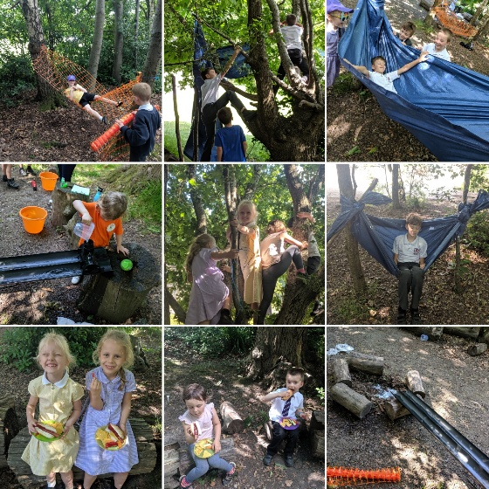

This week has been strongly focused on sports such as Cricket, Rounders and Football. We have also thoroughly enjoyed spending time in our forest school area. – it’s been a welcome relief from some of the sun and heat.

We have also focused a lot on learning about the amazing and varied wildlife within our grounds and the importance of insects and plant life. We also found a Smooth newt whilst exploring our meadow area.
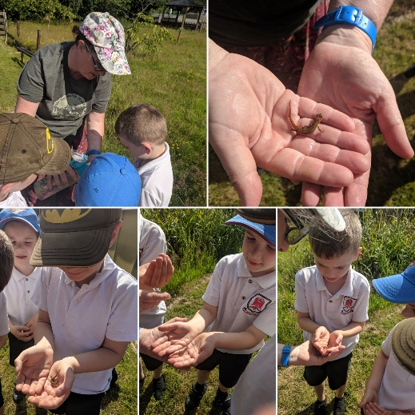

Term Dates:
- Temple Grove: End of Term: Friday 19th July
Start of Term: Tuesday 3rd September
- St Marks: End of Term: Friday 19th July
Start of Term: Tuesday 3rd September
- St Johns: End of Term: Tuesday 23rd July
Start of Term: Wednesday 4th September

During the summer holidays we have a variety of activities happening on and off site.
Summer Holidays:
Monday 22nd July – Tuesday 3rd September 19.

Our extra cost activities are visits from Our Amazing
Animal World, Glazy Daisy, a Bollywood Dance workshop and
a trip to Hastings.

On top of that we will be hosting our ever popular Baking
Days, science days and carnival week.
We will be spending time in our forest school area, bug
sweeping in the meadow & pond dipping in our pond.
For more information or to book in please email Liz at
Hubbubasc@gmail.com or phone 07792263453.

