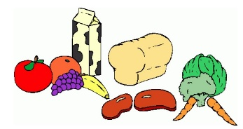**Week One:**

|  |  |  |  |  |  |
| --- | --- | --- | --- | --- | --- |
|  | Breakfast: | AM Snack: | PM Snack: | Tea: | Pudding: |
| Monday: | A selection of cereal, crumpets or toast  (Marmite, Jam or Honey toppings) | Treat Time | Treat Time | Tomato Soup with buttered rolls | Fruit Salad |
| Tuesday: | A selection of cereal, crumpets or toast  (Marmite, Jam or Honey toppings) | Fruit Smoothies | Popcorn with orange segments and blueberries | Macaroni cheese served with garlic bread and crunchy veg sticks | Jelly |
| Wednesday: | A selection of cereal, crumpets or toast  (Marmite, Jam or Honey toppings) | Snack Bars | Rice cakes with cream cheese/ Jam | Hot Dogs with crunchy veg and tortilla chips | Chocolate Mousse |
| Thursday: | A selection of cereal, crumpets or toast  (Marmite, Jam or honey toppings) | Fruity kebabs with yoghurt dip | Ham, cheese and cucumber pretzel bites | Slow cooked chicken korma with poppadom’s and rice | Yoghurts |
| Friday:  *Tango Style Red <strong>Jelly</strong> by rugby471 - Tango Style <strong>Jelly</strong>* | A selection of cereal, crumpets or toast  (Marmite, Jam or honey toppings) | Cereal with Raisins | Cheese and Crackers | Upside Down Cottage Pie with beans or spaghetti | Ice Lollies |

***\*All Allergy information is available on request and displayed in the premises.***

***\*\*Holiday Club Only***