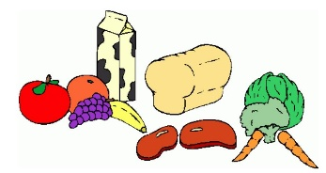
Week Two:

 | Breakfast: | AM Snack: | PM Snack: | Tea: | Pudding:
Monday: | A selection of cereal, crumpets or toast  (Marmite, Jam or Honey toppings) | Ham, cheese and cucumber pretzel bites | Cereal with Raisins | Pasta Bake with Garlic Bread and Crunchy Veg | Tray Bake with custard or chocolate Sauce
Tuesday: | A selection of cereal, crumpets or toast  (Marmite, Jam or Honey toppings) | Treat Time | Treat time | Sausages with Roast potatoes, vegetables and gravy | Fruity Crumble or pie with Squirty cream or custard
Wednesday:  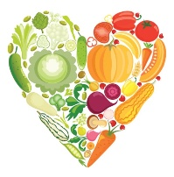 | A selection of cereal, crumpets or toast  (Marmite, Jam or Honey toppings) | Hot Chocolate with a biscuit | Snack Bars | Spaghetti Bolognaise | Jelly
Thursday: | A selection of cereal, crumpets or toast  (Marmite, Jam or honey toppings) | Cheese and Crackers | Popcorn with orange segments and blueberries | Slow cooked Chicken casserole with peas and sweetcorn | Angel Delight with a biscuit
Friday: | A selection of cereal, crumpets or toast  (Marmite, Jam or honey toppings) | Fruity kebabs with yoghurt dip | Rice cakes with cream cheese or jam | Chicken Goujon Wraps with Crunchy Veg | Yoghurts
*All Allergy information is available on request and displayed in the premises.
**Holiday Club Only

