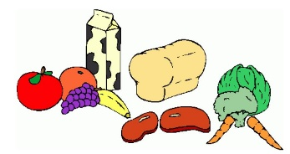
Week Three:

 | Breakfast: | AM Snack: | PM Snack: | Tea: | Pudding:
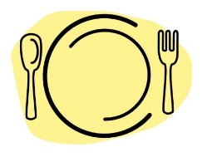  Monday: | A selection of cereal, crumpets or toast  (Marmite, Jam or Honey toppings) | Cereal and raisins | Breadsticks and crunchy veg sticks with dips | Pizza and Mash with Spaghetti | Yoghurts
Tuesday: | A selection of cereal, crumpets or toast  (Marmite, Jam or Honey toppings) | Popcorn with orange segments and blueberries | Snack Bars | Ham and Cheese Broccoli Pasta with garlic bread | Tray Bake with custard or Chocolate Sauce
Wednesday:  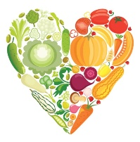 | A selection of cereal, crumpets or toast  (Marmite, Jam or Honey toppings) | Treat Time | Treat Time | Tomato or Chicken Soup with buttered rolls | Fruity Crumble or pie with Squirty cream or custard
Thursday: | A selection of cereal, crumpets or toast  (Marmite, Jam or honey toppings) | Cheese and Crackers | Hot Chocolate with a biscuit | Spaghetti and Meatballs | Jelly
Friday: | A selection of cereal, crumpets or toast  (Marmite, Jam or honey toppings) | Fruity kebabs with yoghurt dip | Ham and cheese Pretzel Bites | Jacket Potato with a choice of toppings  (beans, cheese, tuna) | Chocolate Mousse
*All Allergy information is available on request and displayed in the premises.
**Holiday Club Only

