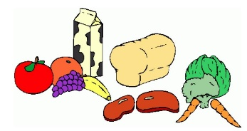**Week Four:**

|  |  |  |  |  |  |
| --- | --- | --- | --- | --- | --- |
|  | Breakfast: | AM Snack: | PM Snack: | Tea: | Pudding: |
| Monday: | A selection of cereal, crumpets or toast  (Marmite, Jam or Honey toppings) | Snack Bars | Popcorn with orange segments and blueberries | Spaghetti and Meatballs | Angel Delight with a biscuit |
| Tuesday: | A selection of cereal, crumpets or toast  (Marmite, Jam or Honey toppings) | Ham, cheese and cucumber pretzel bites | Rice cakes with cream cheese or jam | Scrambled egg and beans with potato waffles | Yoghurts |
| Wednesday: | A selection of cereal, crumpets or toast  (Marmite, Jam or Honey toppings) | Banana bread and berries | Breadsticks and crunchy veg sticks with dips | Slow Cooked chicken Korma with poppadom’s and rice | Ice Lollies |
| Thursday: | A selection of cereal, crumpets or toast  (Marmite, Jam or honey toppings) | Treat Time | Treat Time | Pie and mash with veg and gravy | Fruit Salad |
| Friday:  *Tango Style Red <strong>Jelly</strong> by rugby471 - Tango Style <strong>Jelly</strong>* | A selection of cereal, crumpets or toast  (Marmite, Jam or honey toppings) | Fruity kebabs with yoghurt dip | Cereal with Raisins | Hotdogs with crunchy veg and tortilla chips | Jelly |

***\*All Allergy information is available on request and displayed in the premises.***

***\*\*Holiday Club Only***