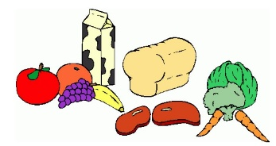
Week Five:

 | Breakfast: | AM Snack: | PM Snack: | Tea: | Pudding:
Monday: | A selection of cereal, crumpets or toast  (Marmite, Jam or Honey toppings) | Popcorn with orange segments and blueberries | Banana Bread and berries | Sausage, Mash and beans | Jelly
Tuesday: | A selection of cereal, crumpets or toast  (Marmite, Jam or Honey toppings) | Hot chocolate with a biscuit | Ham, cheese and cucumber pretzel bites | Pizza with chips, peas and sweetcorn | Chocolate Mousse
Wednesday: | A selection of cereal, crumpets or toast  (Marmite, Jam or Honey toppings) | Cereal with raisins | Cheese and biscuits | Chilli con carne and rice | Yoghurts
Thursday: | A selection of cereal, crumpets or toast  (Marmite, Jam or honey toppings) | Rice cakes | Snack Bars | Chicken goujon Wraps with crunchy veg | Tray Bake with custard or Chocolate Sauce
Friday: | A selection of cereal, crumpets or toast  (Marmite, Jam or honey toppings) | Treat Time | Treat Time | Pasta bake with garlic bread and crunchy veg | Fruity Crumble or pie with Squirty cream or custard
*All Allergy information is available on request and displayed in the premises.
**Holiday Club Only

