Fire Risk Assessment  Sedgeford Village Hall | Responsible Person | Sedgeford Village Hall and Recreation Ground Committee | Date | 09/09/20
Fire Risk Assessment  Sedgeford Village Hall | Risk Assessors | Richard Mills, The RedCat Partnership Ltd | This Review | 06/02/22
Fire Risk Assessment  Sedgeford Village Hall | Risk Assessors | Richard Mills, The RedCat Partnership Ltd | Next Review | 01/02/26

Table 1; Recommendations; Fire Prevention

Item | Recommendation | Priority*
Candles | Refer to the safe use of candles in the Information for Hirers IN PLACE |  | M
Heating | The outbuilding has electric convector heaters; ensure some warning signs/instructions not to store materials close to, or against, the heaters. ALL HEATERS REMOVED |  | M
Store-room storage | Flammable material must not be stored close to (within, say 50cm – 1m) of the electrical distribution board. MATERIALS CLEARED |  | H
Store-room storage | Store flammable hand sanitiser 5l containers this in a way that makes it less likely to be damaged, knocked over, etc. and spilled. ALL STORED CORRECTLY |  | H

Table 2; Recommendations; Fire Control/Mitigation

Item | Recommendation | Priority*
Escape Routes | Might it be worth moving the steps to the opposite side of the stage (the Meeting Room door is less often used, and is not an escape route)? |  | M
Fire Doors | As and when the opportunity arises, upgrade fire doors to incorporate fire rated hinges and cold smoke/ intumescent seals. |  | L
Management | Update the detailed Action Plan to include checking for false alarms. |  | M
Management | Update the Information for Hirers section of the existing fire risk assessment |  | M
Management | I’d advise ensuring that, for Committee organised events, there is a nominated Lead Person to take charge in the event of fire (ensure evacuation, call the fire service, preventing re-entry, etc). |  | M

* Priority
Ultra-High | U | Immediate action required (an enforcement officer might serve a Prohibition Notice)
High | H | Must receive priority planned attention (an enforcement officer might serve an Improvement Notice)
Medium | M | Minor/tolerable defect in the short term but does require planned action
Low | L | Improvement, as and when the opportunity arises, or “best practice”.
Detailed Assessment

Table 3; People at Risk (numbers, familiarity with the premises, vulnerabilities, etc.)
Committee Members
Hirers and their customers/service users (representative of the general population; there are no current/regular hires that attract people with significant mobility/sensory impairment)
Members of the local community, attending events or using the Hall (again representative of the general population with regard to mobility/sensory impairment; it is feasible, indeed likely, that such users will attend the Hall)

Table 4a; Fire Prevention. Ignition hazards, and any control measures (elimination/reduction/control, e.g. “smoking outside, in permitted area only”). OK or NOT OK? If “No” detail the recommendations in Table 1 above
Ignition Hazard | Existing controls | OK; Y/N?
Smoking; | There is no designated smoking area, but neither are there combustion hazards such as waste, which are vulnerable. |  | Y
Other naked flames- e.g. welding, candles, cooking equipment | Very occasional candle use. Add to instructions to hirers; state that candles are OK but notify us and make sure they’re used safety (e.g. tea lights in a jam jar) |  | N
Heating and portable heaters; | Wet central heating (low surface temperature radiators) in the main hall.  The outbuilding has electric convector heaters, wall-mounted at approximately 1.25m; there were some chairs in close proximity. Although it was a warm day and the heaters were not on, such a situation in winter would be an unacceptable risk. Recommend, as a minimum, some warning signs/instructions not to store materials close to, or against, the heaters.  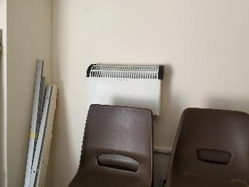  No other portable heaters |  | N
Electrical Fault in the building installation | Electrical installation is subject to a 5-yearly Condition Inspection Report, last completed 15/07/19 and found to be satisfactory.  No actual, or further risk of damage or deterioration were noted during the assessment |  | Y
Electrical fault in a portable electrical appliance or their use, servicing, etc.; | Portable Appliance Testing was carried out at the beginning of 2020. No defects in any appliances were noted during the assessment |  | Y
Use of adapters, extension leads and plug-boards | None were noted as being in use, extensions are available for occasional use. |  | Y
Arson; location, security | There is a history of minor and very limited anti-social behaviour. Not a significant risk. Security and site housekeeping are good. |  | Y
Hot surfaces; | Oil boiler. The horizontal flue passes through the wall to the gravelled area outside, but the hot surface of the flue is protected from contact by a wire cage. |  | Y
Hot surfaces; | Kitchen equipment, none of which requires any special competence, instruction or supervision in its use. 2x built-in ovens (which are clean and used for relatively low-level tasks such as warming sausage rolls), microwave, 2x “Burco” water heaters for drinks. |  | Y
Table 4b; Fire Prevention. Fuel hazards, and any control measures (elimination/reduction/control) OK or NOT OK? If “No” detail the recommendations in Table 1 above
Fuel Hazard | Existing controls | OK; Y/N?
Paper materials; records, brochures, packaging, etc. | No notable accumulations of excessive material, other than in the outbuilding, around the electrical distribution board. Flammable material must not be stored close to (within, say 50cm – 1m) of the electrical distribution board.  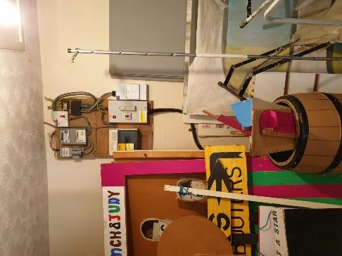  Some storage under the stage, but this is acceptable. |  | N
Furniture (Inc. retardency; check the labels) | Function Room-style chairs, which are commercial in origin (therefore not subject to labelling requirements) |  | Y
Fabric/curtain (Inc. retardency) | Stage curtains are labelled, although in German, translates as “Only flame retardant if there is a >40mm distance to other flat building materials” |  | y
Gasses (mains and bottled), petrol cans & other fuels | None |  | y
Wall and ceiling finishes | All non-flammable |  | y
Refuse (internal and external) | No excessive quantities, and removed regularly |  | Y
Hazardous Substances; dusts or chemicals (with these labels)  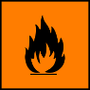 or 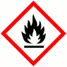 | No significant quantities of cleaning or building maintenance chemicals. There is a small stock of alcohol-based sanitiser in the outbuilding store-room. I’d recommend storing this in a way that makes it less likely to be damaged, knocked over, etc. and spilled.  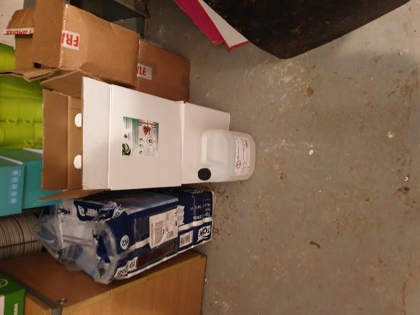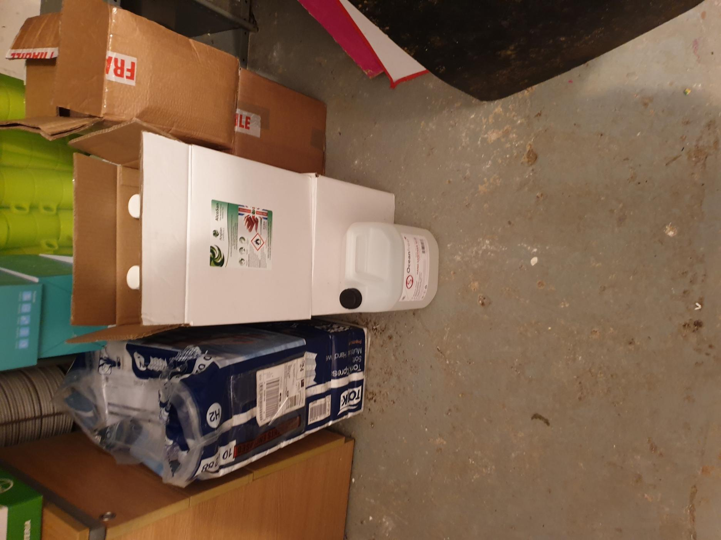 |  | N
Table 4c; Fire Prevention. Oxygen hazards, and any control measures (elimination/reduction/control). OK or NOT OK? If “No” detail the recommendations in Table 1 above
Oxygen Hazard | Existing controls | OK; Y/N?
Bottled oxygen (e.g. medical oxygen, oxy-acetylene cutting set) | None |  | N/A
Oxidising agents, i.e. chemicals with these labels;   or 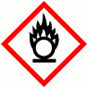 | Minimal quantities, e.g. a bottle of bleach |  | Y

Table 4d; Factors Contributing Towards Fire Development and Spread. OK or NOT OK? If “No” detail the recommendations in Table 1
Hazard Leading to Development and Spread | Existing Control | OK; Y/N?
Fire load and likely speed of growth, pyrolysis, etc. | No significant growth factors, although there will be pyrolysis of material such as furniture, the material under the stage, etc. |  | Y
Surface material, spread to other fuels, etc. Conduction, convection, radiation, etc. | All surface materials are safe. |  | Y
Compartmentation | Generally good |  | Y
Smoke spread, voids, suspended ceilings >800mm, ducts, lifts dumb waiters, service risers, waste chutes, interconnected roof voids, etc. | Roof voids above WC/Meeting Room, and above the kitchen, but other than a small amount of storage above the kitchen these are clear and not particularly likely to lead to the spread of an undetected fire |  | Y

Risk Assessment; Risk of Harm in the Case of Fire

Table 5. Evaluation of The Effects of Fire
Describe Fire Contingency facilities, equipment, arrangements, etc.; |  | Evaluation of risk; are the facilities adequate, Yes or No?  If “no”, detail any recommendations in Table 2
- Fire Fighting | Sufficient fire extinguishers, suitably maintained, with dry powder in the store-room and kitchen. We discussed the suitability of having a DP extinguisher in the kitchen, but on reflection, I’d keep it there. |  | Y
- Fire Warning | Automatic fire detection in key areas. Manual call points at all exits, which are all clearly accessible |  | Y
- Means of Escape  Routes, travel distance, final exits, emergency lighting, compartments & fire doors, signage etc. | All escape routes are clear and well-signed and within the required travel distances. The stage steps do impinge into the route from the Main Hall to the entrance lobby; these are moved up onto the stage when there is a large gathering in the hall. Might it be worth moving the steps to the opposite side of the stage (the Meeting Room door is less often used, and is not an escape route)?  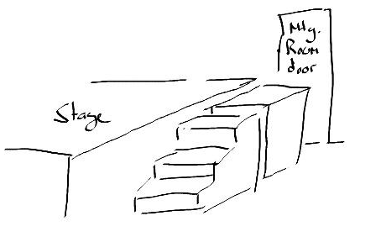  Final exits are all satisfactory; push-bar operated, thumb-latch locks, outward opening, clear pathways outside.  Internal and external emergency lighting is all good.  Fire Doors; Generally good, although fire doors are not up to current standards. Fire doors lack fire rated hinges and cold smoke/intumescent seals.  The door from the Meeting Room to the main hall has been adapted, by cutting a second door and adding this section on top. This will undoubtably interfering with the performance of the door.    As and when the opportunity arises, upgrade fire doors to incorporate fire rated hinges and cold smoke/intumescent seals. |  | N
- Management;  Procedures; action plan, nominated marshals, evacuation (Inc. disabled, sweeping, etc.), drills | Maximum numbers; Hall 150, meeting room 20.  A simple Action Plan is displayed, with a more comprehensive Instruction Sheet given to hirers as part of the Risk Assessment but amended as part of this assessment. In practice, the procedure is to check for false alarms and re-set if necessary. This needs to be included in the procedure.  There is no particular need to establish attendance lists, in/out boards, etc., to record attendees/people on site at any one time.  For hires, the hirer is the clearly nominated “fire marshal” (for want of a better phrase), but there is no specifically nominated lead or “fire marshal” for Committee-organised events. I’d advise ensuring that Committee organised events have a nominated Lead Person to take charge in the event of fire (ensure evacuation, call the fire service, etc). |  | N
- Staff Training  Induction, procedures, fire extinguisher training | No specific training required. Fire extinguisher practical training would be beneficial for key staff, if the opportunity arises. |  | Y
- Maintenance and Testing  (e.g. alarms, emergency lighting, exit doors clear/openable) | All perfectly in order;  - Weekly call point tests  - Servicing of emergency lighting, fire detection and warning and fire extinguishers. |  | Y

Review Date | Review summary (what’s changed);
06/01/22 | 28/09/20: 2kg dry powder extinguisher in kitchen exchanged for 2kg CO2 unit

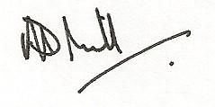
Original Assessor: Richard Mills, The RedCat Partnership Ltd, 8 Thorpe Road, Norwich (Sept 2020)

Representative of the Responsible person: Roger Quick (signed)...............................................................

Chairperson: John Ward (signed)...................................................................................

