
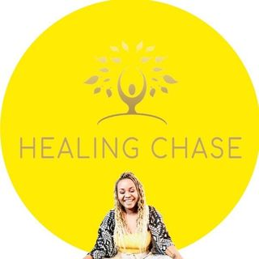
Attachment & History Session

Welcome
These questions are offered as reflection prompts for your individual attachment and relationship history session. You do not need to answer them or write anything down.
The aim is simply to help you reflect on your experiences, relationships, and ways of connecting before we meet. Together, we will explore anything that feels relevant during our session.
There are no right or wrong answers. Please take a little time to reflect on the questions, and I look forward to meeting with you individually and continuing our work together as a couple.

Comfort & Connection in Childhood
• Tell me a little about the family you grew up in.
• Who did you go to for comfort as a child?
• Could you usually count on this person when you needed them?
• When were you most likely to receive comfort, support, or attention?
• How did you let people know you needed comfort or connection?
• What happened if you were upset, frightened, hurt, or distressed?
• How did you comfort yourself when support wasn't available?
• What did you learn about asking for help or needing other people?
• What is one thing you wish you had received more of growing up?

Family Relationships & Emotional Climate
• How did your parents or caregivers show love and affection?
• Were emotions openly expressed in your family?
• What happened when someone was angry, upset, sad, or struggling?
• Were there emotions that felt acceptable and others that were not?
• How was conflict handled in your family?
• Did your parents or caregivers argue? If so, how did they repair or reconnect afterwards?
• Did you see warmth, affection, and closeness between them?
• Did either parent struggle with loss, trauma, mental health difficulties, addiction, stress, or emotional availability?
• How did those experiences affect you?
• What did you learn about relationships from watching them?

Understanding Yourself
• Growing up, what role did you tend to take in your family?
• Did you become independent, responsible, helpful, quiet, invisible, the peacemaker, or something else?
• When did you feel most loved and valued?
• When did you feel most alone, misunderstood, or unseen?
• What did you learn about trusting people?
• What did you learn about vulnerability?
• What did you learn about depending on others?

Conflict & Protection
• When you felt hurt growing up, what did you usually do?
• Did you move towards people for comfort, or away from people to protect yourself?
• What happens inside you now when you feel criticised, rejected, ignored, or misunderstood?
• What do you notice yourself doing when relationships feel difficult?
• What are you protecting yourself from in those moments?

Brief reflection on current relationship
• If your partner could truly understand one thing about your experience, what would you want them to know?
• What do you think your partner misses or misunderstands about you?
• What do you need most when you are hurting?
• What helps you feel emotionally safe?
• If this relationship felt secure and connected, what would be different?

_______________________________________________________________________________
Thank you for taking the time to reflect on these questions. Well done! We will explore these together naturally in our individual sessions.

