
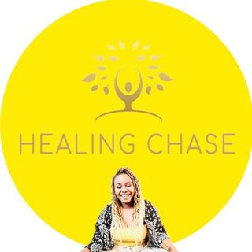
Assessment for Couple Therapy (EFCT)

Welcome, and thank you for being here. As you fill out this intake form, I want to acknowledge that some of these questions may bring up difficult or emotional reflections. Please complete this form individually. There are no right or wrong answers, this will help guide our work together. Please take your time, and if you don’t have some answers now, that’s completely okay, we will explore them naturally in our sessions.

Name:
Date:
- Comfort and Connection in Childhood

- Who did you go to for comfort as a child?

- Could you count on this person when you needed them?

- When were you most likely to be comforted by them?

- How did you express your need for comfort or connection?

- How did you comfort yourself when they weren’t available?

2. Early Relationship Models (Parents/Caregivers)

- How did your parents or caregivers show love and connection?

- Did they argue? If so, how did they repair or reconnect afterwards?

- Were they openly affectionate?

- Did they experience loss, trauma, or emotional difficulties?

- Did you see them struggle in their relationship or individually?

- What is one thing you wish you had more of growing up?

3. Current Relationship Patterns

- When you feel upset or disconnected, what do you tend to do?

- What do you most need from your partner in those moments?

- What do you find most difficult in your relationship right now?

- What helps you feel close and connected?

4. Reflection and Goals
- How do you think your past experiences influence your relationship today? Do you feel your past shapes how you connect with your partner?

- What patterns do you notice in how you relate to your partner?

- What are you hoping to gain from couples therapy?

5. Relationship Cycle
- When you feel hurt or disconnected, what do you tend to do?

- What do you notice your partner does in response?

- How do you usually feel underneath (e.g. hurt, rejected, anxious)?

- What do you most need from your partner in those moments?

- What do you fear might happen if things don’t change?

- Do you notice a pursue/withdraw pattern? If so, describe it.

- What situations tend to trigger conflict?

- How do conflicts typically escalate and end?

_______________________________________________________________________________
Thank you for taking the time to complete this form. I know it can bring up some deep reflections, and I appreciate your openness. Well done! We will explore these answers together naturally in our sessions, and we may refer back to them when it feels right.

