 Registration / E.H.R. Intake Form
Patient Information

- Name (Last, First MI): ______________________________________Date: _________________
- Address: ______________________________________________________________________
Street City State Zip
- Cell Number: ________________________________ Cell Provider: ____________________
- Email: ________________________________________________________________________
- Date of Birth: __________/_________/ ____________ Age: ____________
- Gender (circle one): Male / Female / Other____________________
- Status (circle one): Minor (under 18) / Single / Married / Other
  - Parent /Spouses Name: ________________________ DOB: ______/______/______
- Emergency Contact: _______________________________ Number: ___________________
- How did you find us? (circle one): Internet / MVP / __________________________________

Chief Complaints (CC) & History of Present Illness (HPI)

- Reason For Visit: ________________________________________________________________
- Use Body Diagram: Place an X on the primary areas / place an O on the secondary areas
- How Long (circle one): ________ Days / Weeks / Months / Years
- Prognosis (circle one): Better / Same / Worse
- Rate Pain (circle range) from 1 to 10 (worst pain)
1 2 3 4 5 6 7 8 9 10
- What type of pain / discomfort (circle all that apply):
Sharp Dull Throbbing Stiffness
Numb Ache Shooting Tingling
Burn Cramp Burning _______________
- Frequency (circle one): Constant / Frequent / Intermittent
- Does it interfere with your (circle all that apply):
Work Sleep Daily Routine Recreation
- What increases the pain (circle all that apply):
Sitting Standing Walking Bending Lying Down
- Is this condition due to (circle one): Automobile Accident / Injury from Employment / Neither
  - Date of Auto/Work Accident: __________/_________/_____________

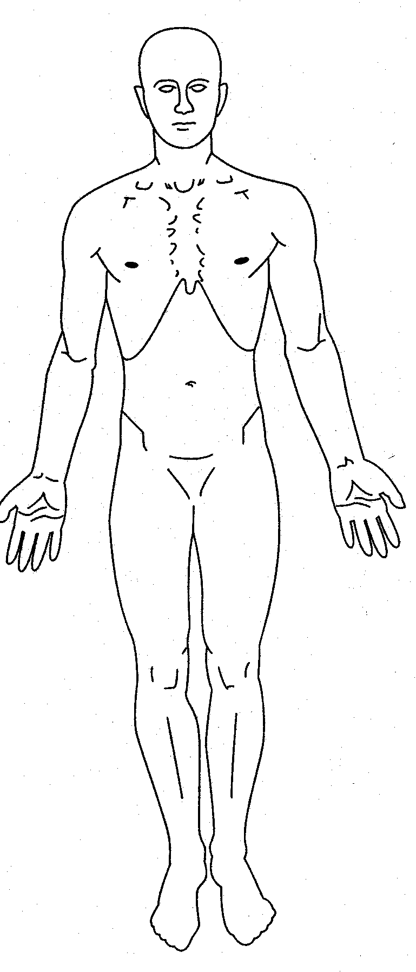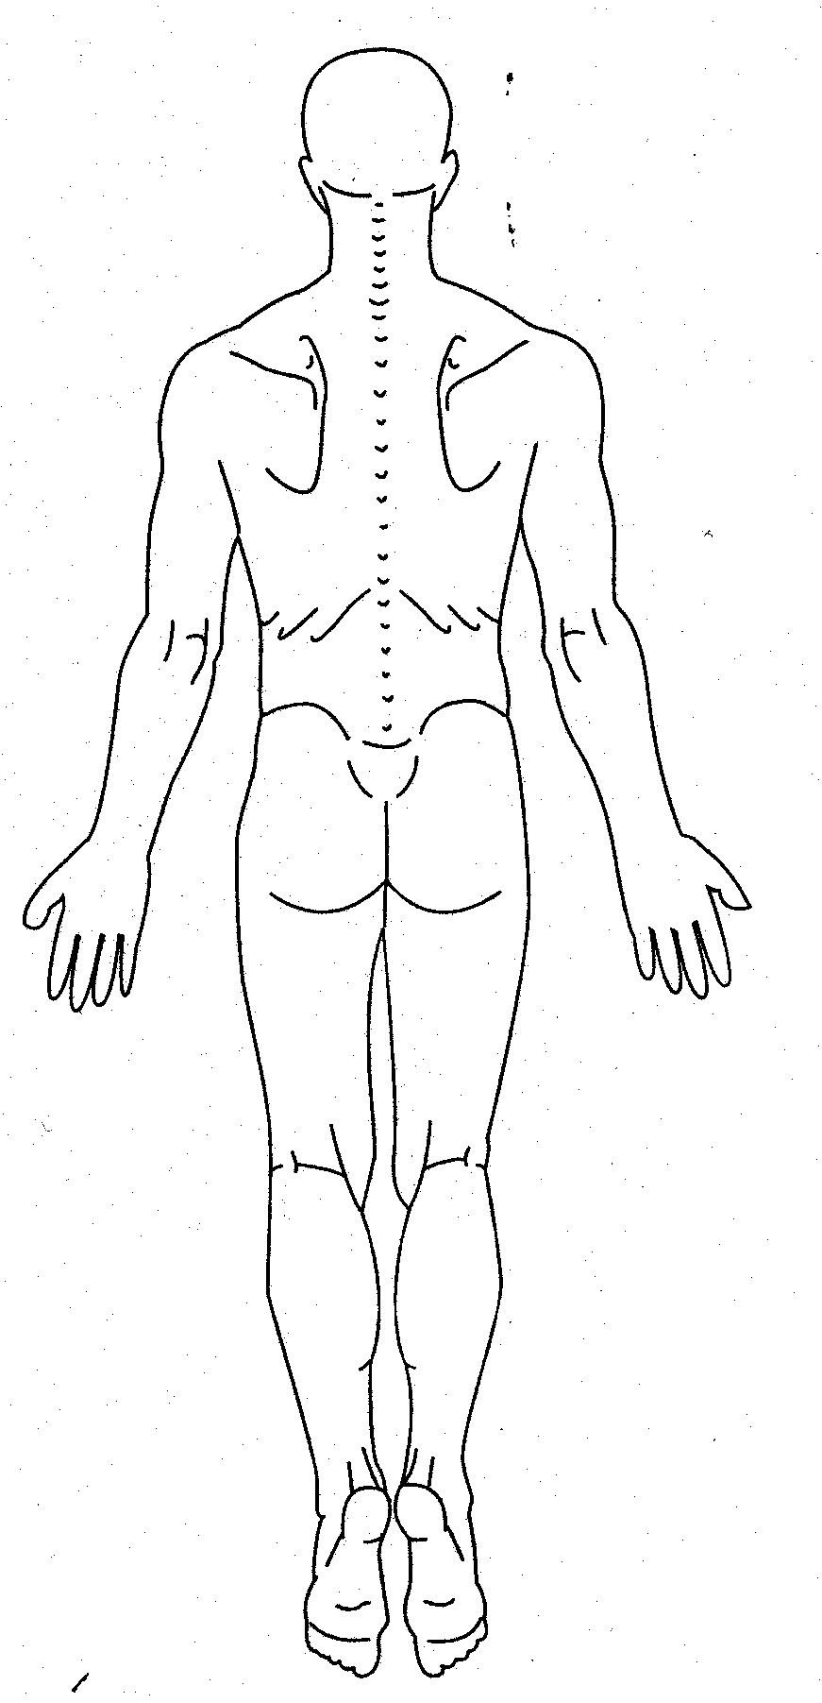
Insurance (please provide insurance card and license for copy)

- Insurance Company (circle one): BCBS / BCN / Priority Health / Medicare / Medicaid / Aetna / Cigna
_______________________________________________
- Insurance #: _________________________________ Group #: _________________________
- Who is responsible for this account? (circle one): Self / Spouse / Parent or Guardian
- Subscribers Name: ________________________________ DOB: _______/_______/________
- Assignment and Release: I, the undersigned certify that I (or my dependent) have insurance coverage with the above and assign directly to Dr. Burkhart/The Wellness Center of West Michigan all insurance benefits, if any otherwise payable to me for services rendered. I understand that I am financially responsible for all charges whether or not paid by insurance. I hereby authorize the doctor to release all information necessary to secure the payment of benefits. I authorize the use of this signature on all insurance forms.
- Responsible Party Signature: ____________________________ Date: _____/_____/_______

Review of Systems (ROS) & Past, Family, Social History (PFSH)

- What treatments have you tried (now or in the past) for this condition (circle all that apply)?
None Chiropractic OTC Meds Prescription Meds Physical Therapy Exercises
- What is helping/has helped this condition: ______________________________________________
______________________________________________________________________________
- Have you seen your Primary Care Physician for this condition (circle one): Yes No
  - Name of PCP: __________________________________________________________________
  - What is their Diagnosis: _________________________________________________________
- Are you a previous Chiropractic patient here or elsewhere (circle one)? Yes No
  - Name of Chiropractor: _________________________________________________________
  - What did you like: _______________________________________________________
  - What did you dislike: ___________________________________________________________
- Past X-rays (region & date): ______________________________________________________________
_______________________________________________________________________________
- Past MRI (region & date): _________________________________________________________________
- Past Spine Injuries/Diagnosis: Arthritis / Disc / Scoliosis / Fracture / Osteoporosis
_______________________________________________________________________________
_______________________________________________________________________________
- Respiratory History/Diagnosis: none __________________________________________________
- Cardiovascular History/Diagnosis: none _______________________________________________
- Gastrointestinal History/Diagnosis: none ______________________________________________
- Ear, Nose, Throat History/Diagnosis: none _____________________________________________
- Past Operations/Surgeries: Disc Surgery / Fusion / Joint Replacement / Joint Surgery
________________________________________________________________________________
________________________________________________________________________________
- Sleeping Positions (circle all that apply): Face Up / Side / Face Down
- How many hours per day do you sit (circle range): 2 / 4 / 6 / 8 / 10 / 12
- Weekly Diet Ranking (circle one): Poor / Decent / Good / Excellent
- Weekly Physical Activity (circle one): Seditary / Light / Moderate / Heavy
- Medications: ________________________________________________________________________
________________________________________________________________________________
- Allergies: ____________________________________________________________________________
- Family History (hereditary risk factors: Cancer, osteoporosis, ect.): _________________________________
________________________________________________________________________________
- Social History (anxiety, depression, ect.): ____________________________________________________
- Female – Are you Pregnant? Yes No Due Date: ______________________________
- Sudden Weight Gain or Loss: Yes No
- Recent Fever or other Flu Symptoms: Yes No
- Smoking History: Every Day / Occasional / Former / Never
- Height: _______’_________” Weight: ______________lbs B.P.: __________/____________

E.H.R. Reporting Specific Questions (required to ask as Medicare Provider by Federal Government)

- Race (circle one): Decline to Answer / ____________________________
- Ethnicity (circle one): Decline to Answer / ________________________________
- I choose to (circle one) decline / accept receipt of my clinical summary after each visit.
(these summaries are often blank because of the nature and frequency of chiropractic care.)
- Patient Signature: ________________________________________ Date: ______/______/__________

 Terms of Acceptance

When a patient seeks chiropractic health care and we accept a patient for such care, it is essential for both to be working towards the same objective.

Chiropractic has only one goal. It is important that each patient understand both the objective and the method that will be used to attain it. This will prevent any confusion or disappointment.

Adjustment: An adjustment is the specific application of forces to facilitate the body’s correction of vertebral subluxation. Our chiropractic method of correction is by specific adjustments of the spine.

Health: A state of optimal physical, mental, and social well being, not merely the absence of infirmity.

Vertebral Subluxation: A misalignment of one or more of the 24 vertebra in the spinal column which causes alterations of nerve function and interference to the transmission of mental impulses resulting in a lessening of the body’s innate ability to express its maximum health potential.

We do not offer to diagnose or treat any disease or condition other than the vertebral subluxation. However, if during the course of a chiropractic spinal examination, we encounter non-chiropractic or unusual findings, we will advise you. If you desire advice, diagnosis or treatment of non-chiropractic findings, we will recommend that you seek the services of a health care provider that specializes in that area.

Regardless of what the disease is called, we do not offer to treat it. Nor do we offer advice regarding treatment prescribed by others. OUR ONLY PRACTICE OBJECTIVE is to eliminate a major interference to the expression of the body’s innate wisdom. Our only method is specific adjusting to correct vertebral subluxations.

I understand that chiropractic treatments have minimal inherent risk associated with the nature of the therapy. Including but are not limited to: sprains, strains, dislocations, fractures and strokes. I am fully aware of the risk. I consent to the treatments and all risk associated with the treatments.

I, __________________________ being the parent or legal guardian of _________________________, hereby grant permission to The Wellness Center of West Michigan to evaluate and treat _____________________.

All questions regarding the doctor’s objectives pertaining to my care in this office have been answered to my complete satisfaction.

I therefore accept chiropractic care on this basis.

I, ___________________________ have read and fully understand the above statements.
(please print your name)

_____________________________________ ____________
(signature) (date)

Consent for Purposes of Treatment, Payment and Healthcare Operations
I acknowledge that The Wellness Center of West Michigan “Notice of Privacy Practices” has been provided to me.
I understand I have a right to review The Wellness Center Of West Michigan’s Notice of Privacy Practices prior to signing this document. The Wellness Center of West Michigan’s Notice of Privacy Practices can been provided to me, upon my request. The Notice of Privacy Practices describes the types of uses and disclosures of my protected health information that will occur in my treatment, payment of my bills or in the performance of health care operations of The Wellness Center of West Michigan. A copy of the Notice of Privacy Practices for The Wellness Center of West Michigan is on display in the common waiting area of this practice. This Notice of Privacy Practices also describes my rights and The Wellness Center of West Michigan’s duties with respect to my protected health information.
The Wellness Center of West Michigan reserves the right to change the privacy practices that are described in the Notice of Privacy Practices. I may obtain a revised notice of privacy practices by calling the office and requesting a revised copy be sent in the mail or asking for one at the time of my next appointment.

Signature of Patient or Personal Representative Date

Name of Patient or Personal Representative

Description of Personal Representative’s Authority

