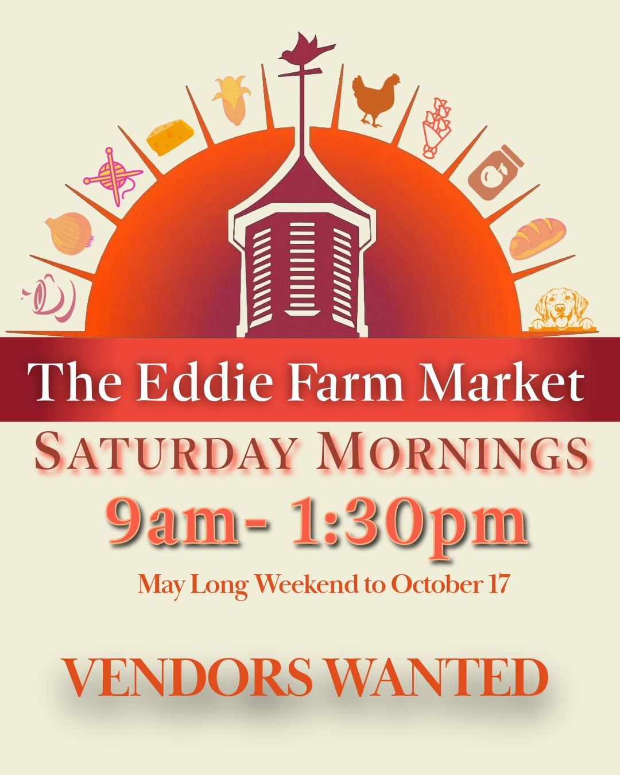
2026

The Eddie Hotel and Farm

Saturday Market Vendor Application Form
First Name: ________________________Last Name:____________________________

Business Name:___________________________________________________________

Email: _{(primary} _{source} _{of} _{communication)} __________________________________________________
Address: _______________________________________________________________
____________________________________________________________
Phone: (Home): ________________________________ (Business)_________________
Website: ________________________________________________________________
Social Media Handle: _____________________________________________________

Product Category: ☐ Clothing/ Accessories ☐ Arts/Crafts/Christmas
- Jewelry/ Body Care ☐ Locally Grown/Manufactured

Your Product is: ☐ Handmade by you/locally☐ Made in North America/Europe
- Commercial / Mass Produced
- Other: …………………………………………………………………………………………..... Have you participated in other markets? If so, please give details or provide photo.
YES ☐ NO ☐
…………………………………………………………………………………………………………………………………

…………………………………………………………………………………………………………………………………
Please mail completed applications to:
The Eddie Hotel and Farm 15786 Loyalist Parkway, Bloomfield, ON K0K 3L0 or markets@theeddie.ca
For inquiries, please contact The Eddie at markets@theeddie.ca

Please Select Vendor Package (all prices plus tax)-
- a) Full Season Vendor- 22 Markets- $550/Season ($450 if paid in full by April 30, 2026)
- b)Part Season Vendor – 10 Markets- $450/season
  - c) Monthly Vendor- 1 Market per month- 6 markets- $350
  - d) Occasional Vendor- $40 or with tent and table- $75
  - e) Charity or Community Vendor- No charge for qualified charities

PLEASE EMAIL THIS FORM TO INFO@THEEDDIE.CA AND

MARKETS@THEEDDIE.CA TO CONFIRM YOU SPOT

Please confirm me as a Vendor for the 2026 Saturday Market at The Eddie.

By Signing below, I agree to the following terms and conditions.

Vendor Hereby Agrees to:
- Vendors must prominently display their business name on their booth/table. Vendor signage must not be affixed in any permanent way.
- Prices and products must be prominently displayed.
- Vendor must be open for the entire duration of the Market’s hours of operation
- Behavior that is deemed offensive, aggressive, dangerous or in any way hinders the right to conduct business or enjoy the market for fellow vendors or attendees is unacceptable and will not be tolerated. The Eddie retains the right to remove
vendors for abusive or offensive behavior, racism, sexism or other offensive speech which may offend patrons or vendors.
- By completing the Vendor Application Form and upon paying the fee, all Vendors participating in the Eddie Farm Market grants permission The Eddie Hotel and Farm Inc and others as may be designated for Marketing or informational purposes to use photographs and video taken at the event and vendor information in marketing medium including but, not limited to websites, newsletters, Television, print and radio media.
- The vendor, by signing below, releases The Eddie Hotel and Farm, Michael von Teichman, Alexander Portman, their affiliated companies, their agents, staff and service providers from any claim of liability or damages for accident, injury, death, theft or damage which may be caused while on the properties or associated properties, or in travel to and from the properties. I hereby acknowledge the market takes place on a working farm and hazards exists, and all persons should use extra caution when on the property.
- I acknowledge; reading, understanding and agreeing to the terms set out in the Vendor Agreement
Signature: _________________________________________________ Date:___________________________

Name:

Company name for directory:

