  - September 05 2025

  - Town of Canton Airport Pollution Challenge
Document Overview:
This document outlines an increasingly severe situation impacting the residents of the town of Canton Massachusetts. The situation stems from the abuse of our town’s environment by the purposeful infringement of aircraft (planes and helicopters) from the Norwood Airport on our families’ homes, schools: air quality and lives. These aircraft are polluting our environment with Lead, noise and invading our personal privacy. This is causing direct and severe health impacts to our children, grandchildren and family’s quality of life. This is being done at our expense as taxpayers and benefitting a few elite aircraft owners and the Town of Norwood.
Detailed Problem Statement:
Norwood airport is attempting to operate increasing larger aircraft and are hosting / providing large amounts of helicopter and small aircraft training flights. These aircraft and training flights are transiting increasingly at low altitude over our town of canton residential areas.
These aircraft are directed to operate at low altitude levels purposefully and directly over our Canton homes, schools, playgrounds and to avoid operating over the Town of Norwood.
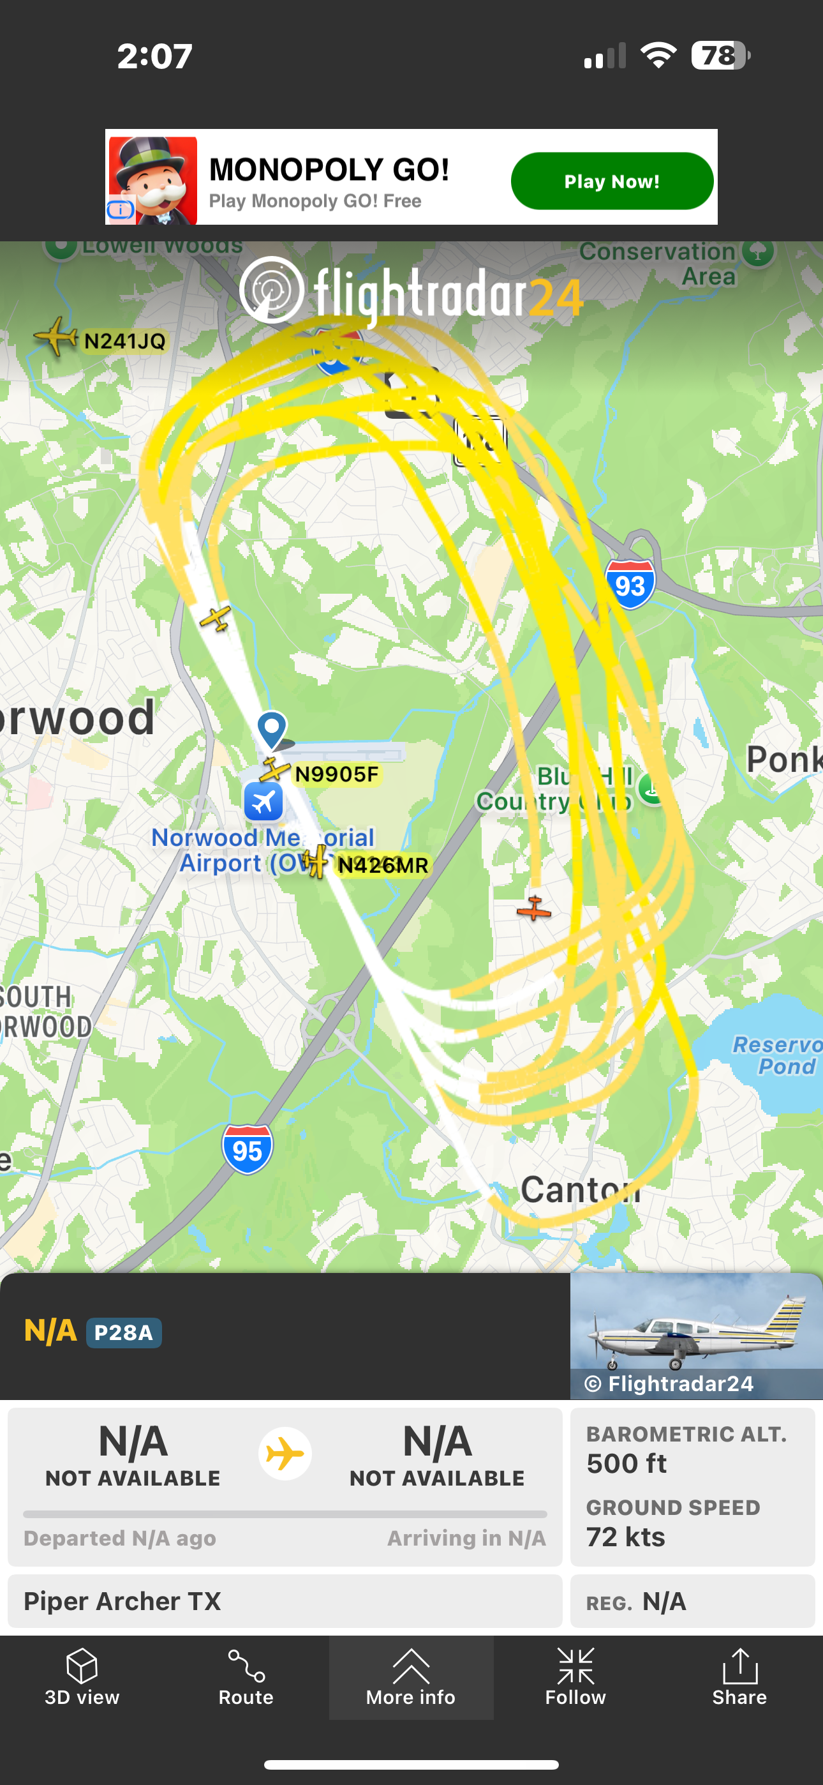
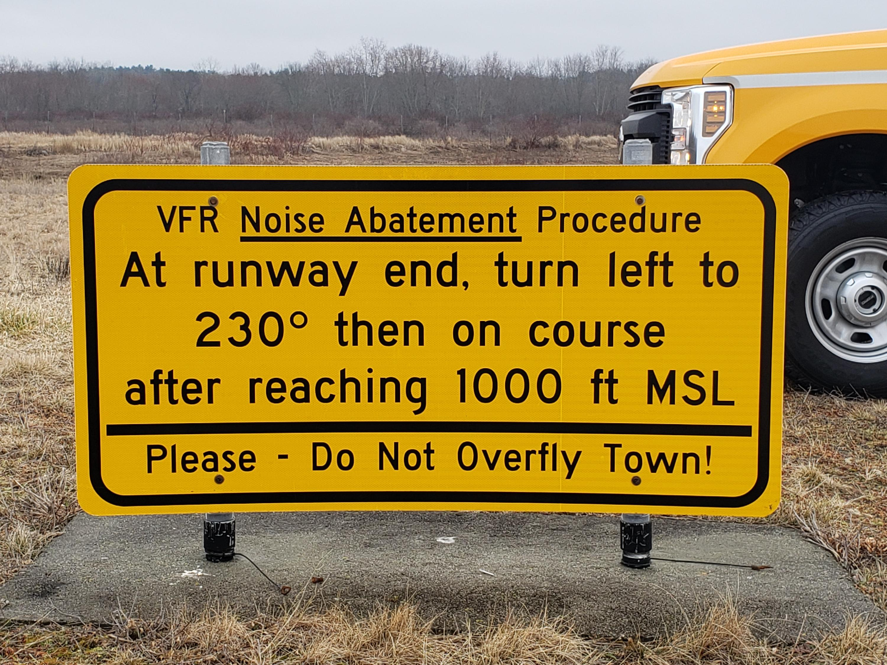

The Airport looks to be trying to expand and profit at the Town of Canton’s residents’ expense with no benefit to us.

These aircraft are operating with Leaded Aviation fuel even though Lead has been eliminated in our cars and trucks for over 30 years. Recent FAA – EPA studies have shown severe Lead pollution impacts on populations in proximity (with in 1500 feet) of small aircraft operation. See appendix for additional information. The Aircraft from Norwood airport are operating directly over our homes, schools, playgrounds and sports fields at altitudes of 400 to1000 feet.
These aircraft repeatedly (many the same craft) circle over Canton, sometimes 3-5 at the same time. This is a continuous noise and pollution stream descending on our families.
The noise from these aircraft repeatedly circling starts, at approx. 8 AM in the morning and continues well into the night, including after 12AM the following morning. (Night and day, seven days a week). We can’t enjoy our own homes, backyards, decks and get to sleep some evenings.
Noise such as these aircraft have shown to cause major health issues including severe stress causing heart disease, cancer, learning challenges and brain issues. We in Canton are being directly and purposely exposed to this by the Norwood Airports operation.
The helicopters not only produce incredible noise, but they fly and hover low of our back yards. Question, what are they looking at ?
We have in this area and in proximity to the airport a large amount of open and non-residential space: Highways, golf courses, malls, car dealerships, green space. There is plenty of operational non-residential space for aircraft operation with modification of the flight paths.
The airport says, the FAA selected the flight paths, complain to them? The FAA provides an unintelligible response? It’s almost like the airport management, and the regional FAA have a circular excuse chain that is designed to purposely frustrate anyone that attempts to complain.
I am positive that if the airport management wanted to, they could work with the towns and the FAA to create a workable noise and pollution operational flight plan system. We need to make them want to!
To the best of our knowledge there is no environmental impact study for the airport including the impacts on the quality of life of the surrounding towns.
There has not been a Noise study performed for the operation of the Airport since 1997 (OVER 27 YEARS)!
Many residents have complained via the Norwood Airport Noise complaint process (well over 150 with no response, engagement or mitigation). Reaching out to East Coast Aero Club one of the flight schools, the president told us that “If you don’t like it, you can move”
Additionally, the Airport has a Master plan for expansion of its runways! This can only bring more and larger aircraft to the area (including more jets).
This expansion project has been covertly moved through the approval process without: Noise study, comprehensive environmental impact statement including the surrounding towns, without notifying or having input and voting by the surrounding town's impacted residents. This expansion will bring increased traffic, noise, pollution and severely impact the town of Cantons residents’ quality of life.
Questions:
Is this what the residents of our Town want for our families and our future.?
Will the reduction of quality of life and impacts on our family’s health, children’s learning be a benefit to the property values in canton?
Don’t we want to be able to safely enjoy the hard built lives and homes that we have created in this town?
Does the town of Canton care if the Town of Norwood is taking advantage of our residents for their profit and the benefit of a few elite aircraft owners?
What will the select board do to act on this issue on behalf of the town of Canton’s residents.

Proposed Solutions / Actions:
- Immediately seek to defund and halt any / all airport expansion
  - It’s not needed for this area and brings no benefit other than for the profit of a few elites.
  - The funds are sorely needed for our children’s education not for longer runways!
- Execute a comprehensive noise study for 2025 and implement an acceptable noise mitigation process, plan and active feedback to the mitigation process for the Airport’s operation.
  - Study must be performed by a totally independent entity from the airport. Preferably managed by an independent board of surrounding towns representatives.
- Execute a comprehensive environmental impact study for 2025 including all surrounding towns, including the impacts on health of all residents from Noise, Lead and infringement of privacy.
  - Study must be performed by a totally independent entity from the airport. Preferably managed by an independent board of surrounding towns representatives.
- Provide equal voting and management representation on the Norwood Airport board by residents / representatives of the surrounding towns (Canton, Westwood, Sharon, other).
- Immediately cease all low level (under 1500 ft, other than for emergencies, law enforcement, emergency) small airplane flyovers of ALL Canton residential areas. STOP poisoning our families!
- Immediately cease all (non-LifeFlight, law enforcement, military) helicopter overflights of residential areas! They do not need runways, and they do not need to be looking down on to our personal yards and spaces!
- Implement and enforce limited hours of operation of the airport. especially evening and midnight repeated overflights are abusive and uncalled for.
Recommended Next Steps:
- Effectively communicate the seriousness of the issues to all Canton residents for them to understand, weigh in and act upon.
- BOS (Board of select persons) and BOH (board of health) immediately engage with the Town of Norwood to hold mitigation discussions
  - Force action from Norwood not excuses!
  - Take legal action if needed
  - Engage with our State and federal representatives to force Norwood to engage and collaborate with us to mitigate this severe health and quality of life situation.
- Defund the expansion of the airport by engaging with our State and federal agencies to remove the funding for any work (Other than comprehensive Noise and Environmental studies).
  - Step up communication with our state and federal representatives by town officials, drive to an action plan and their commitment to address this situation before it’s too late.
- Comprehensive Independent Noise Study and mitigation plan executed immediately
- Comprehensive Independent Environmental Study and mitigation plan executed immediately

Prepared for:

Town of Canton Board of Selectmen and Board of Health
801 Washington St 2nd floor
Canton MA 02021

Prepared by:

Scott Haigh
64 Oakdale Rd
Canton Ma 02021
shaigh2009@gmail.com
617-510-7400

APPENDIX

References:

The Norwood Airport commision knows this information, mitigates the health impacts for their town, their key mitigation is to directly route the aicraft over the town of Canton and away from the Town of Norwood!

Refer to attached documents for comprehensive small airport impact studies:
- Aircraft Noise and Health Impacts Studies in table format 090525 V1
- Lead Pollution from Small Aircraft Operation 090525 V1

Websites other:
- https://nomassairnoise.org/
- Local airport pollution
- Norwood Airport negative impacts

Norwood Airport Master Plan:
- Norwood Airport Technical Master Plan Update

