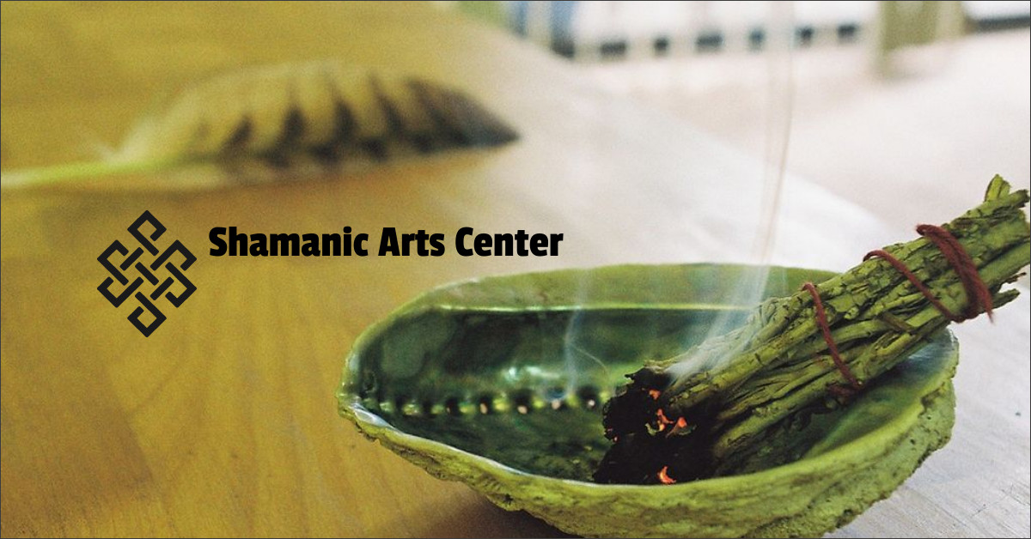

Art Exhibit Release of Liability (Hold Harmless)
(No artwork will be considered for display without this signed form)
• Artist/Exhibitor grants permission for the Shamanic Arts Center to reproduce his/her name, information describing his/her work, representations of his/her work and any other information he/she has provided for the purpose of display, promotion and publicity either now or in the future.
Artist/Exhibitor agrees to display, pack, transport and provide for the return of his/her artwork at his/her own risk and expense.
If Artist/Exhibitor is not available on-site to display, re-pack or re-transport his/her work, he/she gives permission to Shamanic Arts Center to do so on his/her behalf at his/her own risk and expense.
Release of Liability: Shamanic Arts Center or the Creamery Art Center shall not be liable for any injury to Artist/Exhibitor, their personnel, agents or employees or for any damage or loss of Artist’s/Exhibitor's work, equipment or other personal property arising out of the above exhibitions/displays, the mounting and/or any other activities involved in the preparation and/or presentation of the exhibitions/displays. Artist/Exhibitor agrees to assume all risk of damage to or loss of his/her own art from whatever cause. Artist/Exhibitor further agrees to release and to hold harmless Shamanic Arts Center its officers, directors, employees, volunteers and agents from any and all liabilities and damages to art work and/or persons as a result of any part of Artist’s/Exhibitor's participation in the Exhibit.
Indemnification: Artist/Exhibitor shall indemnify, save and hold harmless Shamanic Arts Center and the Creamery Art Center, its officers, directors, employees, volunteers and agents and the participating exhibition venues from any and all claims, demands, causes of action and judgments, losses, costs and expenses, including but not limited to reasonable attorney’s fees, arising due to the negligence of Artist/Exhibitor, their employees, agents or other personnel hereunder, including but not limited to any representation, warranty, term and/or condition of this Agreement.
Insurance: Artist/Exhibitor shall be solely and exclusively responsible to insure properly and adequately their work and property.
Assignment: Neither Party shall assign to transfer any of its rights or obligations under this Agreement and any attempt to do so shall be void and of no effect.
Waiver and Effective Nullity: Waiver by either party of any provision of this Agreement shall not operate or be construed as a waiver of any provision by such party at any time hereafter. The nullity of any provision hereunder shall not affect the validity or enforceability of the remaining provisions hereunder of the Agreement, which shall survive.

Artist Name ______________________________________________________________

Address _________________________________________________________________

Phone: __________________________________________________________________

Signature: _________________________________________________________________

SAC Rep Signature: _________________________________________________________

